The pages of this pack give some general information about tigers and some fun and engaging activities to foster and develop children’s interest in them.

**Tiger**

**This pack includes:**

* Fact posters x3 (Could be used as stimuli for a lesson input)
* Number slice activity (1-10) (Can be pre-cut for a pure number ordering activity or left to be cut by child to add scissor practice)
* Number slice activity - colouring version (1-10) (As above but to be coloured before cutting)
* Description sheet (Can be used as an independent writing activity or with an adult scribing the ideas of a younger child)
* A4 poster
* A4 poster - colouring version
* ‘Body Parts’ x3 (fully labelled, initial sounds only, blank)
* Draw and write sheets x3 (blank sheet, wide lines and narrow lines)
* 1x 4-piece puzzle
* Multimats x4 (for Colouring/Art & Craft/Loose Parts/Playdough)

© 2021 Little Owls Resources

This pack includes:

The pages of this pack give some general information about the role of a paramedic and some fun and engaging activities to foster and develop children’s interest in this role in society.

© 2021 Little Owls Resources

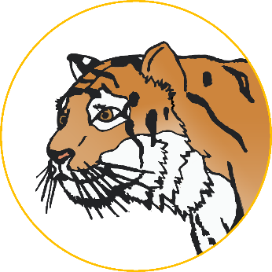

**Tiger Facts**

**biggest**



Wild tigers can live for

years.

**10**

Tigers eat **meat**.

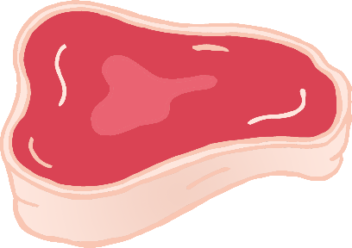

Tigers are the cats in the world!

Humans have hunted and killed many tigers.

Humans have destroyed lots of places that tigers used to live.

This means there is a very high risk that they may become extinct.



**Tigers are** Endangered.

© 2021 Little Owls Resources

**How big is a Tiger?**

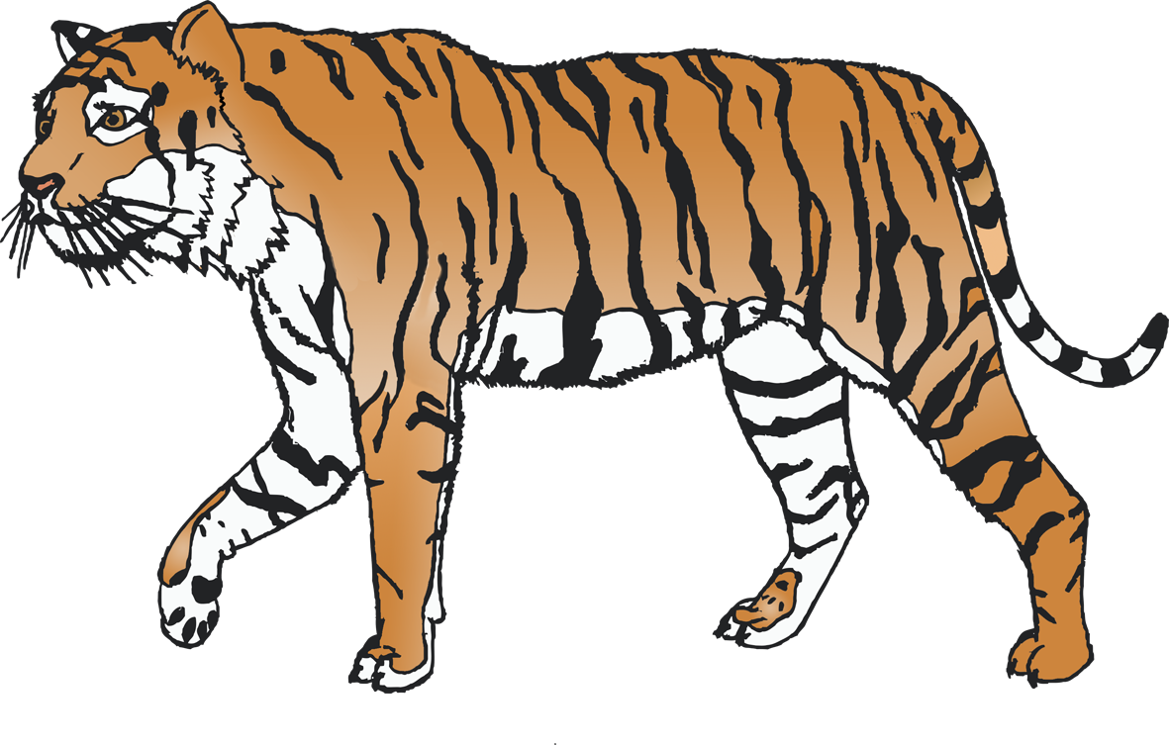

200cm / 2m

© 2021 Little Owls Resources

1

2

3

4

5

6

7

8

9

10

© 2021 Little Owls Resources

© 2021 Little Owls Resources

1

2

3

4

5

6

7

8

9

10

© 2021 Little Owls Resources

**What words would you use to describe a tiger?**

**Tiger**

© 2021 Little Owls Resources

**Tiger**

© 2021 Little Owls Resources



**Tiger body parts**

© 2021 Little Owls Resources

back

**w**hisker

cla**w**

pa**w**

tail

ear

b

**w**

c

p

tail

e



**Tiger body parts**

© 2021 Little Owls Resources



**Tiger body parts**

© 2021 Little Owls Resources

© 2021 Little Owls Resources

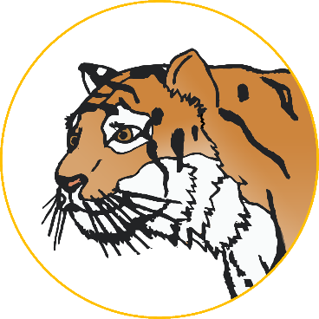

**Draw a Tiger!**

© 2021 Little Owls Resources



**Draw and write about a Tiger!**

____________________________________________________

© 2021 Little Owls Resources



**Draw and write about a Tiger!**

______________________________________________________________________________________________________

**Tiger**

© 2021 Little Owls Resources

© 2021 Little Owls Resources

**Tiger Multimat – Tiger**

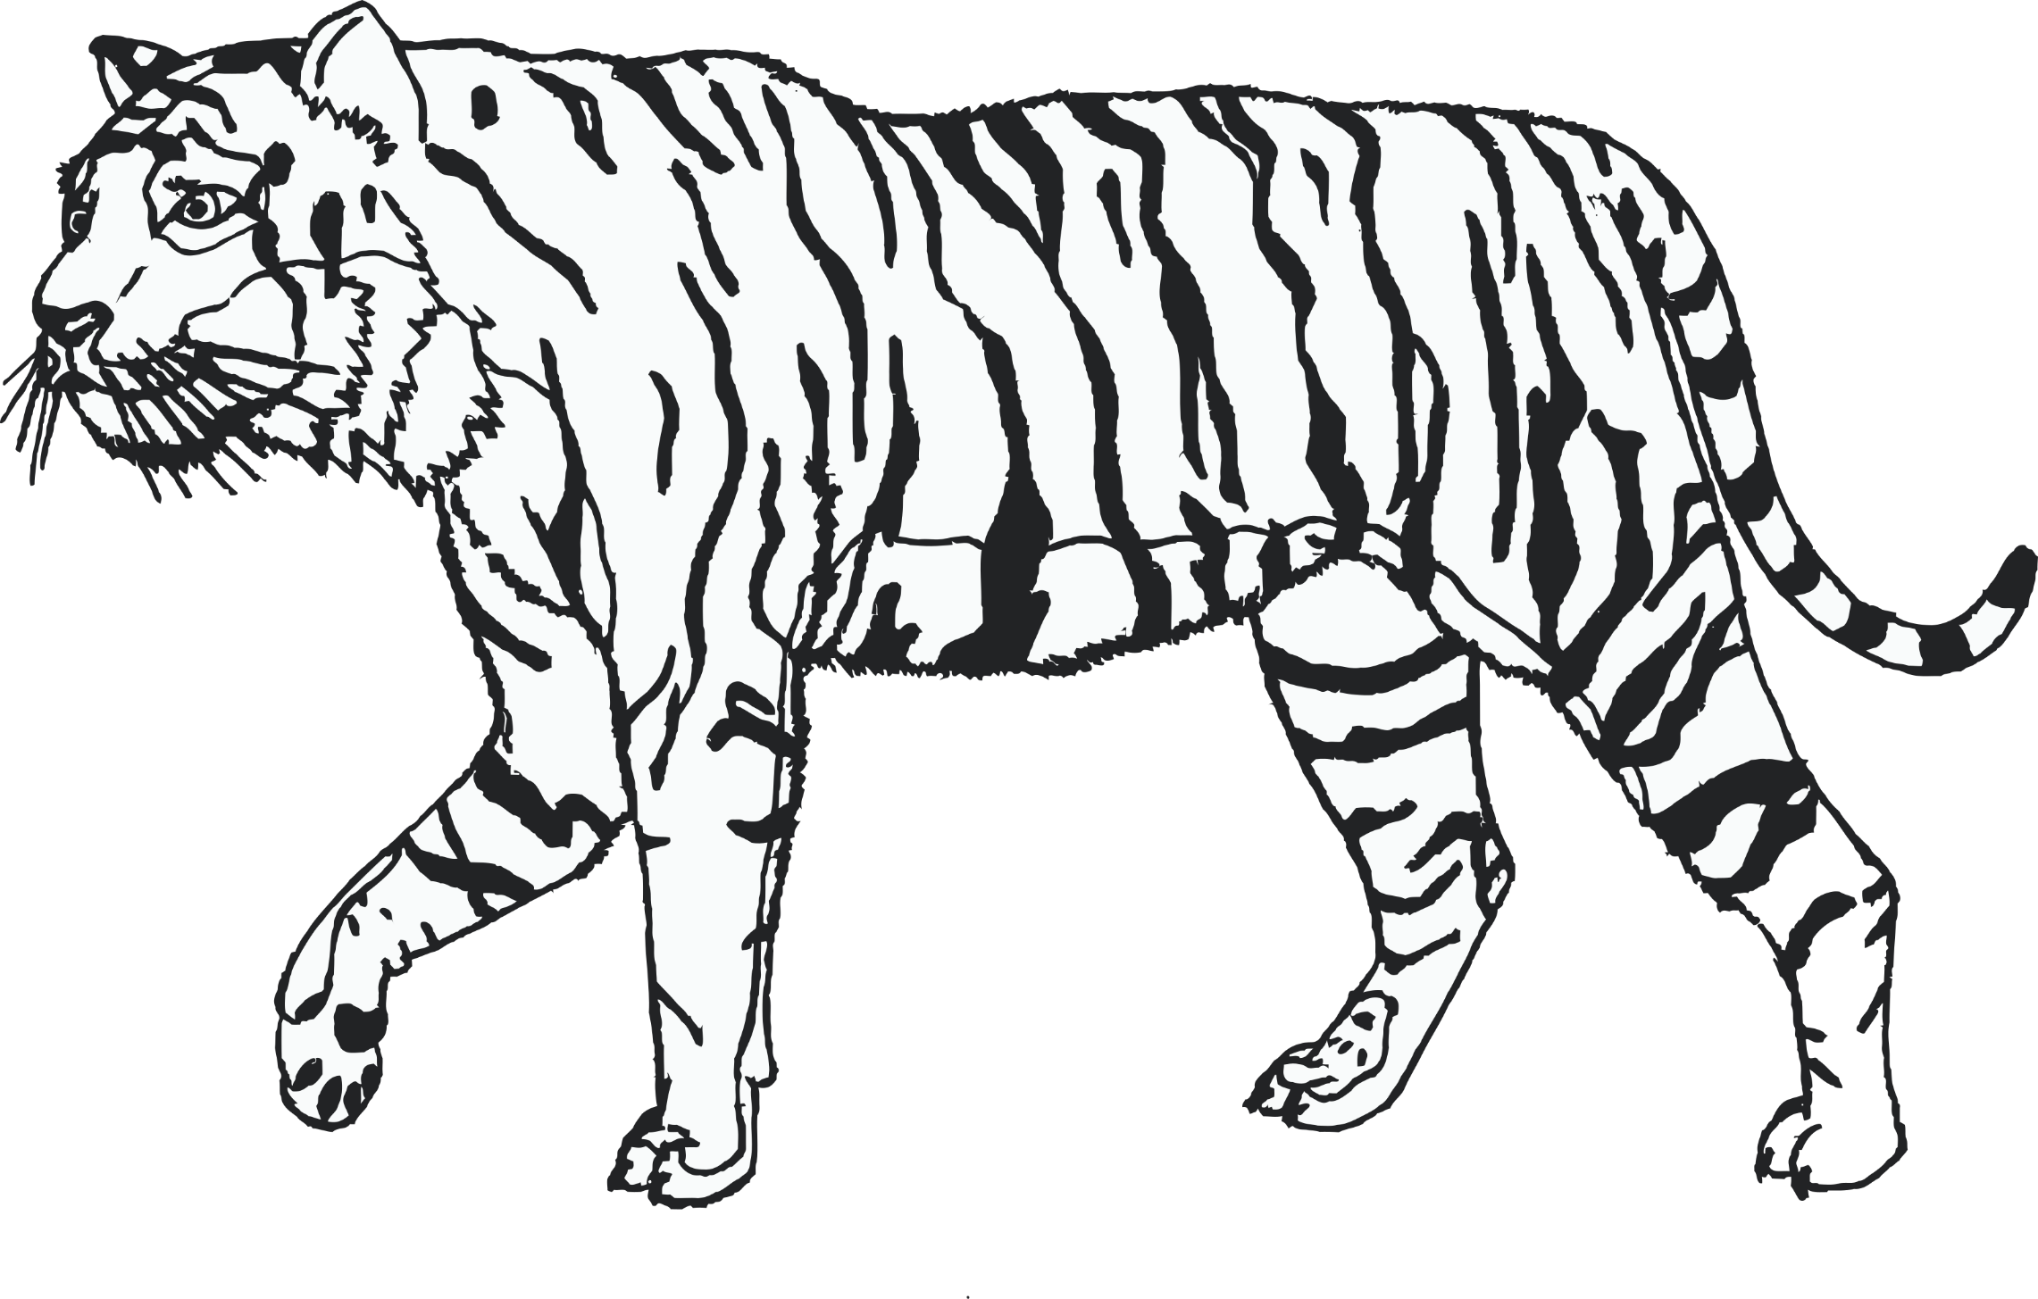

© 2021 Little Owls Resources

**Tiger Multimat – Can you add some stripes?**

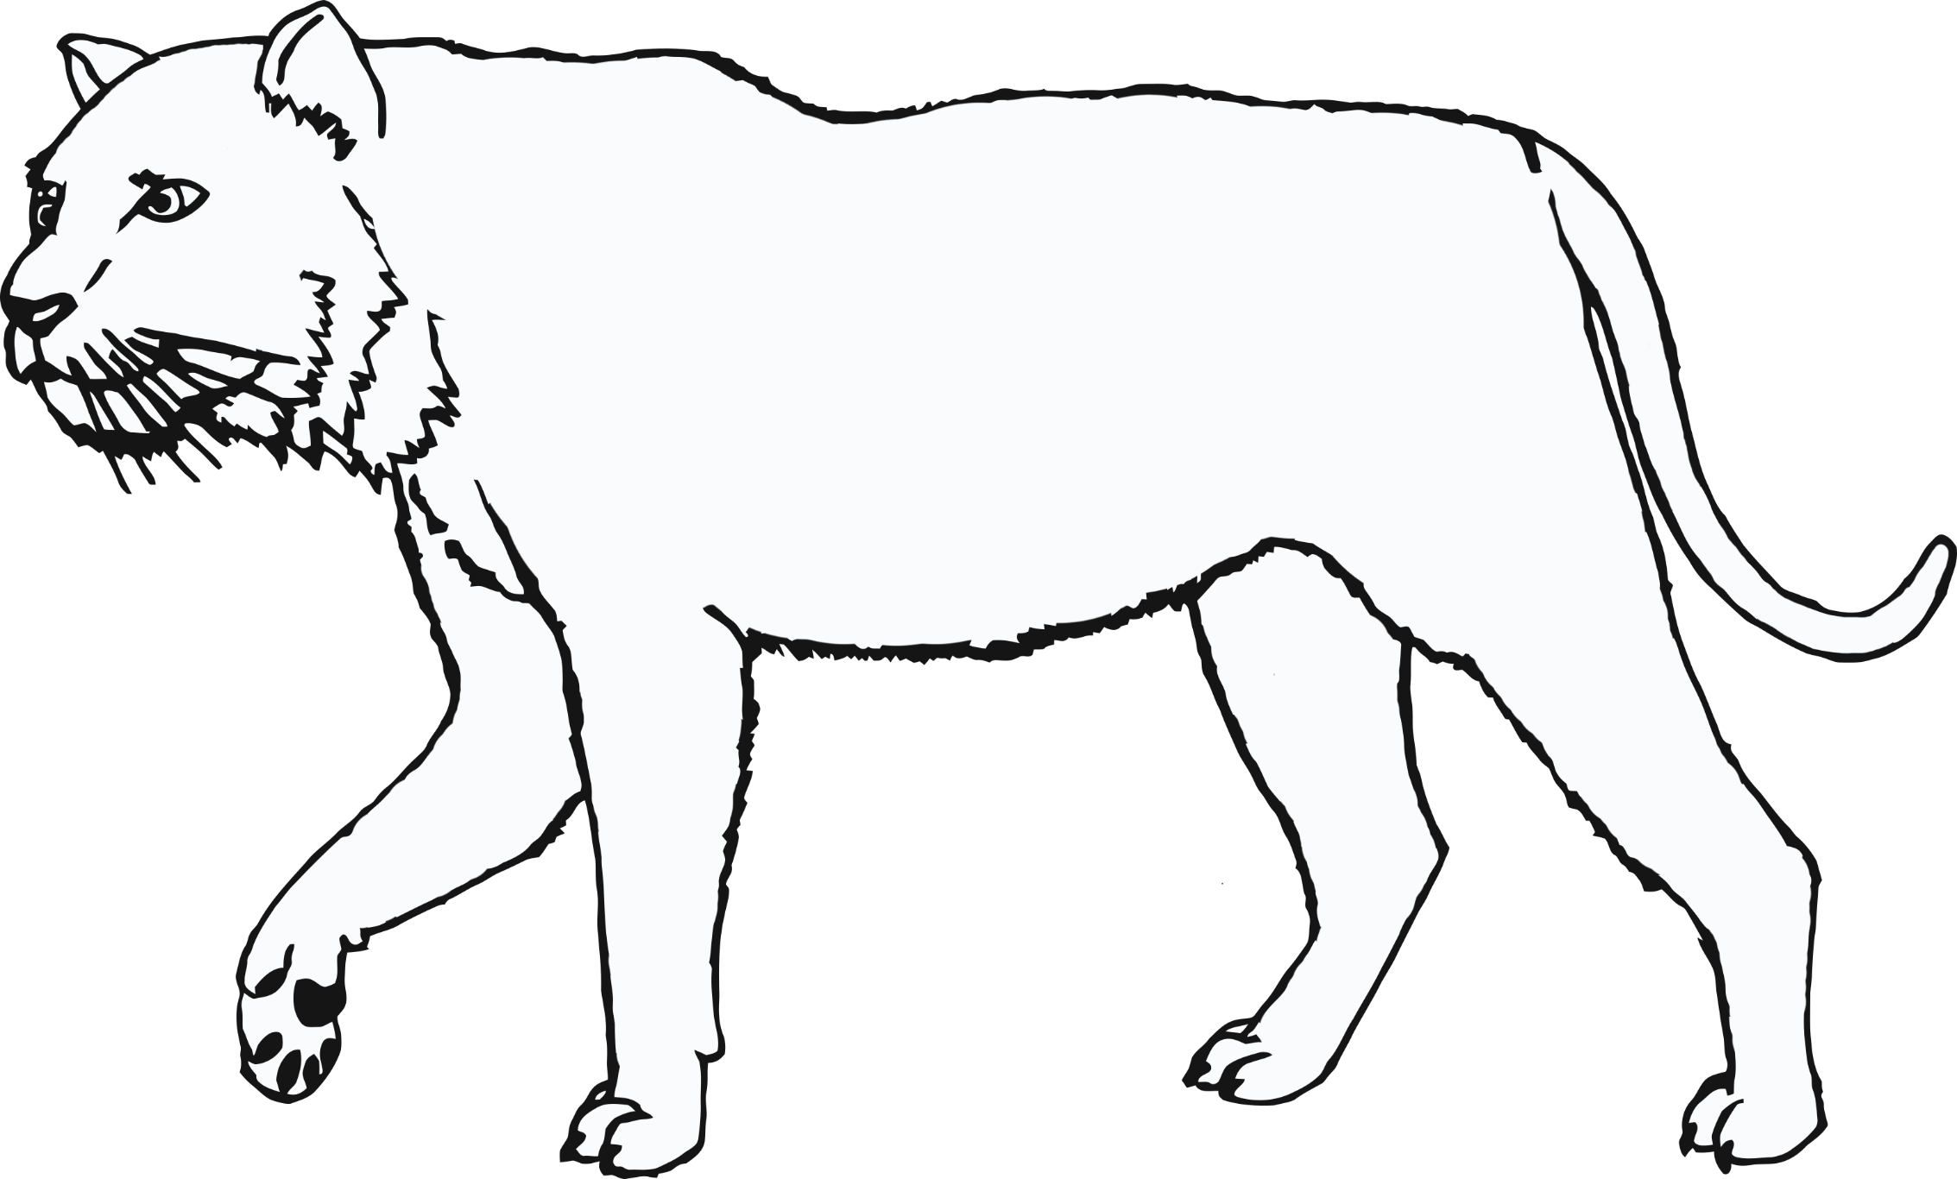

© 2021 Little Owls Resources

**Tiger Multimat – Footprint**



© 2021 Little Owls Resources

**Tiger Multimat – Footprints**

