Three Little Pigs

Wolf

Wolf

Wolf Blowing

© 2021 Little Owls Resources

© 2021 Little Owls Resources

© 2021 Little Owls Resources

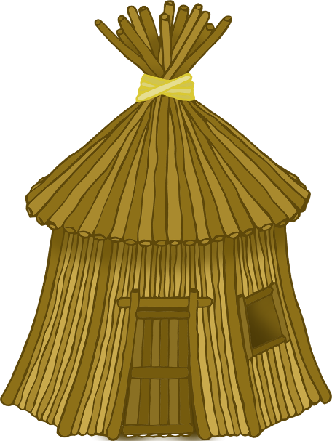

Brick House

Stick House

Straw House

© 2021 Little Owls Resources

© 2021 Little Owls Resources

© 2021 Little Owls Resources

Straw

© 2021 Little Owls Resources

© 2021 Little Owls Resources

© 2021 Little Owls Resources

Sticks

Pot

Bricks

Chimney

© 2021 Little Owls Resources

© 2021 Little Owls Resources

three little pigs

wolf blowing

wolf

© 2021 Little Owls Resources

© 2021 Little Owls Resources

© 2021 Little Owls Resources

straw house

brick house

stick house

© 2021 Little Owls Resources

© 2021 Little Owls Resources

© 2021 Little Owls Resources

sticks

straw

© 2021 Little Owls Resources

© 2021 Little Owls Resources

© 2021 Little Owls Resources

pot

chimney

bricks

© 2021 Little Owls Resources

© 2021 Little Owls Resources