**What happens next?**

These sheets can be used to consolidate the children’s knowledge of the story. The child can draw what they remember happening next in the lower box.

To extend older children, labels/descriptions via emergent writing could be encouraged.

Have fun!

© 2021 Little Owls Resources

The wolf is standing outside the straw house…

© 2021 Little Owls Resources

**What happens next?**

The first pig’s house is blown down…

© 2021 Little Owls Resources

**What happens next?**

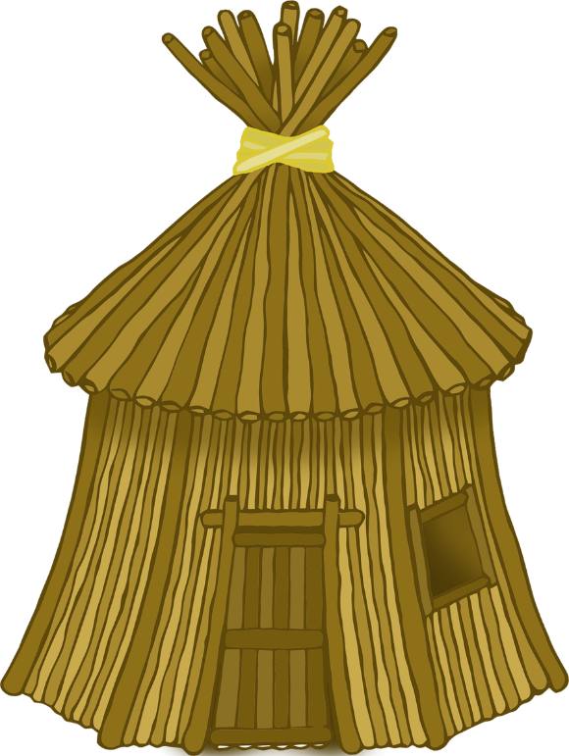

The wolf is standing outside the stick house…

© 2021 Little Owls Resources

**What happens next?**

The wolf is standing outside the straw house…

© 2021 Little Owls Resources

**What happens next?**

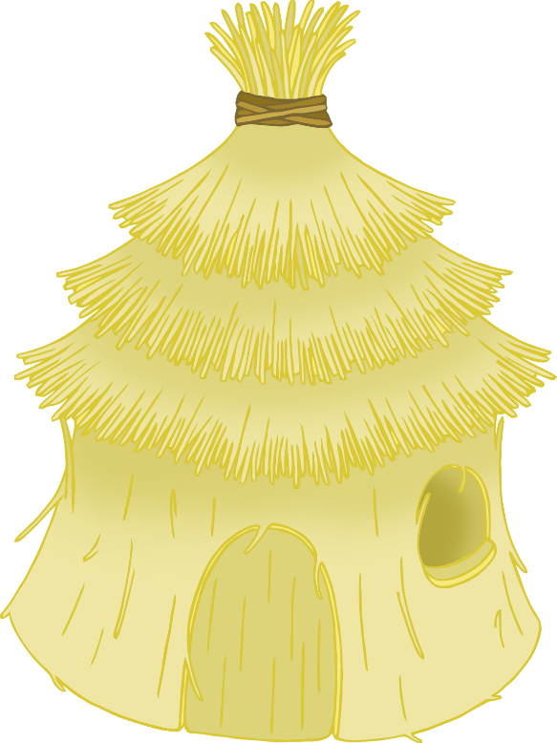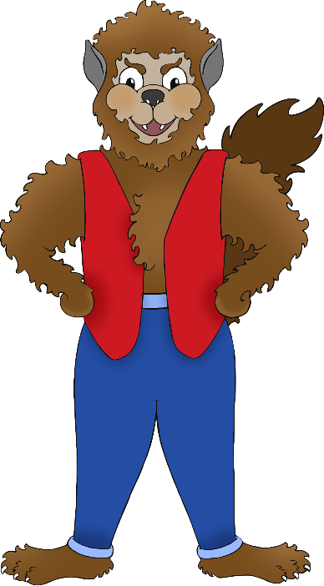

The second pig’s house is blown down…

© 2021 Little Owls Resources

**What happens next?**

The wolf is standing outside the brick house…

© 2021 Little Owls Resources

**What happens next?**

The wolf decides to climb down the chimney…

© 2021 Little Owls Resources

**What happens next?**