The first little pig built his house from straw.

© 2021 Little Owls Resources

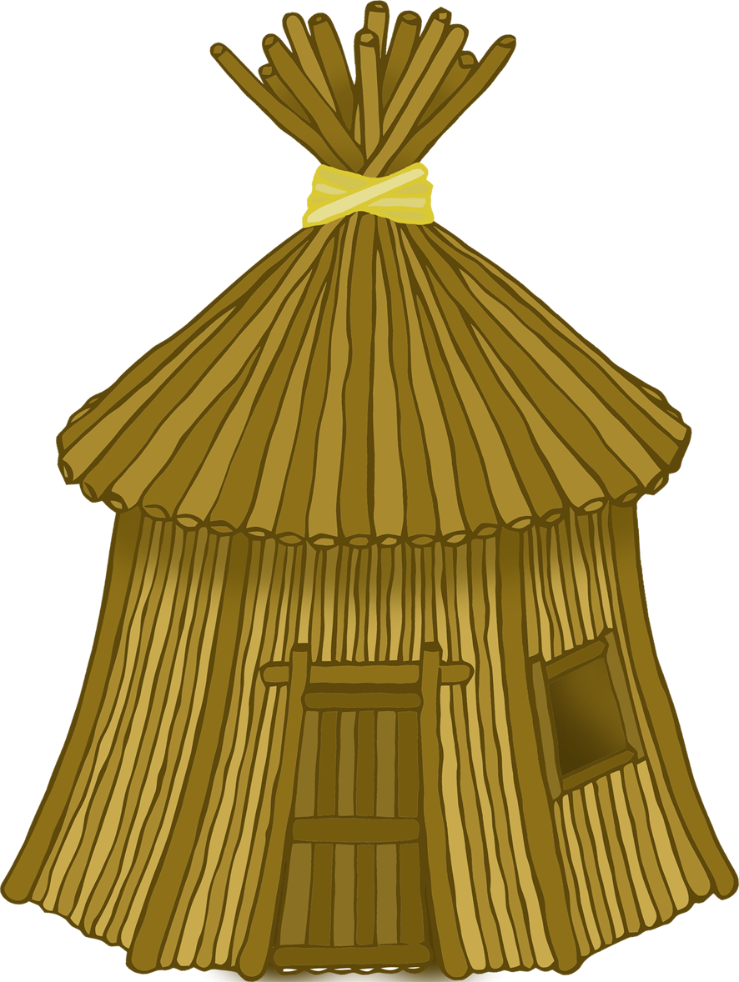

The second little pig built his house from sticks.

© 2021 Little Owls Resources

The third little pig built his house from bricks.

© 2021 Little Owls Resources

The big bad wolf blew the straw house down!

© 2021 Little Owls Resources

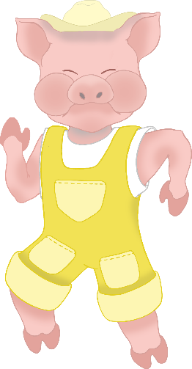

The big bad wolf blew the stick house down!

© 2021 Little Owls Resources

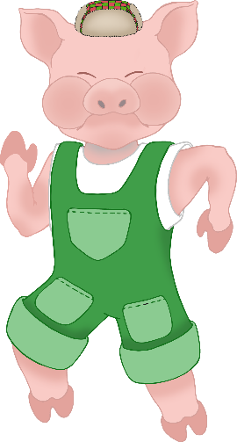

The big bad wolf *couldn’t* blow the brick house down!

© 2021 Little Owls Resources

The wolf climbed into the brick house through the chimney and fell into the boiling cooking pot!

© 2021 Little Owls Resources

The three little pigs lived happily ever after.

© 2021 Little Owls Resources