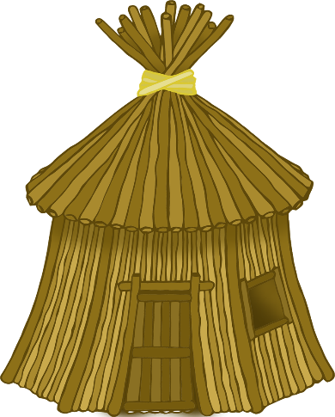

© 2021 Little Owls Resources

© 2021 Little Owls Resources

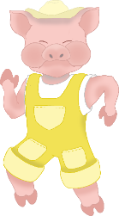

© 2021 Little Owls Resources

© 2021 Little Owls Resources

© 2021 Little Owls Resources

© 2021 Little Owls Resources

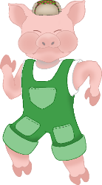

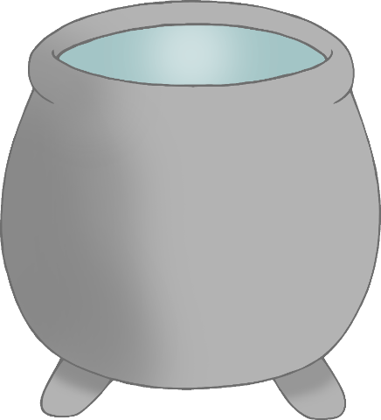

© 2021 Little Owls Resources

© 2021 Little Owls Resources

The second little pig built his house from sticks.

© 2021 Little Owls Resources

© 2021 Little Owls Resources

The big bad wolf blew the straw house down!

The third little pig built his house from bricks.

The first little pig built his house from straw.

© 2021 Little Owls Resources

© 2021 Little Owls Resources

The big bad wolf *couldn’t* blow the brick house down!

The three little pigs lived happily ever after.

The wolf climbed into the brick house through the chimney and fell into the boiling cooking pot!

The big bad wolf blew the stick house down!

© 2021 Little Owls Resources

© 2021 Little Owls Resources

© 2021 Little Owls Resources

© 2021 Little Owls Resources