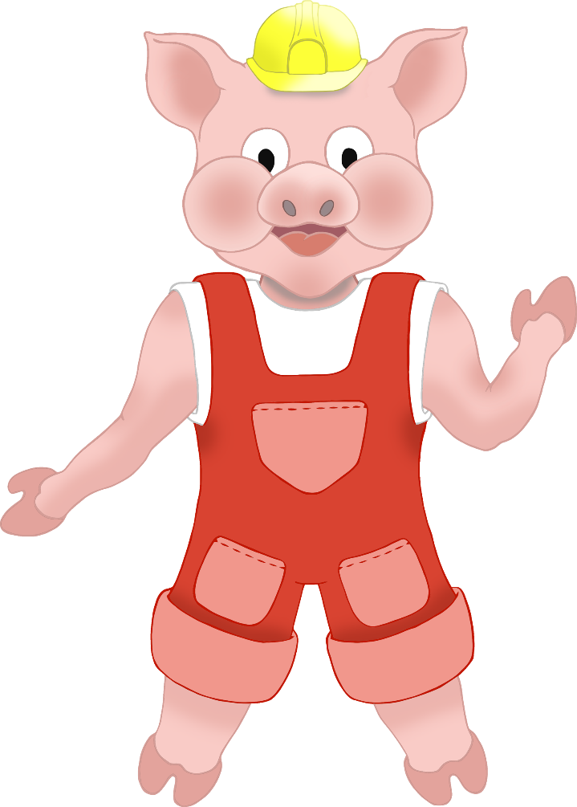

Three Little Pigs Characters

for

Lollipop Puppets



