**The Three Little Pigs**

**The Big Bad Wolf**

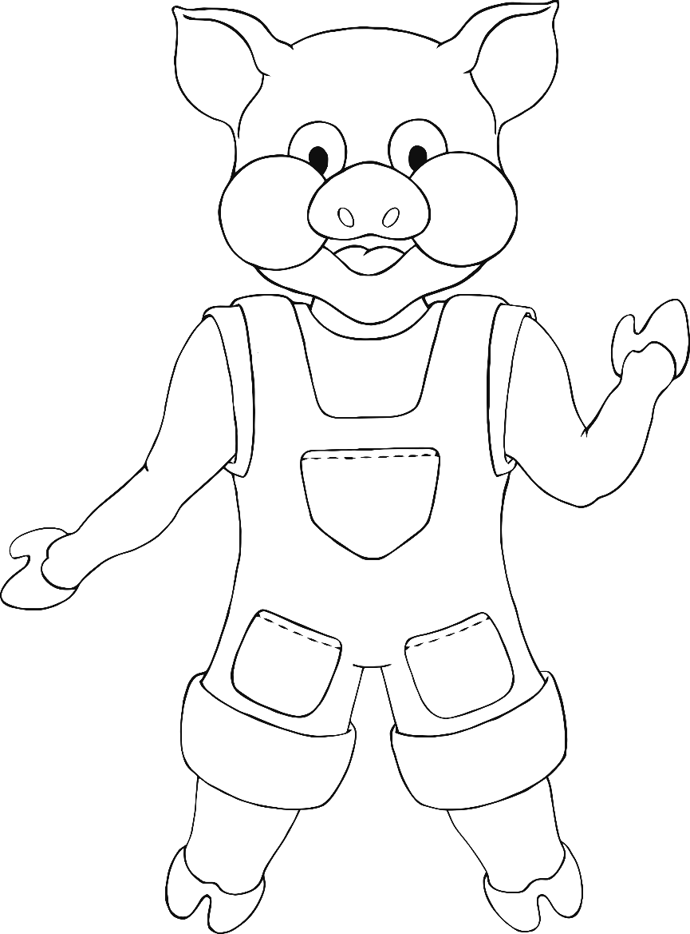

**The Three Little Pigs**

**The Straw House**

**The Stick House**

**The Brick House**

