**The Three**

© 2020 Little Owls Resources

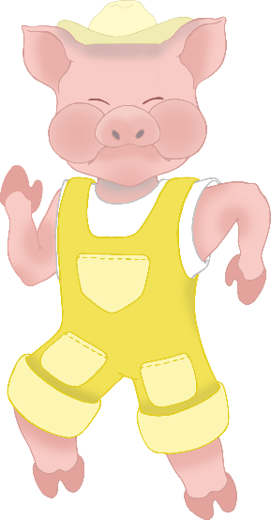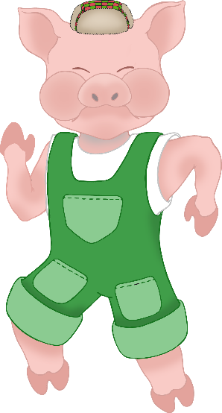

**Little Pigs**

Little pig, little pig, let me come in!

Then I’ll huff and I’ll puff and I’ll blow your house in!

Huff! Puff! Huff! Puff!

Not by the hair on my chinny chin chin!