1

**Three Little Pigs**

**Activity Challenge!**

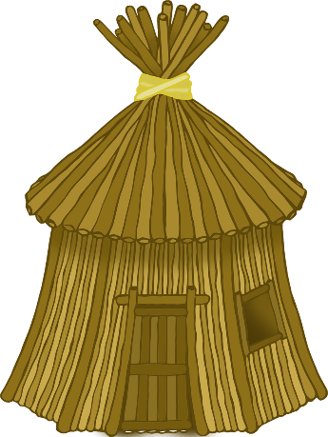

**L-I-F-T… B-U-I-L-D**

Build a house slowly using HEAVY bricks.

**Lift, Build – Lift, Build**

**Lift, Build – Lift, Build**

Build houses quickly using straw and sticks.

**Three Little Pigs**

**Activity Challenge!**

© 2021 Little Owls Resources

2

© 2021 Little Owls Resources

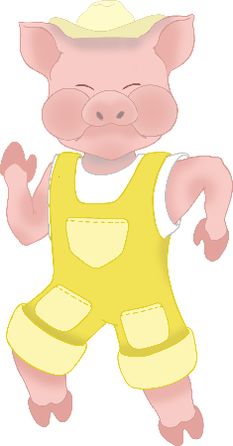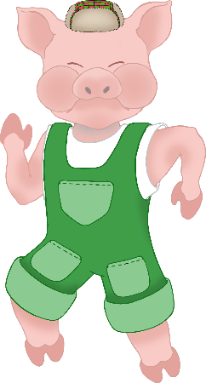

Run away from the wolf!

**RUN!**

(on the spot)

**Huff! Puff! CRASH!**

The wolf blows down the straw house and the stick house!

**Three Little Pigs**

**Activity Challenge!**

**Three Little Pigs**

**Activity Challenge!**

3

© 2021 Little Owls Resources

4

© 2021 Little Owls Resources

5

© 2021 Little Owls Resources

© 2021 Little Owls Resources

6

**Huff! Puff! Huff! Puff! HUFF! PUFF!**

The wolf climbs up to the chimney!

**Climb! Climb! Climb!**

(lift arms and legs)

The wolf can’t blow the brick house down!

**Three Little Pigs**

**Activity Challenge!**

**Three Little Pigs**

**Activity Challenge!**

The wolf is gone! Jump up and down with happiness!

**Jump! Jump! Jump!**

**Three Little Pigs**

**Activity Challenge!**

7

© 2021 Little Owls Resources