

This music makes me feel

confused

© 2023 Little Owls Resources



This music makes me feel

happy

© 2023 Little Owls Resources



This music makes me feel

sad

© 2023 Little Owls Resources



This music makes me feel

excited

© 2023 Little Owls Resources



This music makes me feel

worried

© 2023 Little Owls Resources



This music makes me feel

scared

© 2023 Little Owls Resources



This music makes me feel

sleepy

© 2023 Little Owls Resources

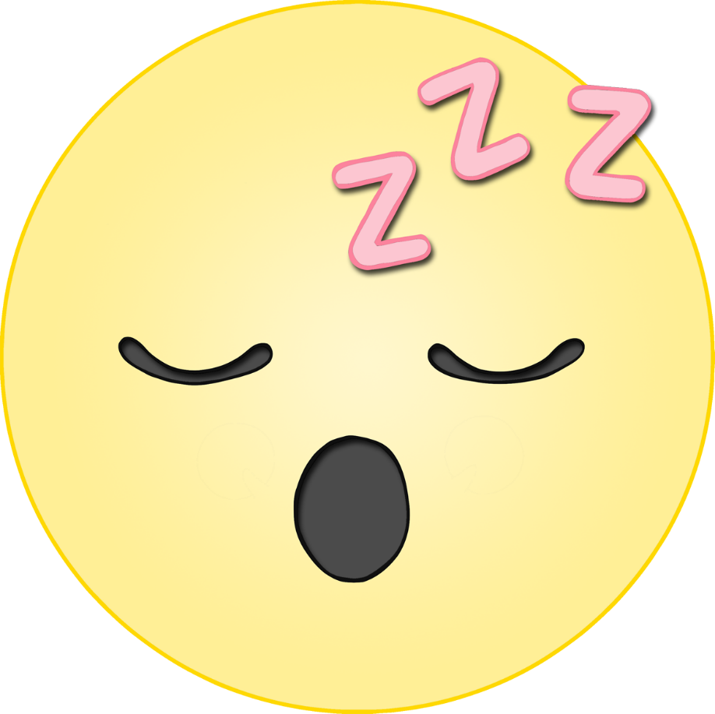

This music makes me feel

love

© 2023 Little Owls Resources



This music makes me feel

angry

© 2023 Little Owls Resources



This music makes me feel

fine

© 2023 Little Owls Resources



This music makes me feel

frustrated

© 2023 Little Owls Resources

This music makes me feel

bored

© 2023 Little Owls Resources