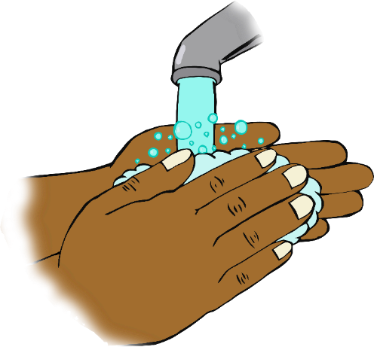

© 2020 Little Owls Resources

© 2020 Little Owls Resources

**Wash your hands!**

**Wash your hands!**