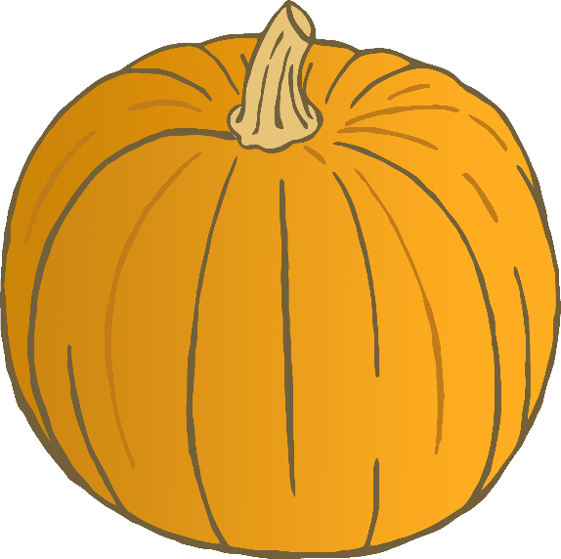

Pumpkin

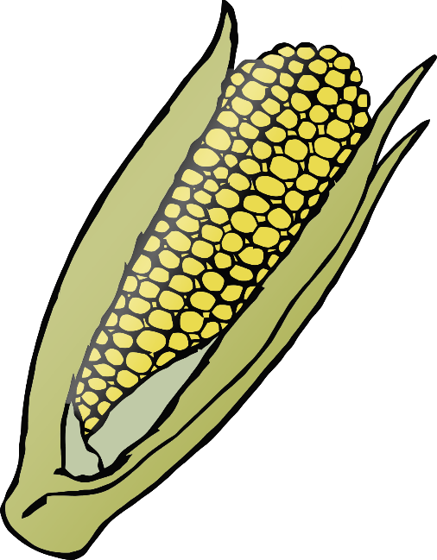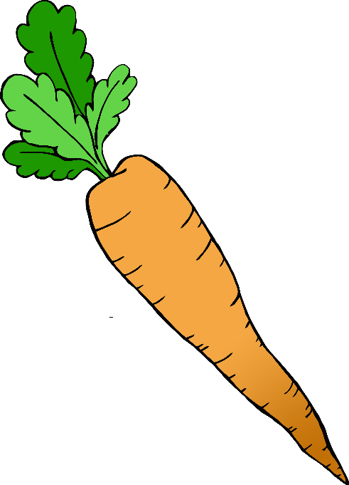

© 2019 Little Owls Resources

© 2019 Little Owls Resources

© 2019 Little Owls Resources

Carrot

Corn

Turkey

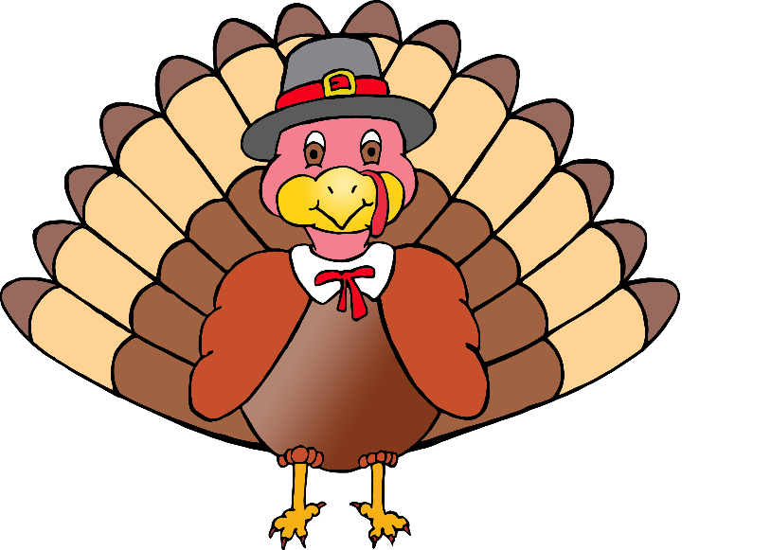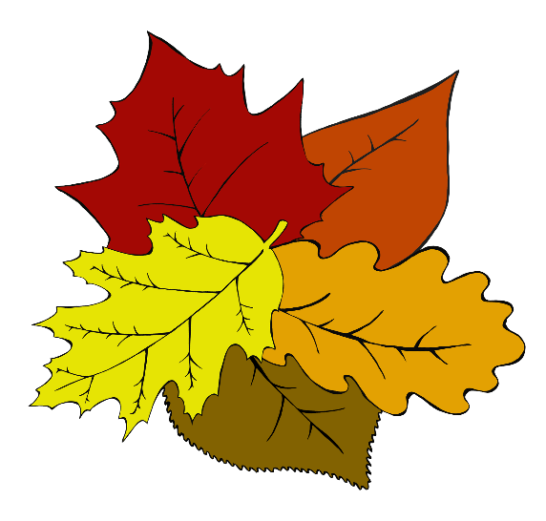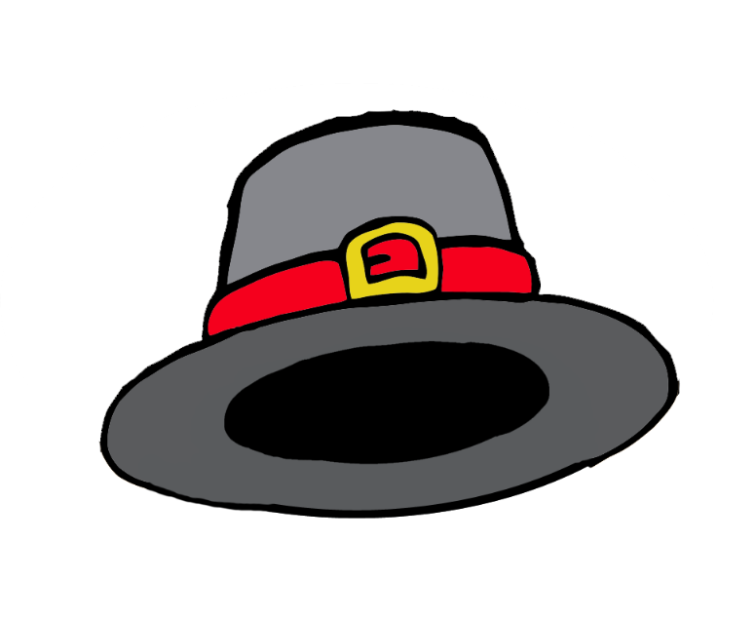

© 2019 Little Owls Resources

© 2019 Little Owls Resources

© 2019 Little Owls Resources

Leaves

Pilgrim Hat

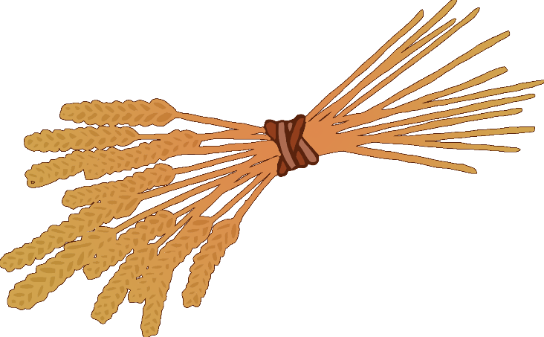

Wheat

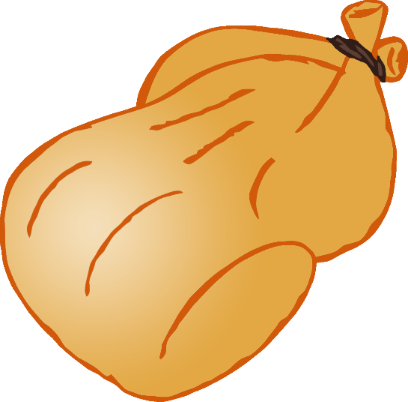

© 2019 Little Owls Resources

© 2019 Little Owls Resources

Cooked Turkey