© 2019 Little Owls Resources

© 2019 Little Owls Resources

Pumpkin

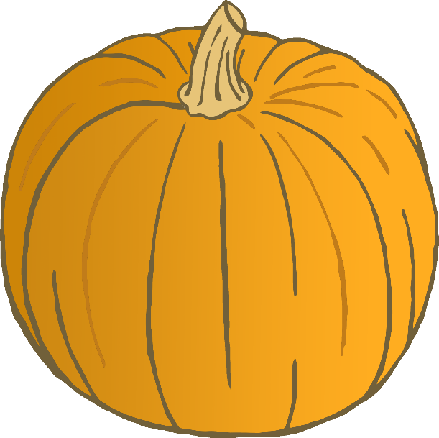

Pumpkin





Pumpkin

© 2019 Little Owls Resources

© 2019 Little Owls Resources

Pumpkin

Leaves

Leaves

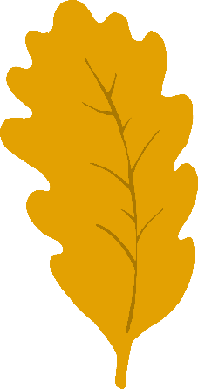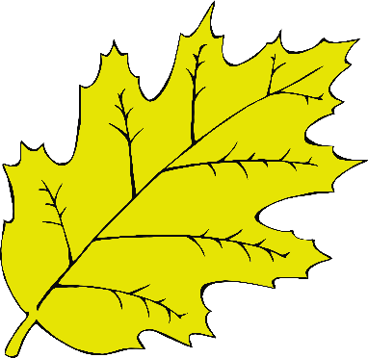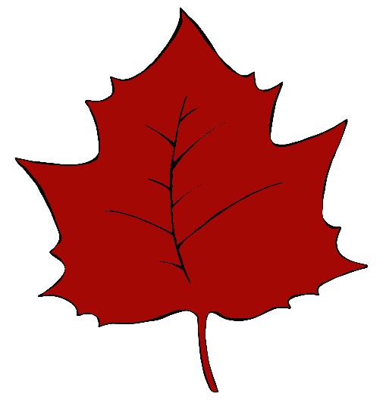

© 2019 Little Owls Resources

© 2019 Little Owls Resources

www.littleowlsresources.com

© 2019 Little Owls Resources

© 2019 Little Owls Resources

Leaves

Leaves

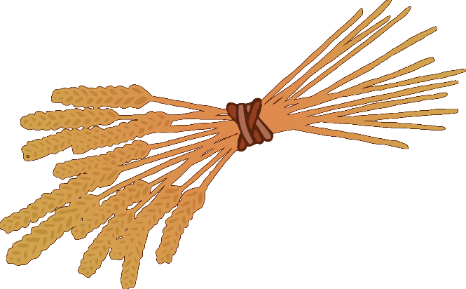

Wheat



Wheat

© 2019 Little Owls Resources

© 2019 Little Owls Resources



Wheat



Wheat

© 2019 Little Owls Resources

© 2019 Little Owls Resources

© 2019 Little Owls Resources

© 2019 Little Owls Resources

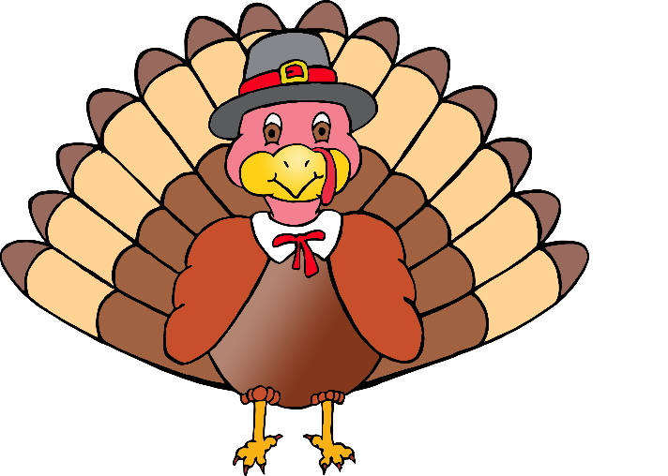

Turkey



Turkey

© 2019 Little Owls Resources

© 2019 Little Owls Resources



Turkey



Turkey

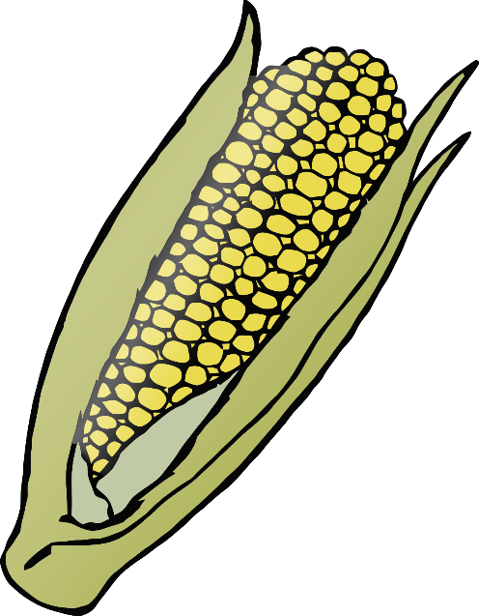

Corn



Corn

© 2019 Little Owls Resources

© 2019 Little Owls Resources



Corn



Corn

© 2019 Little Owls Resources

© 2019 Little Owls Resources

© 2019 Little Owls Resources

© 2019 Little Owls Resources

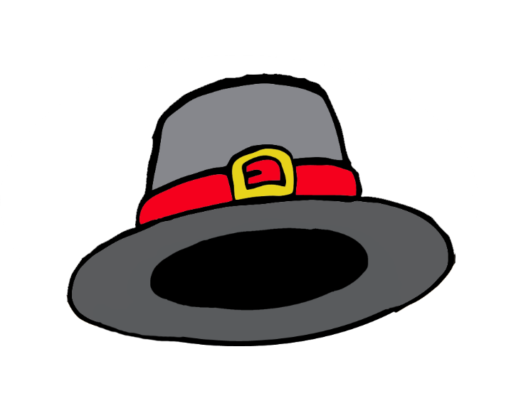

Hat



Hat

© 2019 Little Owls Resources

© 2019 Little Owls Resources



Hat



Hat

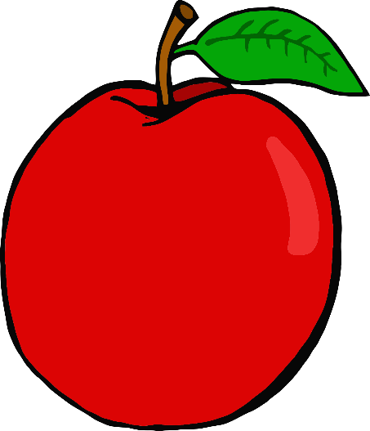

Apple



Apple

© 2019 Little Owls Resources

© 2019 Little Owls Resources

© 2019 Little Owls Resources

© 2019 Little Owls Resources



Apple



Apple

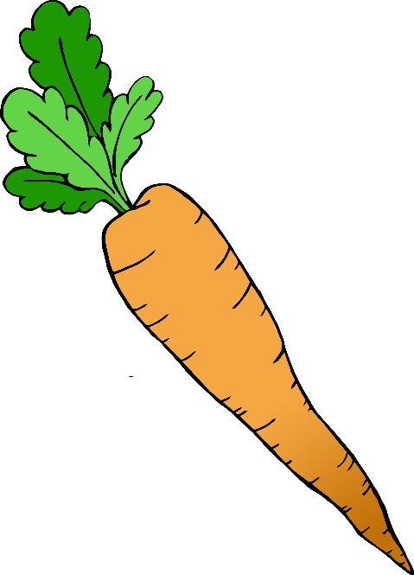

Carrot



Carrot

© 2019 Little Owls Resources

© 2019 Little Owls Resources

© 2019 Little Owls Resources

© 2019 Little Owls Resources



Carrot



Carrot