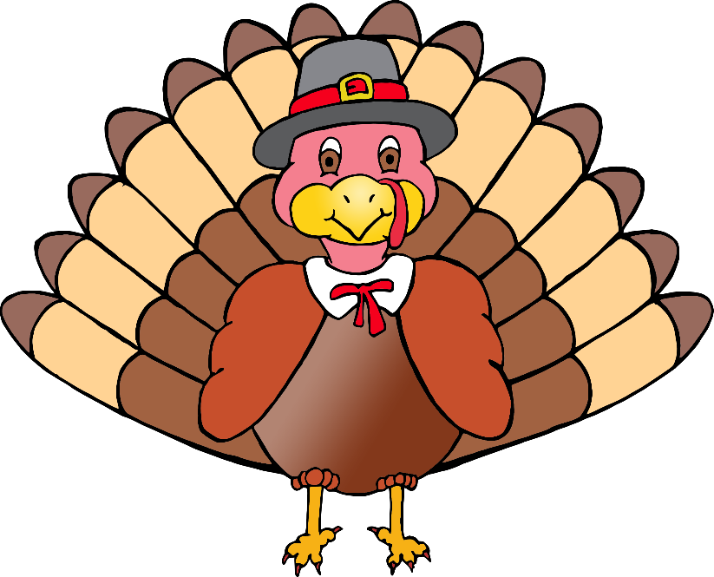

1

2

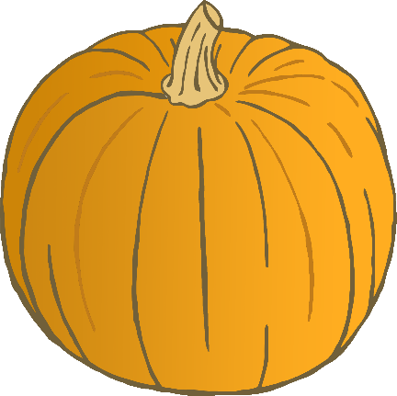

© 2019 Little Owls Resources

© 2019 Little Owls Resources

© 2019 Little Owls Resources

© 2019 Little Owls Resources



3

4

© 2019 Little Owls Resources

© 2019 Little Owls Resources

© 2019 Little Owls Resources

© 2019 Little Owls Resources

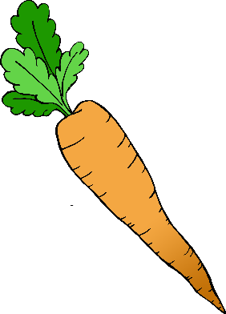

5

6

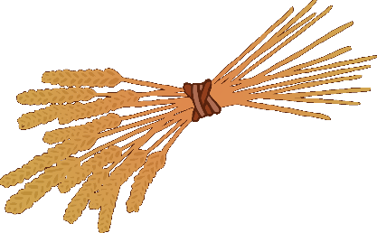

© 2019 Little Owls Resources

© 2019 Little Owls Resources

© 2019 Little Owls Resources

© 2019 Little Owls Resources

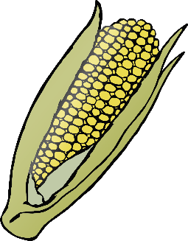

© 2019 Little Owls Resources

© 2019 Little Owls Resources

© 2019 Little Owls Resources

© 2019 Little Owls Resources

8

7

9

10

© 2019 Little Owls Resources

© 2019 Little Owls Resources

© 2019 Little Owls Resources

© 2019 Little Owls Resources

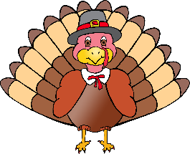

11

12

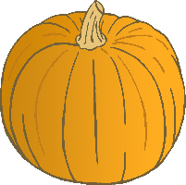

© 2019 Little Owls Resources

© 2019 Little Owls Resources

© 2019 Little Owls Resources

© 2019 Little Owls Resources

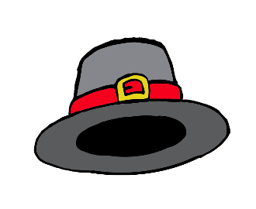

14

13

© 2019 Little Owls Resources

© 2019 Little Owls Resources

© 2019 Little Owls Resources

© 2019 Little Owls Resources

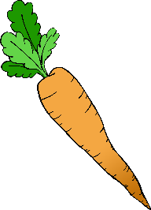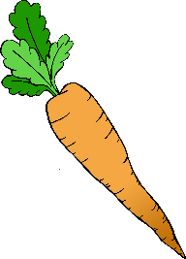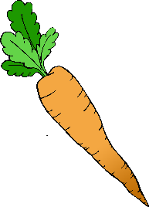

16

15

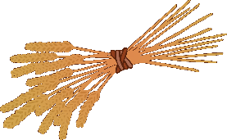

© 2019 Little Owls Resources

© 2019 Little Owls Resources

© 2019 Little Owls Resources

© 2019 Little Owls Resources

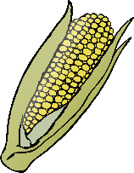

17

18



© 2019 Little Owls Resources

© 2019 Little Owls Resources

© 2019 Little Owls Resources

© 2019 Little Owls Resources

© 2019 Little Owls Resources

© 2019 Little Owls Resources

© 2019 Little Owls Resources

© 2019 Little Owls Resources

19

20