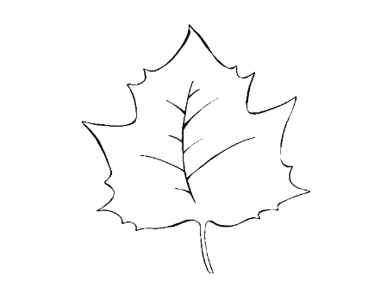

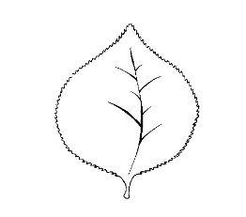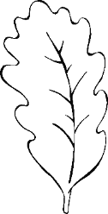

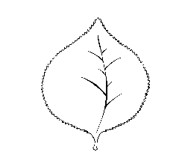

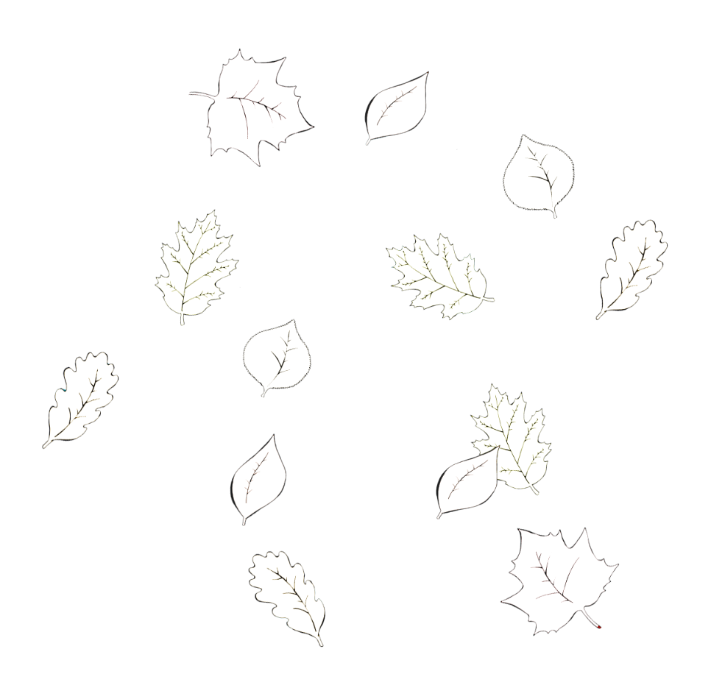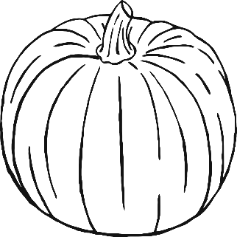

© 2019 Little Owls Resources

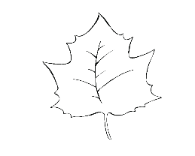

Happy

Thanksgiving!

Happy

Thanksgiving

© 2019 Little Owls Resources



© 2019 Little Owls Resources

Happy

Thanksgiving!

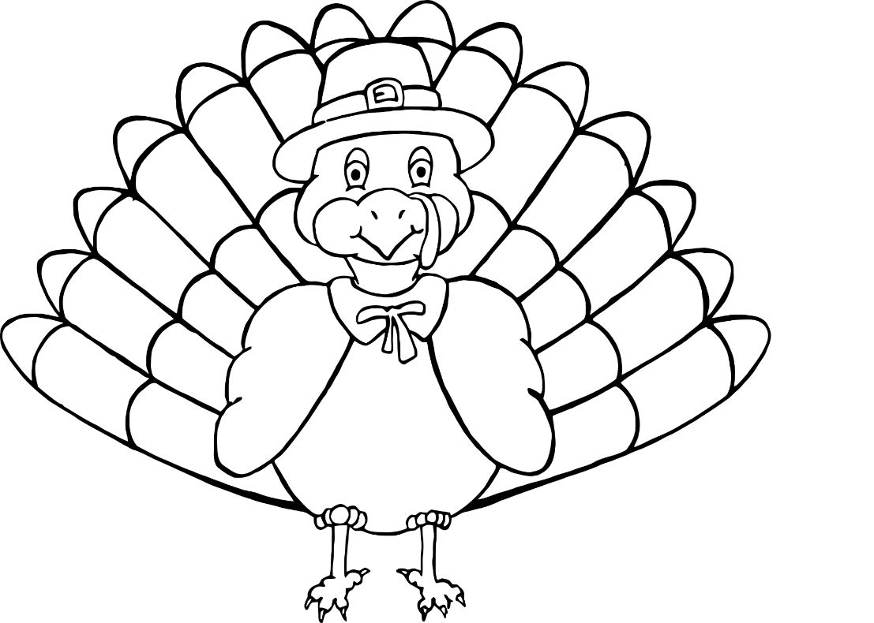

© 2019 Little Owls Resources

Happy

Thanksgiving

Happy

Thanksgiving

© 2019 Little Owls Resources

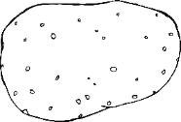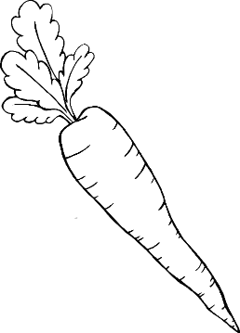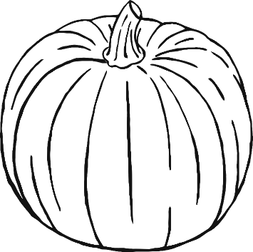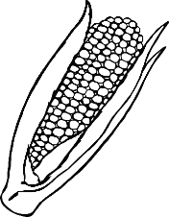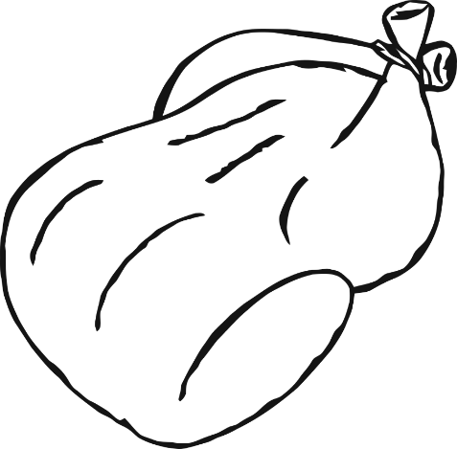

© 2019 Little Owls Resources

Happy Thanksgiving!

Happy

Thanksgiving

© 2019 Little Owls Resources

© 2019 Little Owls Resources