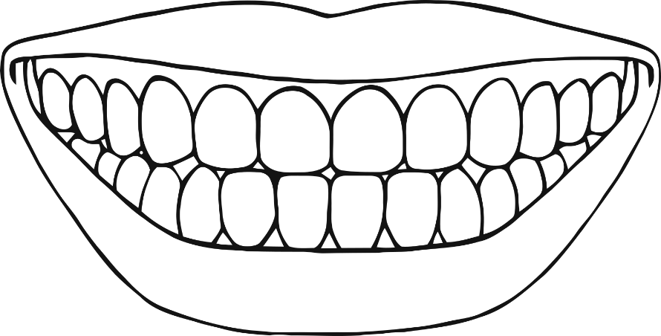



**Teeth**

**toothpaste**

**toothbrush**

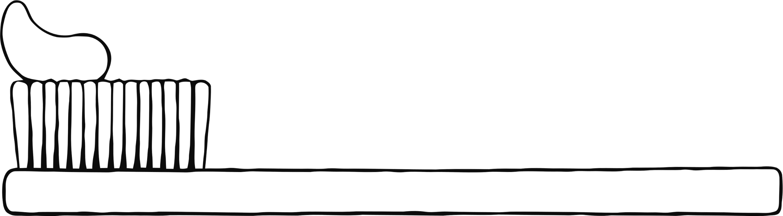

**Brushing teeth**

**Look after your teeth**

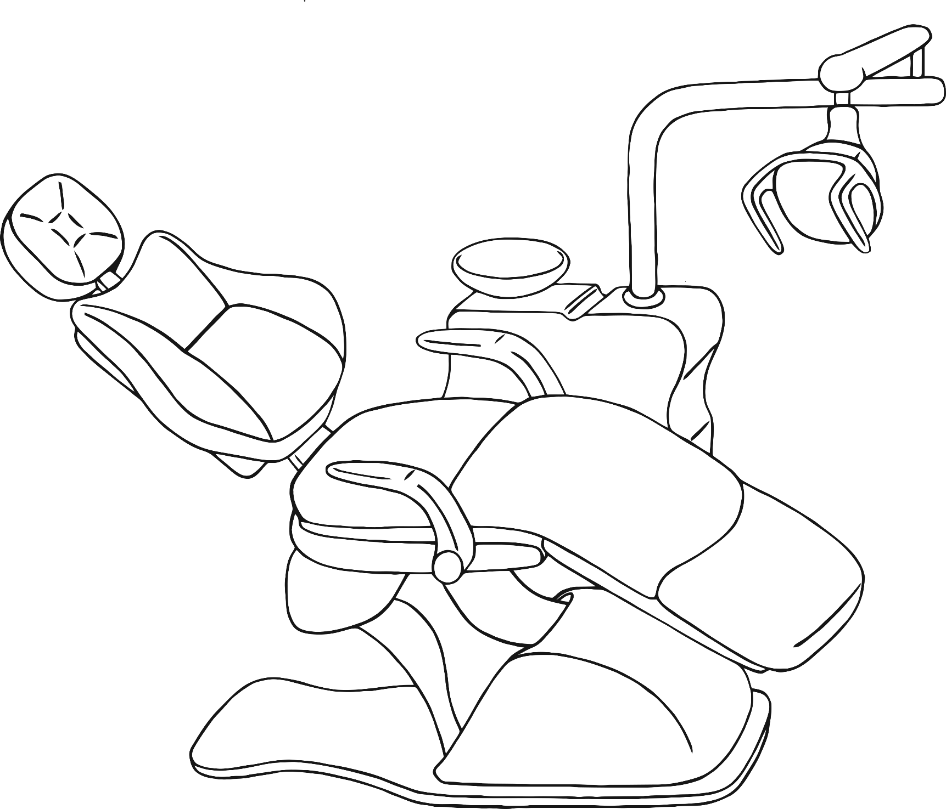

**dentist**

