© 2021 Little Owls Resources

Broken arm

© 2021 Little Owls Resources

Earache

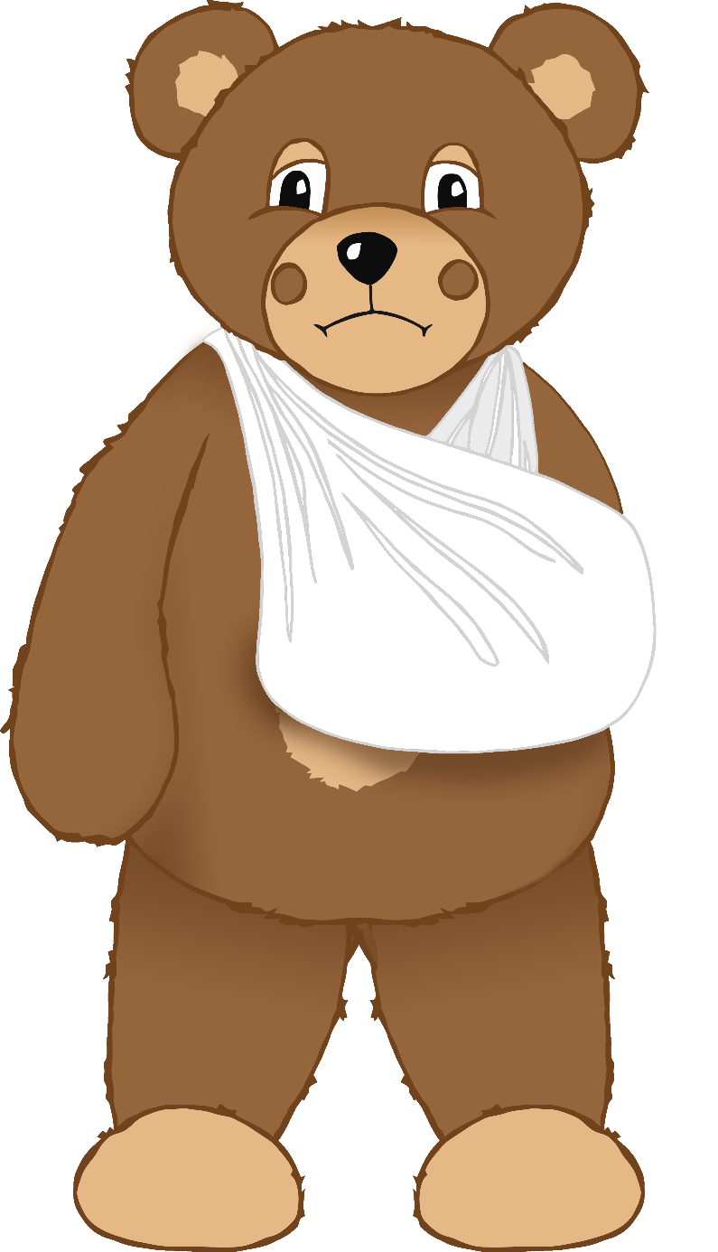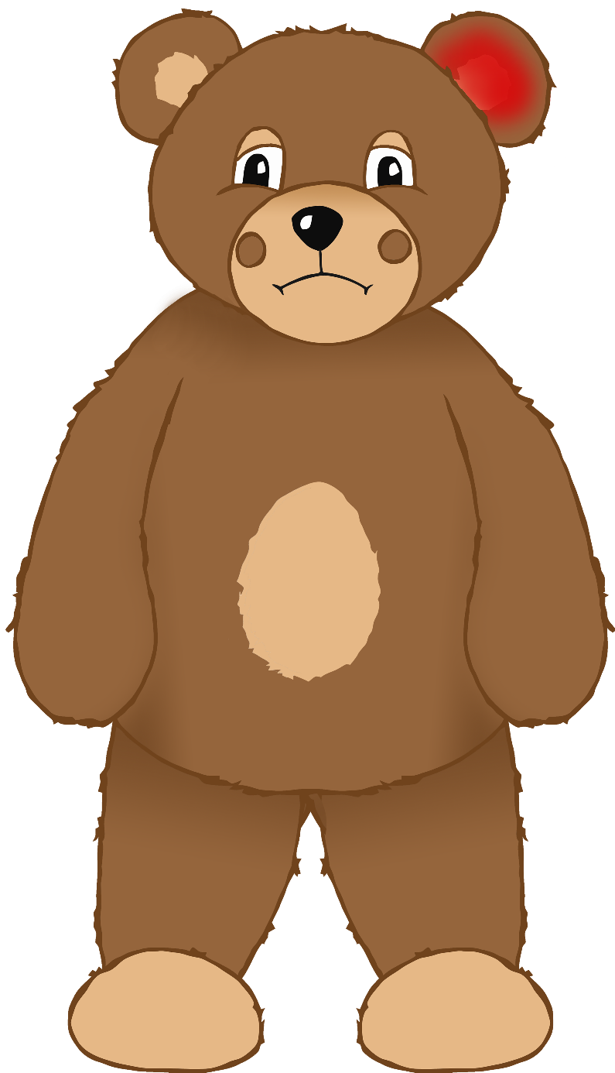

© 2021 Little Owls Resources

Broken leg

© 2021 Little Owls Resources

Sore eye

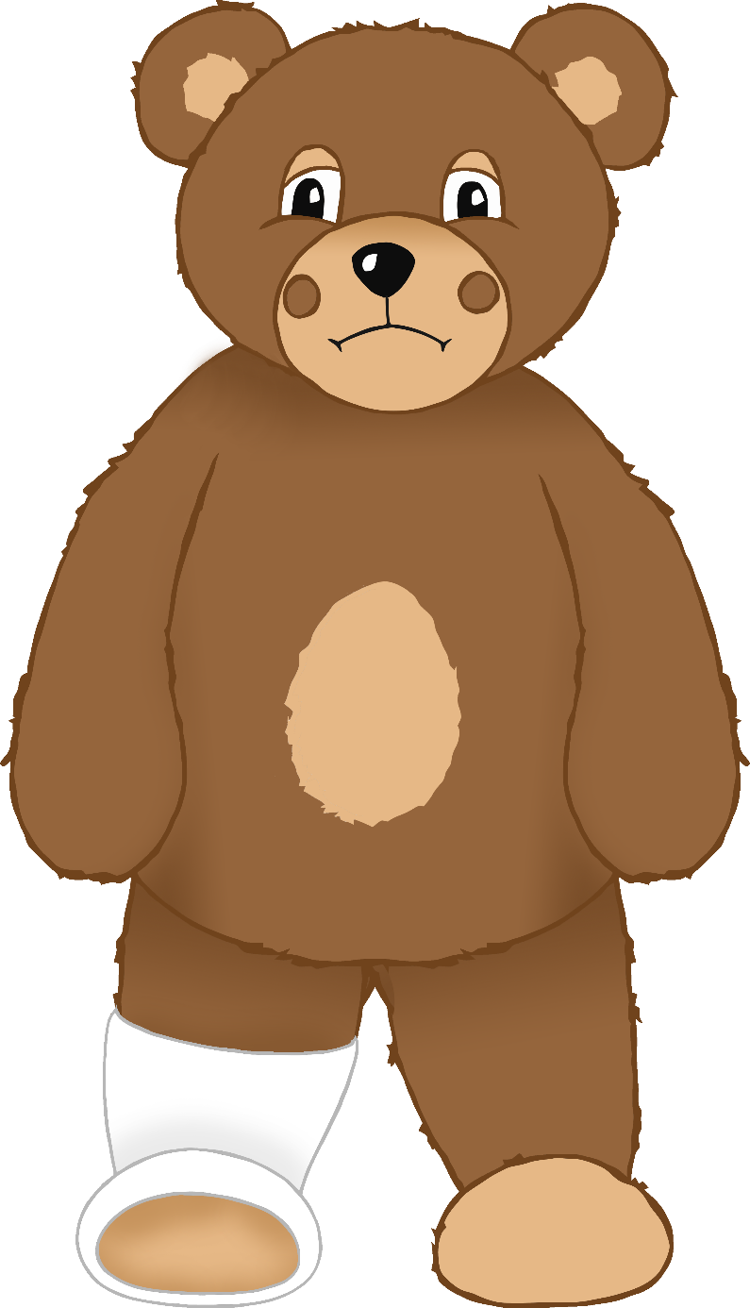

© 2021 Little Owls Resources

Bumped head

© 2021 Little Owls Resources

Headache

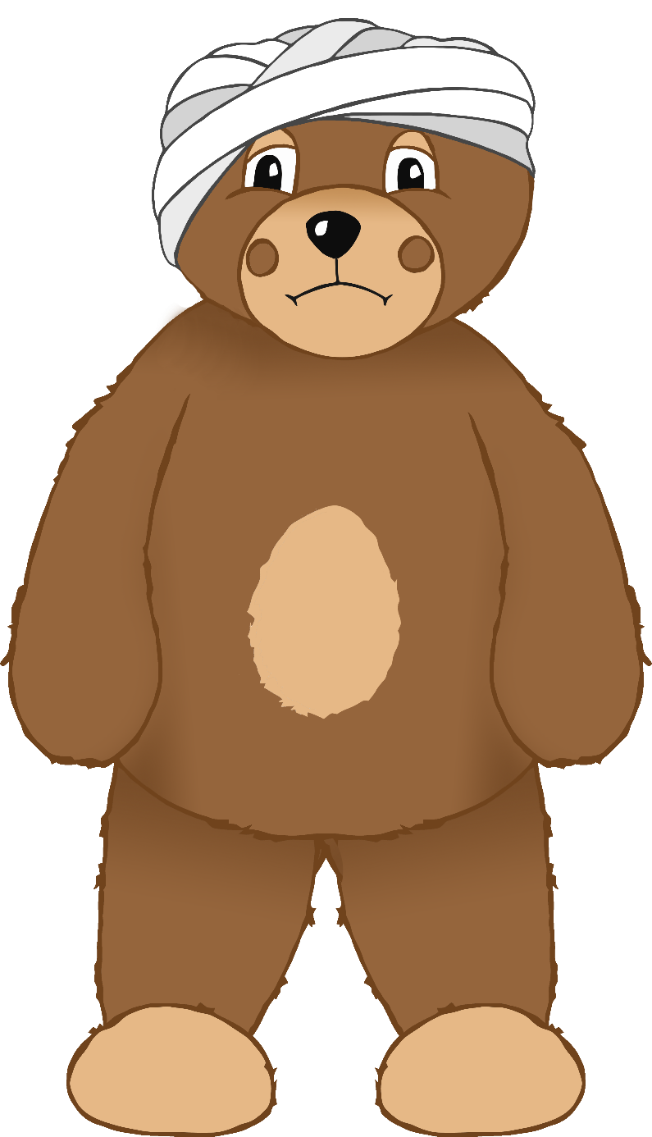

© 2021 Little Owls Resources

Bumped Knee

© 2021 Little Owls Resources

Sore mouth

© 2021 Little Owls Resources

Stomach ache

© 2021 Little Owls Resources

Sore nose

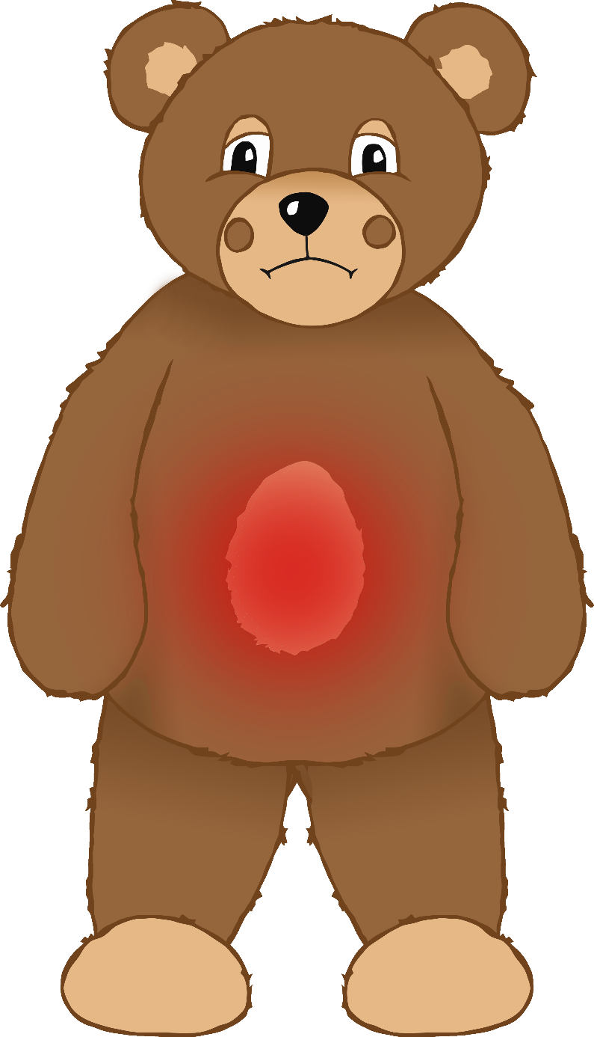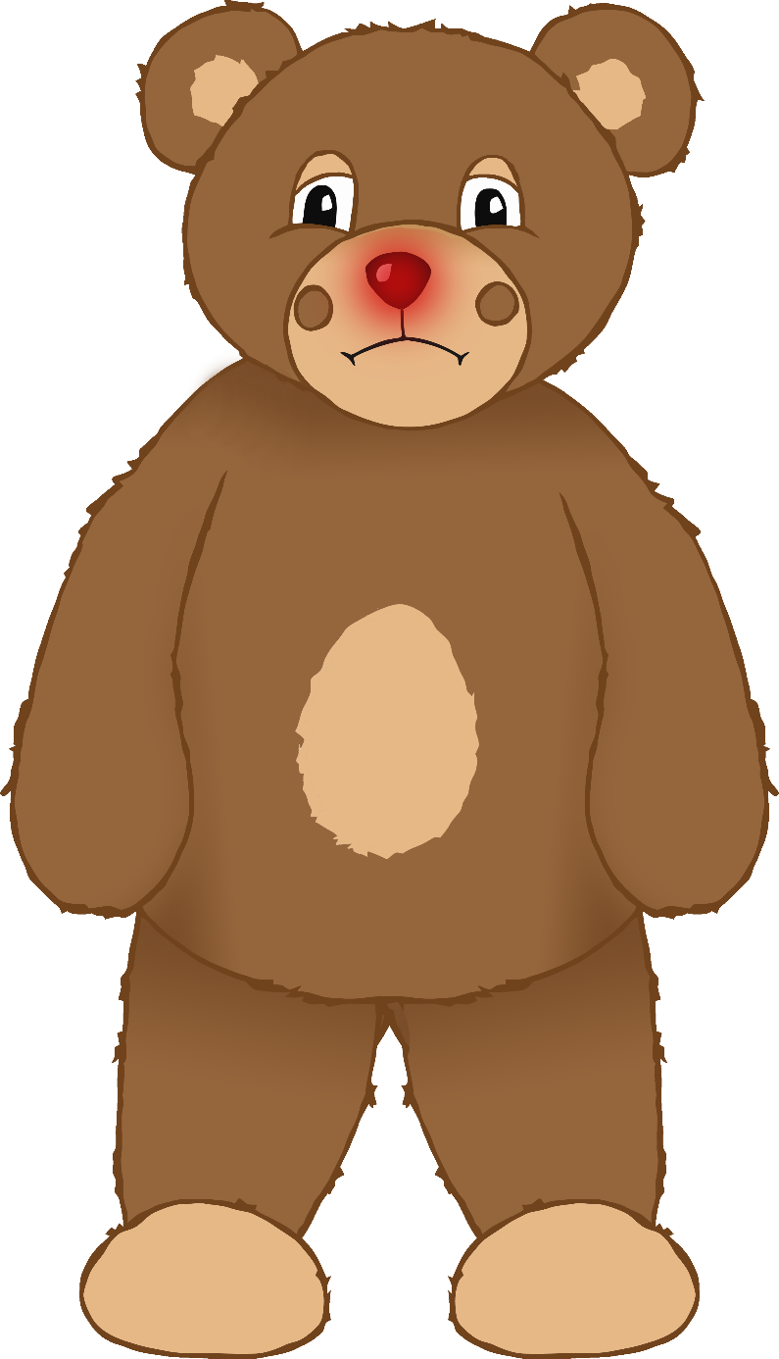

© 2021 Little Owls Resources

Feeling very sad