© 2021 Little Owls Resources

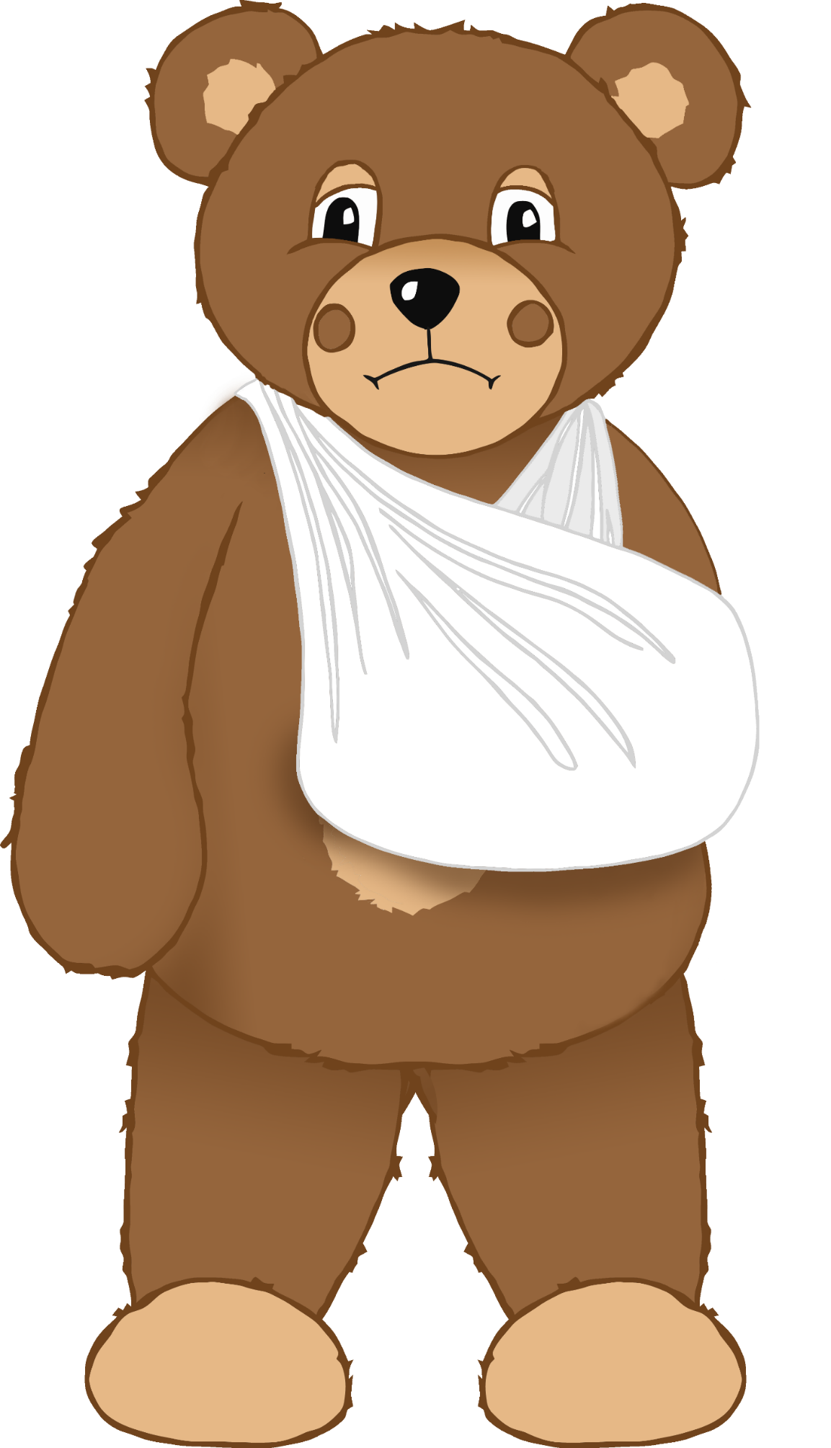

Broken arm

© 2021 Little Owls Resources

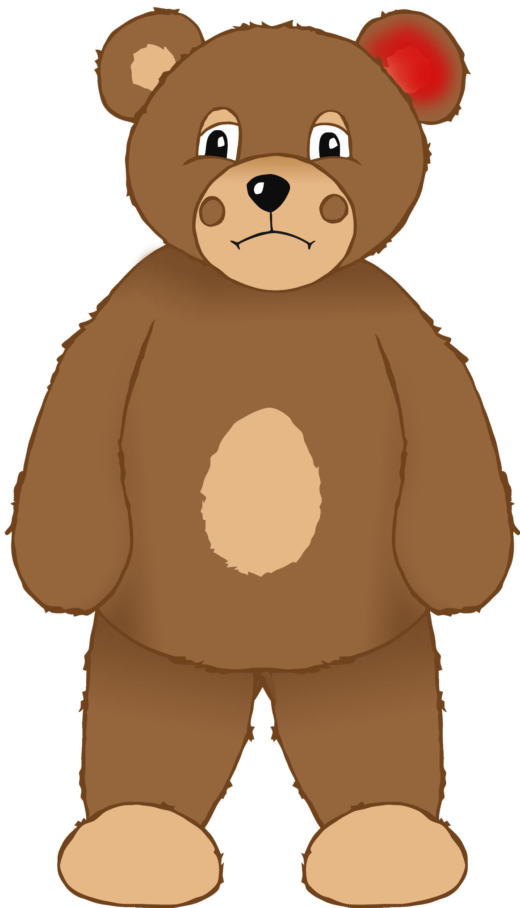

Earache

© 2021 Little Owls Resources

Sore eye

© 2021 Little Owls Resources

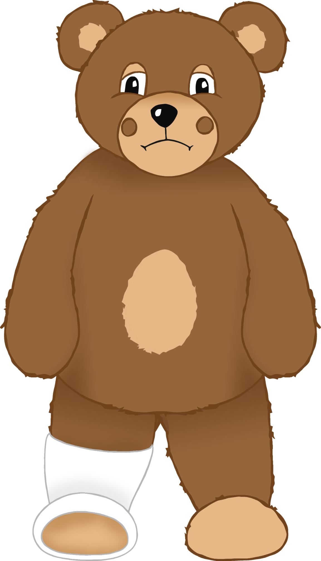

Broken leg

© 2021 Little Owls Resources

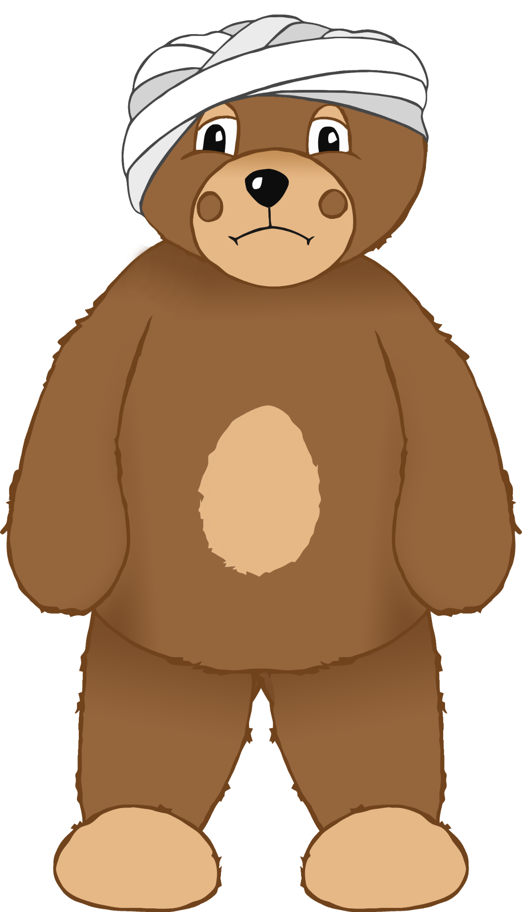

Bumped head

© 2021 Little Owls Resources

Headache

© 2021 Little Owls Resources

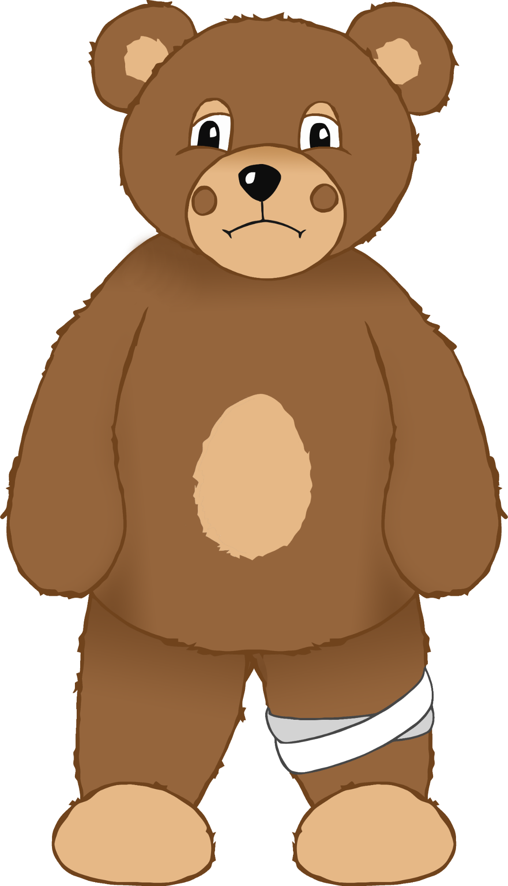

Bumped knee

© 2021 Little Owls Resources

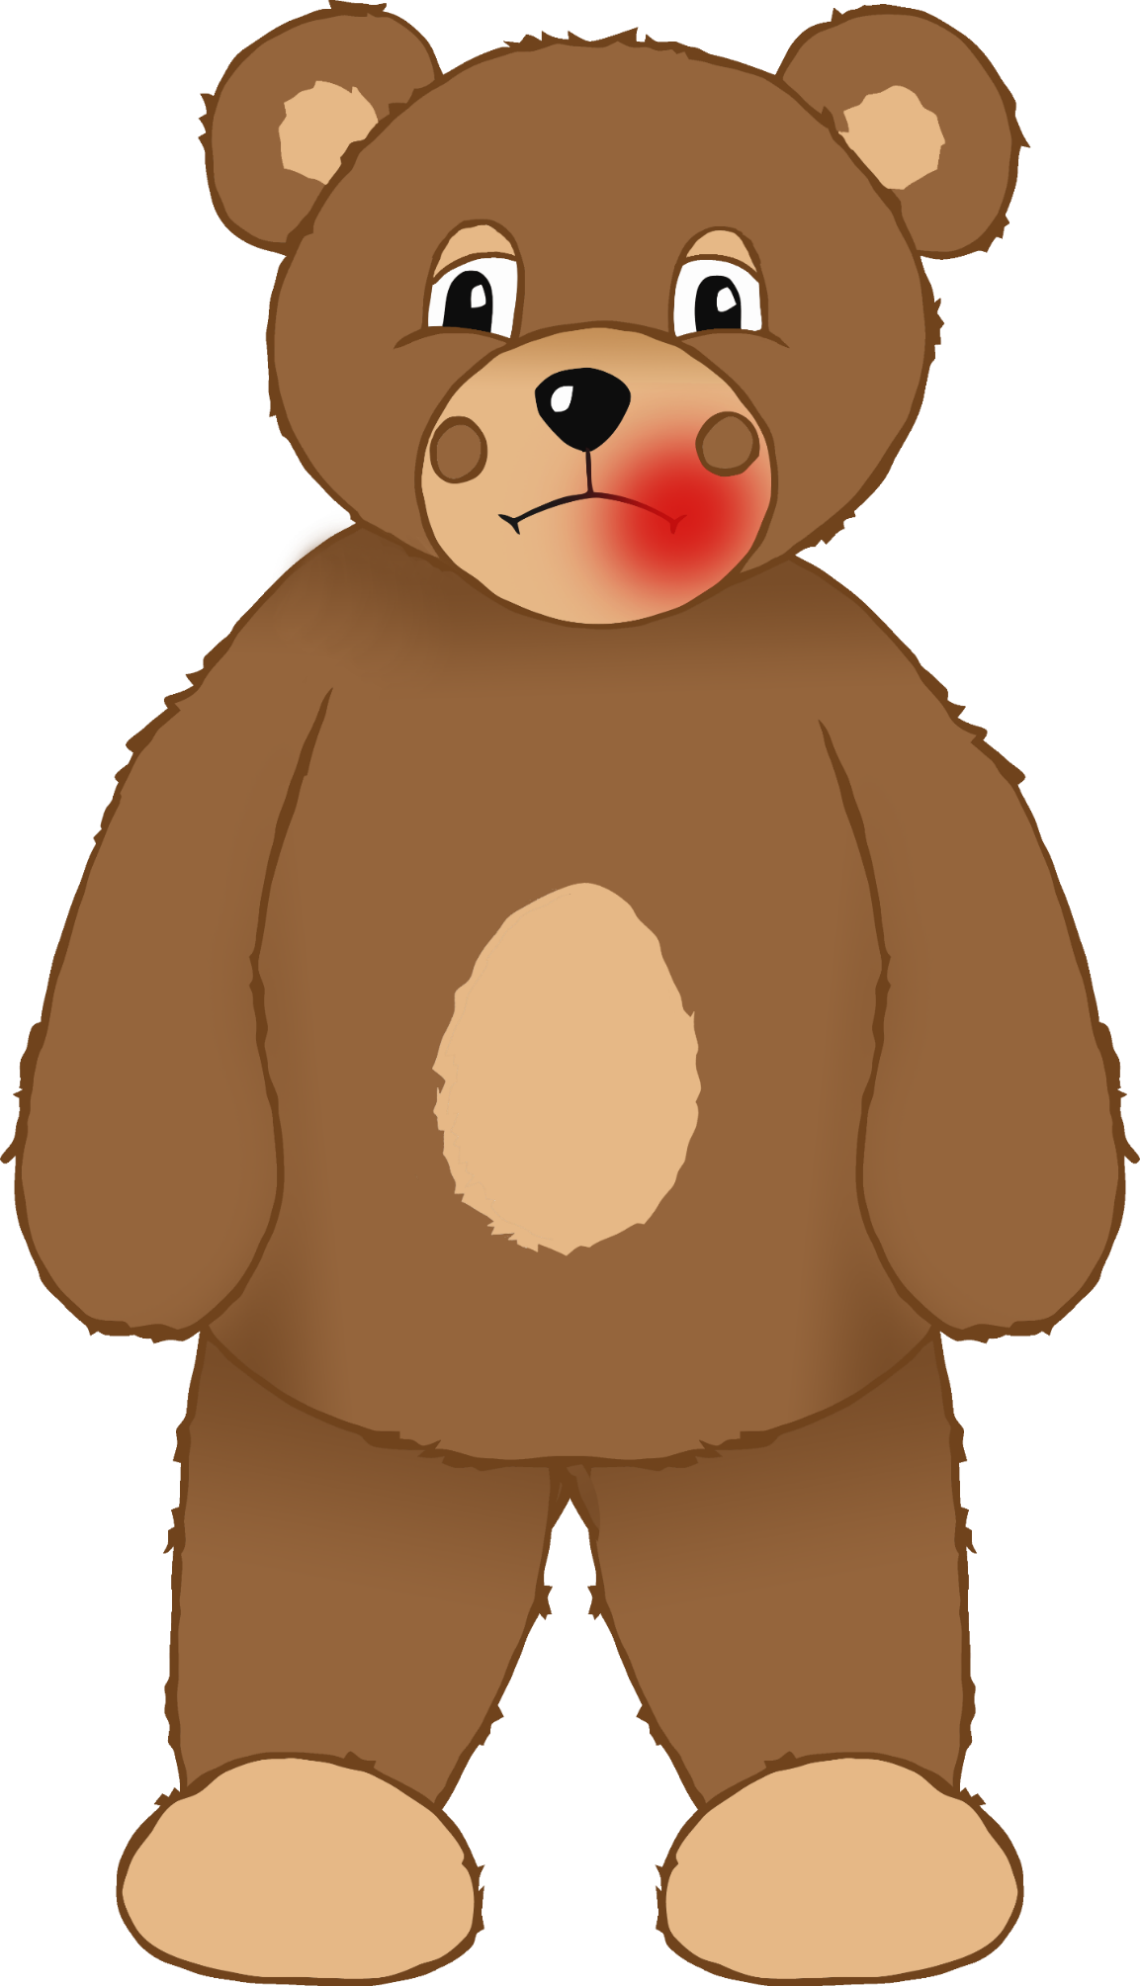

Sore mouth

© 2021 Little Owls Resources

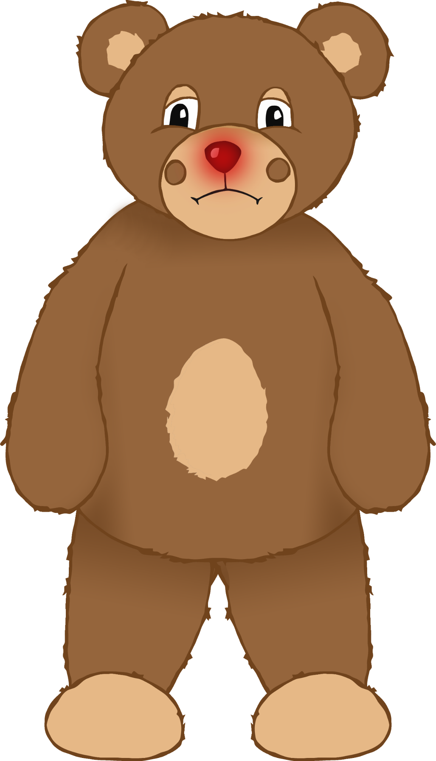

Sore nose

© 2021 Little Owls Resources

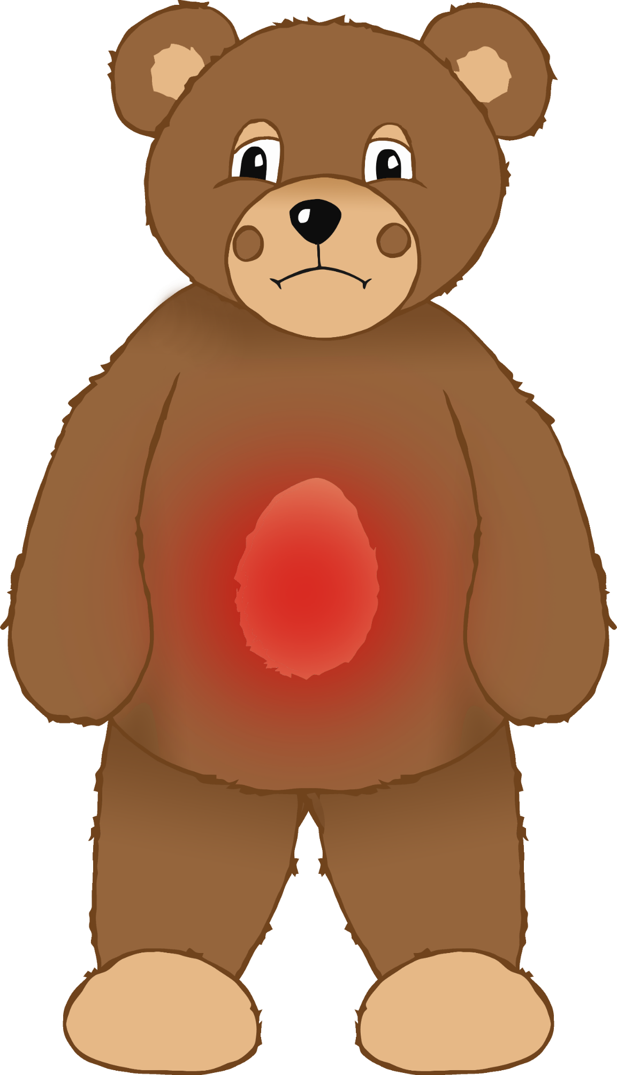

Stomach ache

Feeling very sad

© 2021 Little Owls Resources