© 2021 Little Owls Resources

© 2021 Little Owls Resources

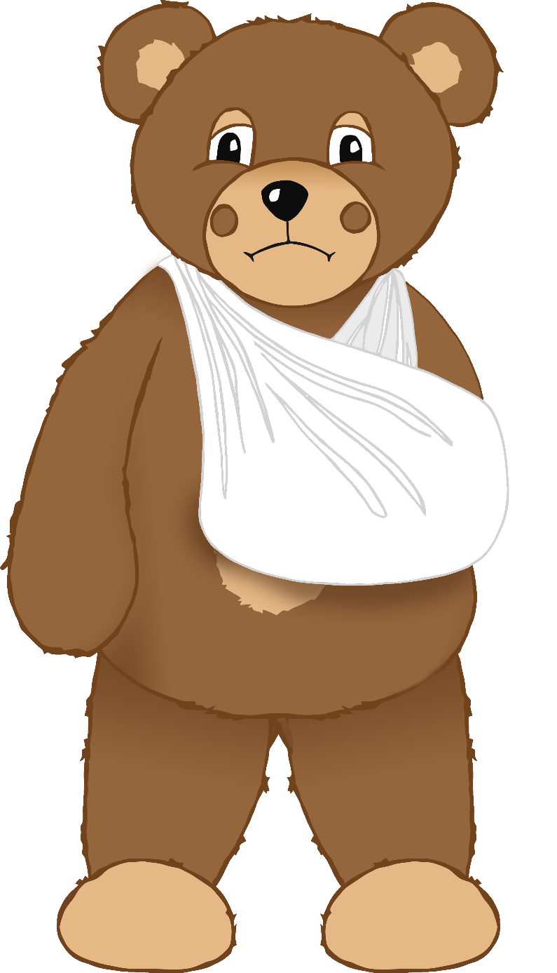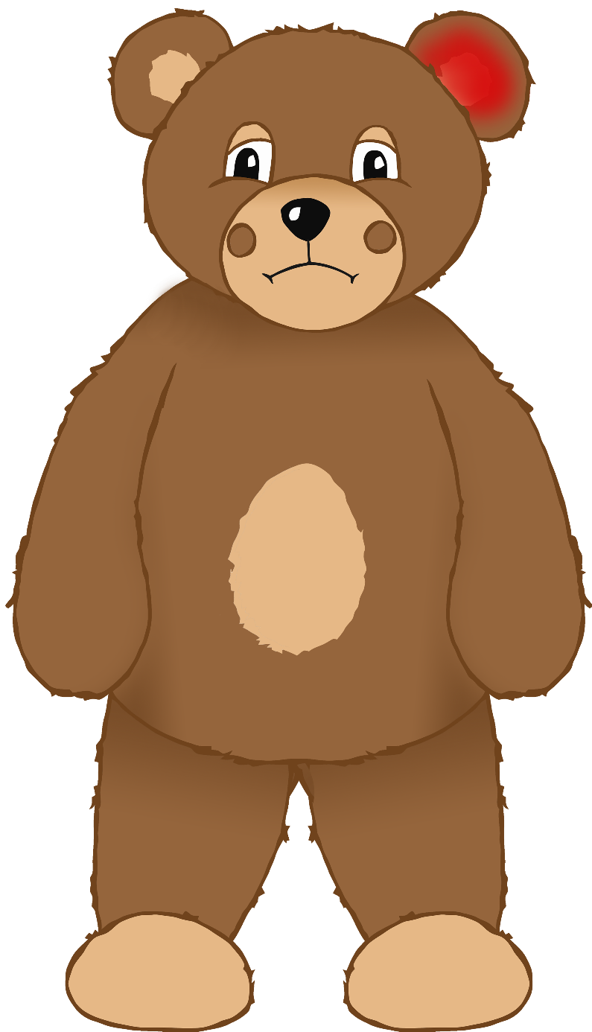

© 2021 Little Owls Resources

© 2021 Little Owls Resources

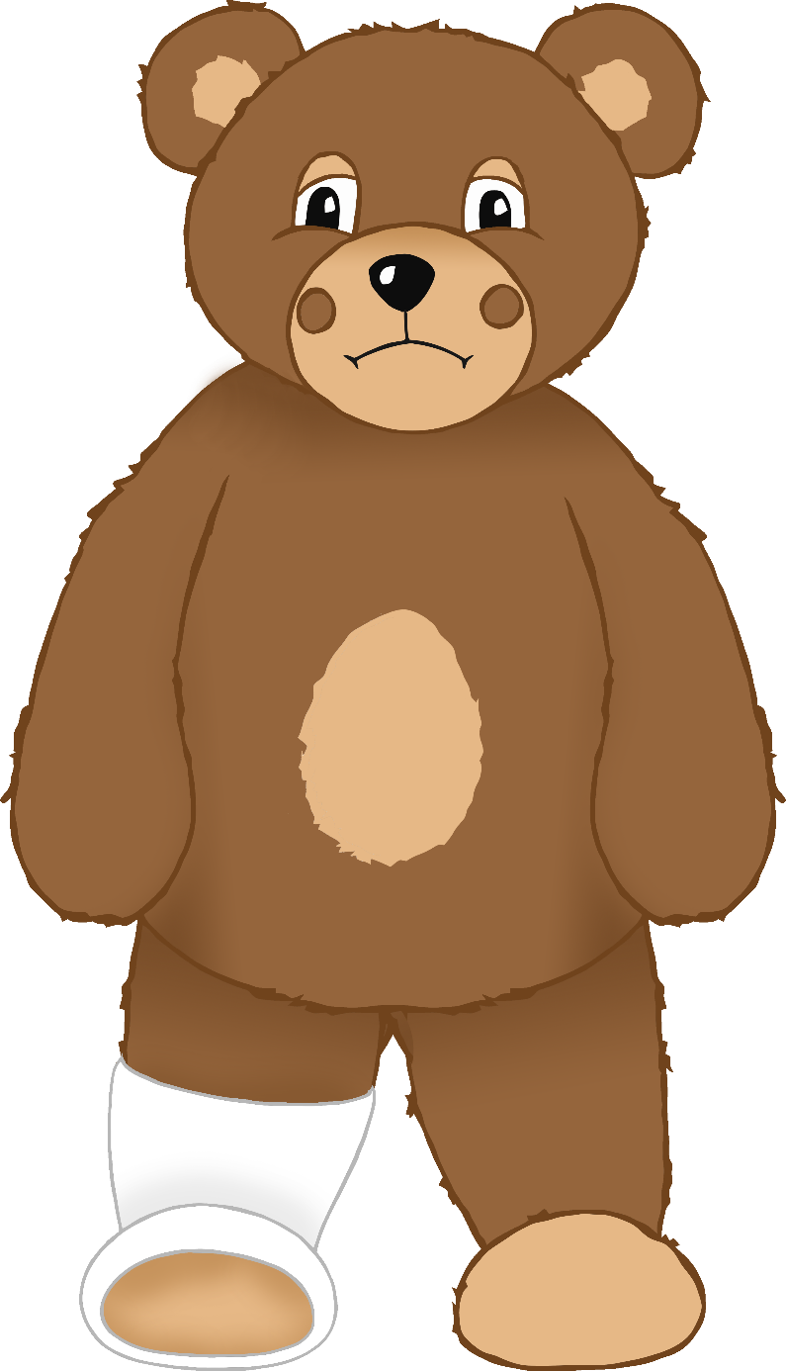

© 2021 Little Owls Resources

© 2021 Little Owls Resources

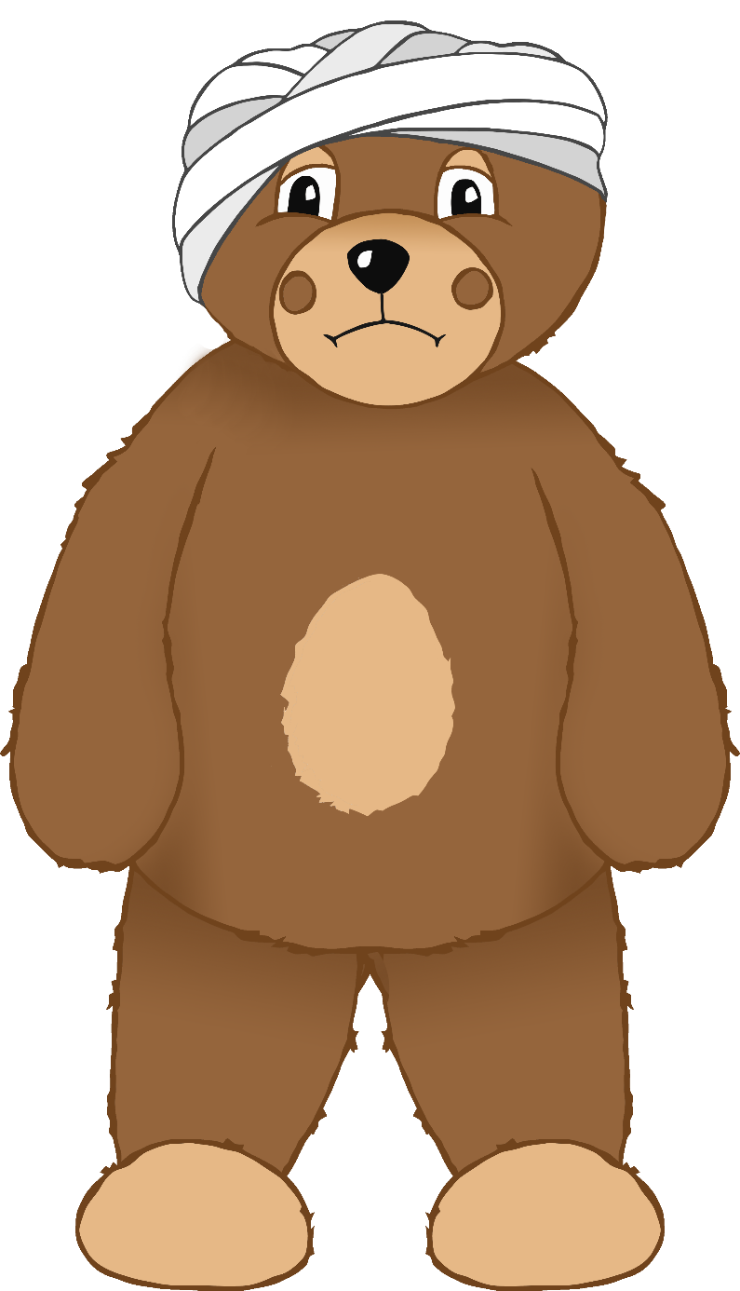

© 2021 Little Owls Resources

© 2021 Little Owls Resources

© 2021 Little Owls Resources

© 2021 Little Owls Resources

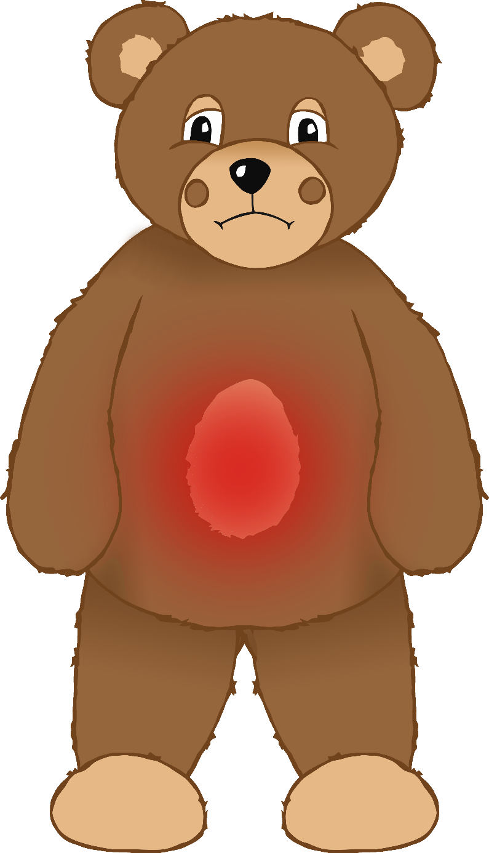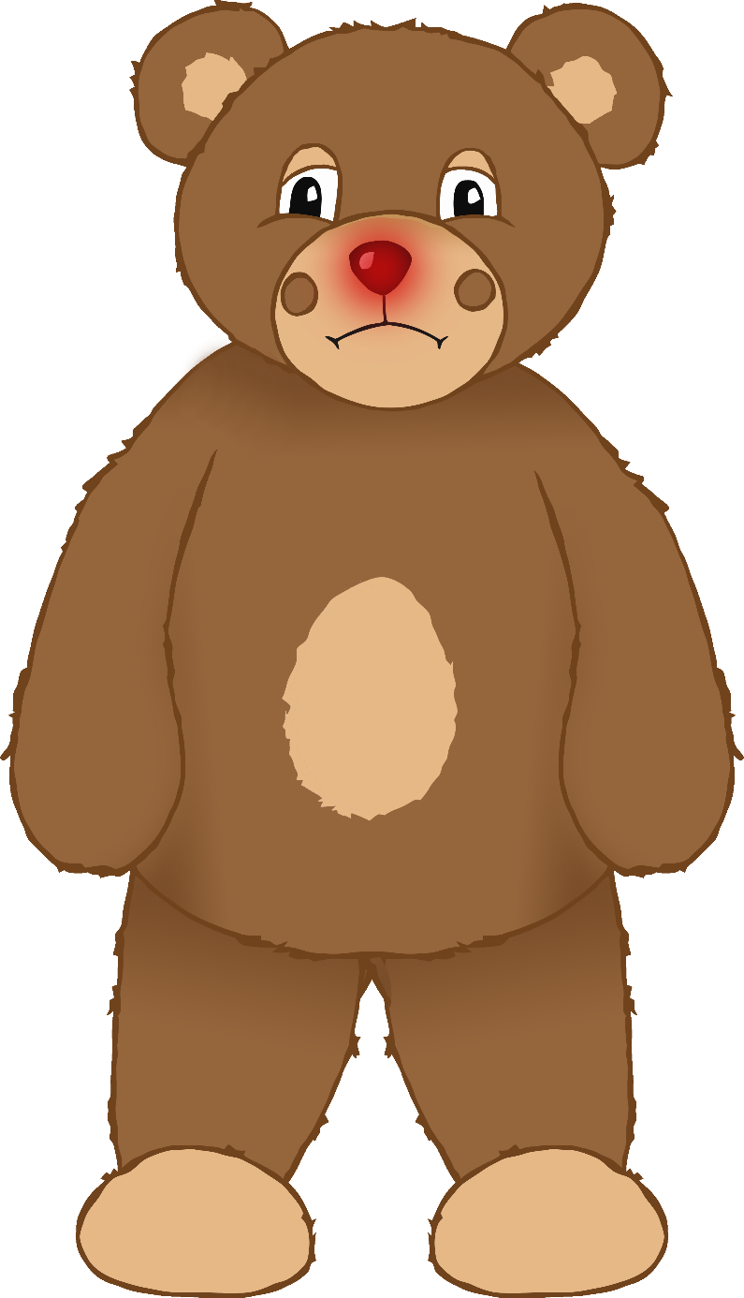

© 2021 Little Owls Resources

I fell from a climbing frame and hurt my arm badly. I had to go to the hospital and now my arm is in a sling.

© 2021 Little Owls Resources