© 2021 Little Owls Resources

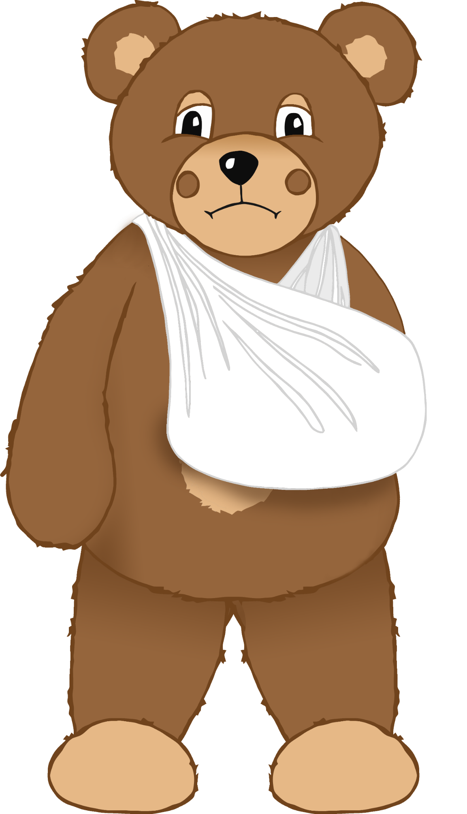

© 2021 Little Owls Resources

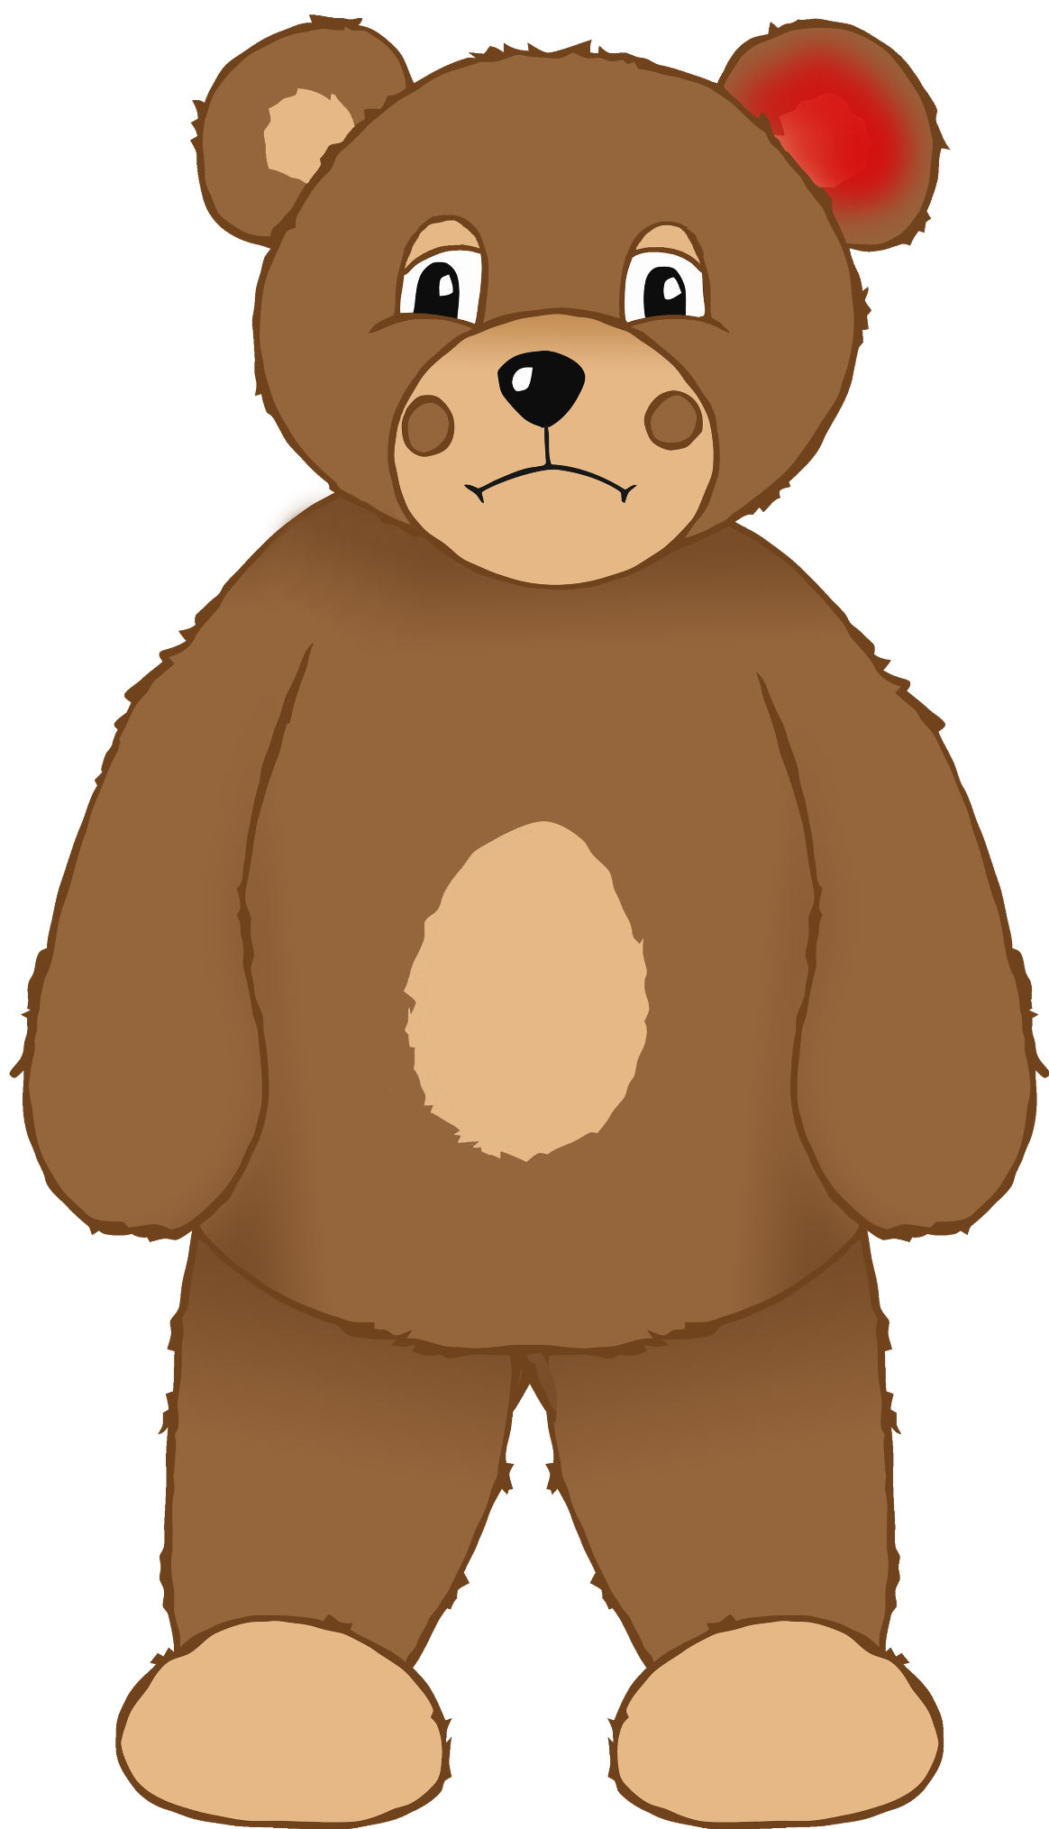

© 2021 Little Owls Resources

© 2021 Little Owls Resources

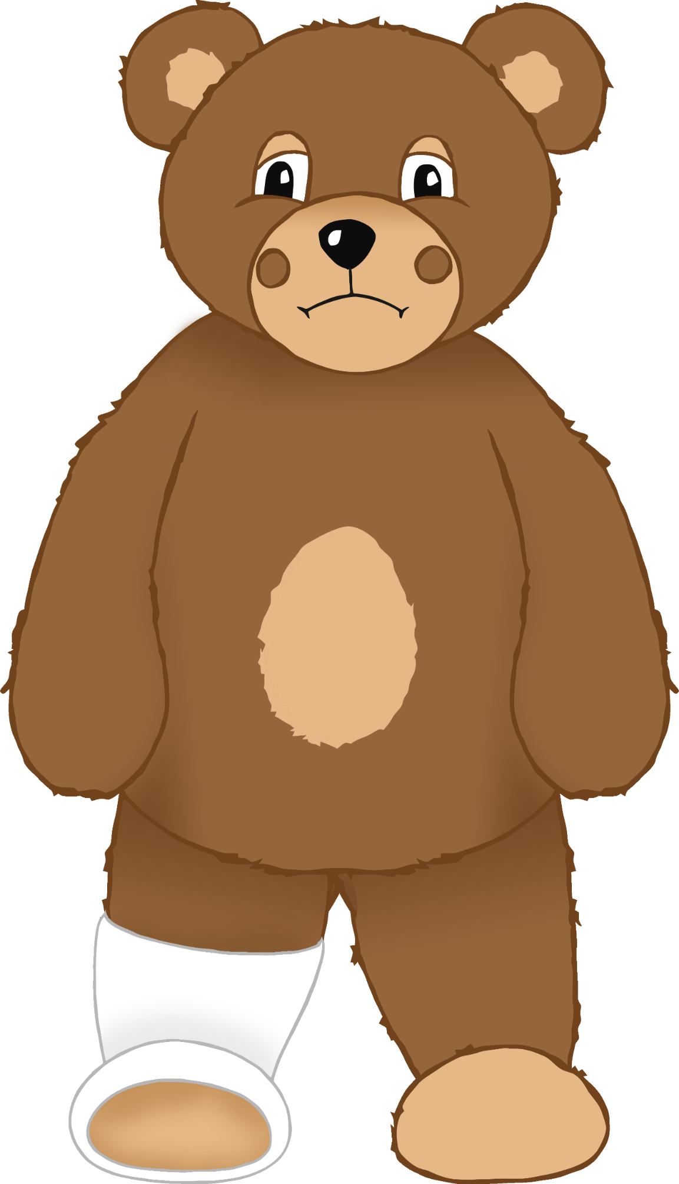

© 2021 Little Owls Resources

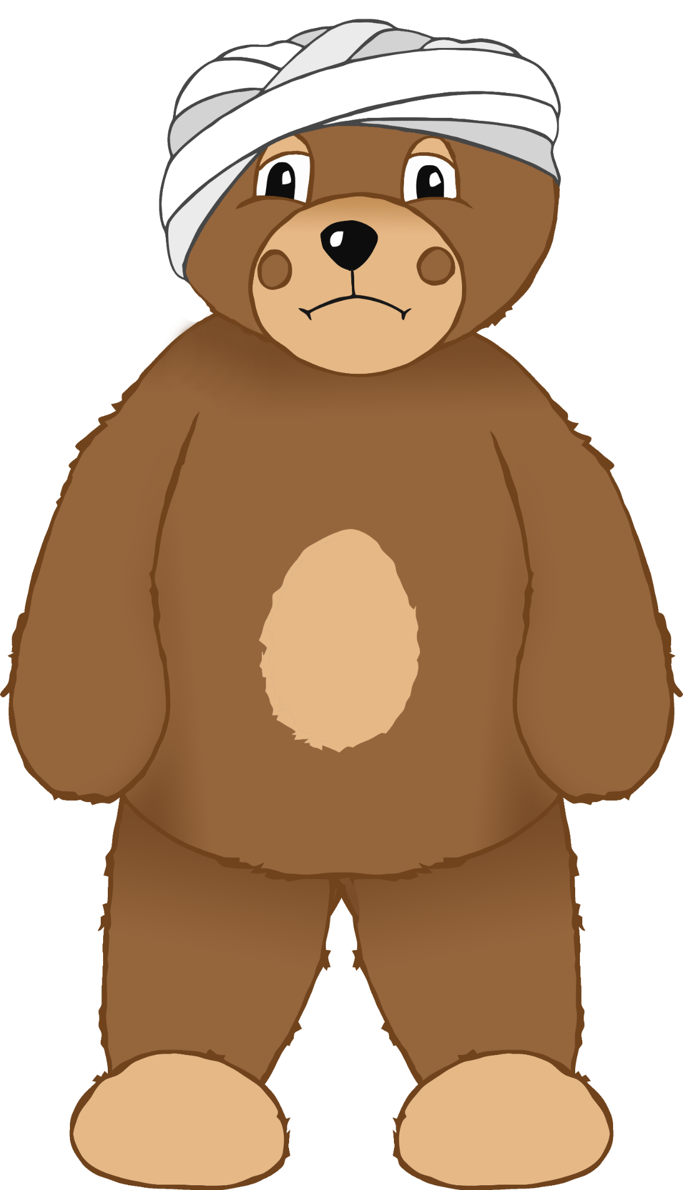

© 2021 Little Owls Resources

© 2021 Little Owls Resources

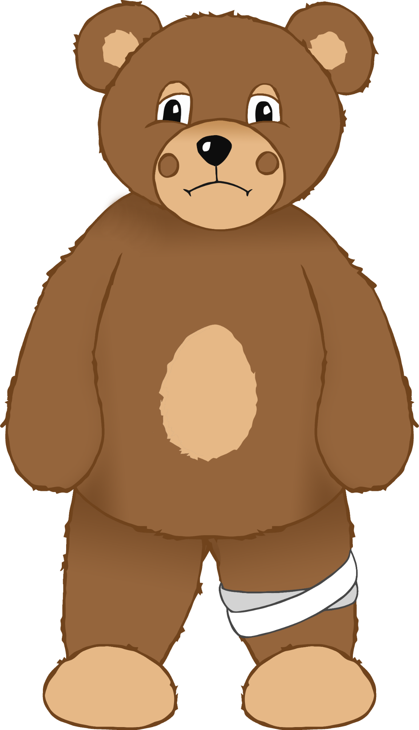

© 2021 Little Owls Resources

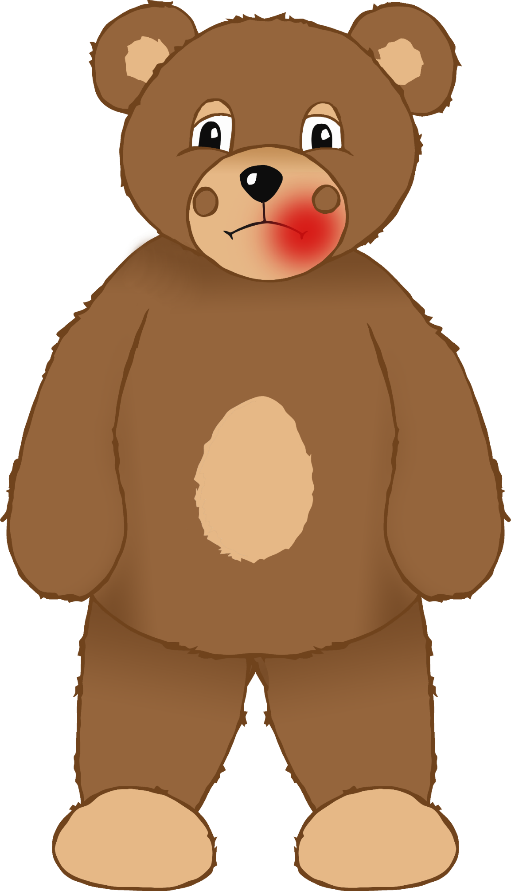

© 2021 Little Owls Resources

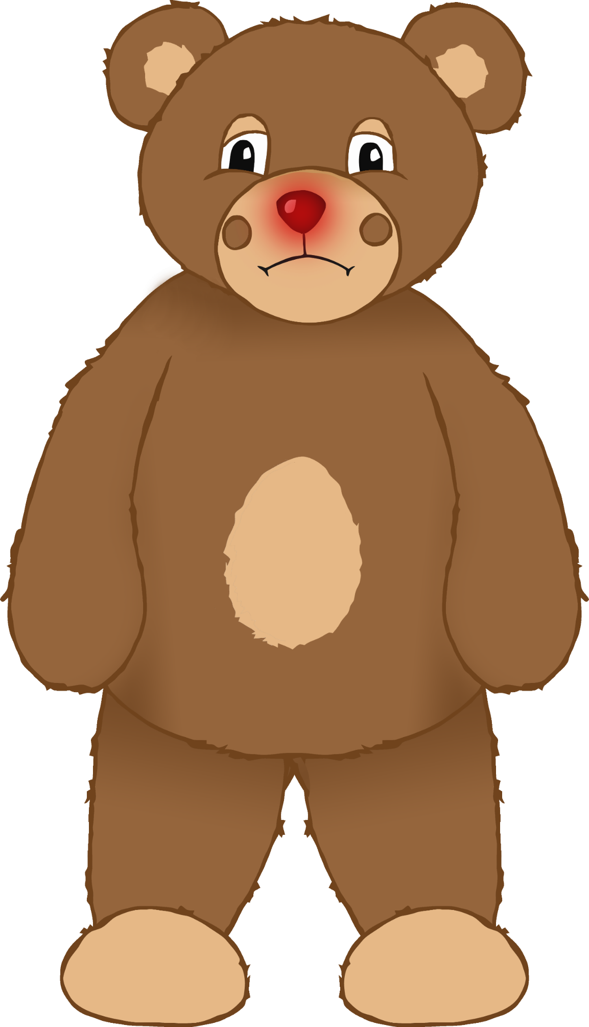

© 2021 Little Owls Resources

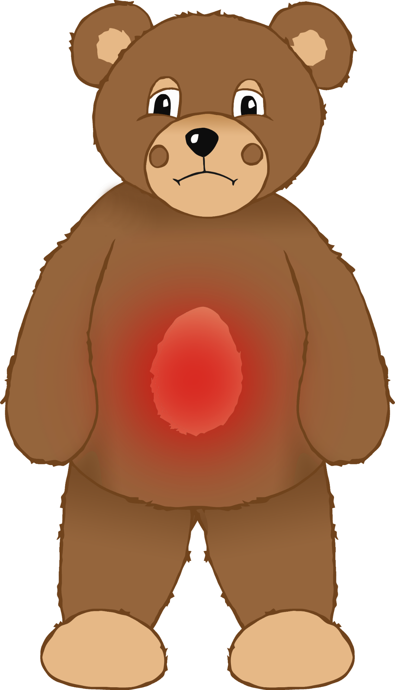

© 2021 Little Owls Resources

© 2021 Little Owls Resources

Earache

© 2021 Little Owls Resources

Headache

© 2021 Little Owls Resources

Broken arm

© 2021 Little Owls Resources

Bumped head

© 2021 Little Owls Resources

Sore eye

© 2021 Little Owls Resources

Bumped knee

© 2021 Little Owls Resources

Sore nose

© 2021 Little Owls Resources

Sore mouth

© 2021 Little Owls Resources

Broken leg

© 2021 Little Owls Resources

Stomach ache

© 2021 Little Owls Resources

Feeling very sad