© 2021 Little Owls Resources

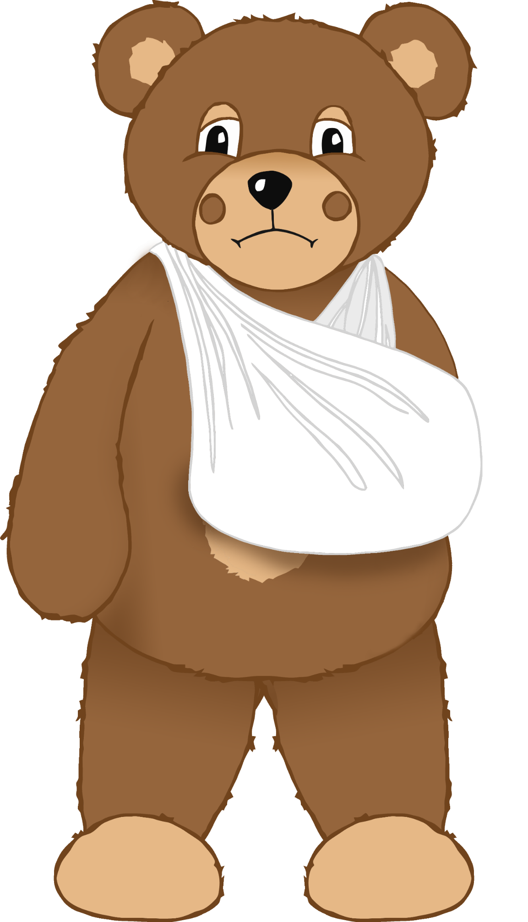

© 2021 Little Owls Resources

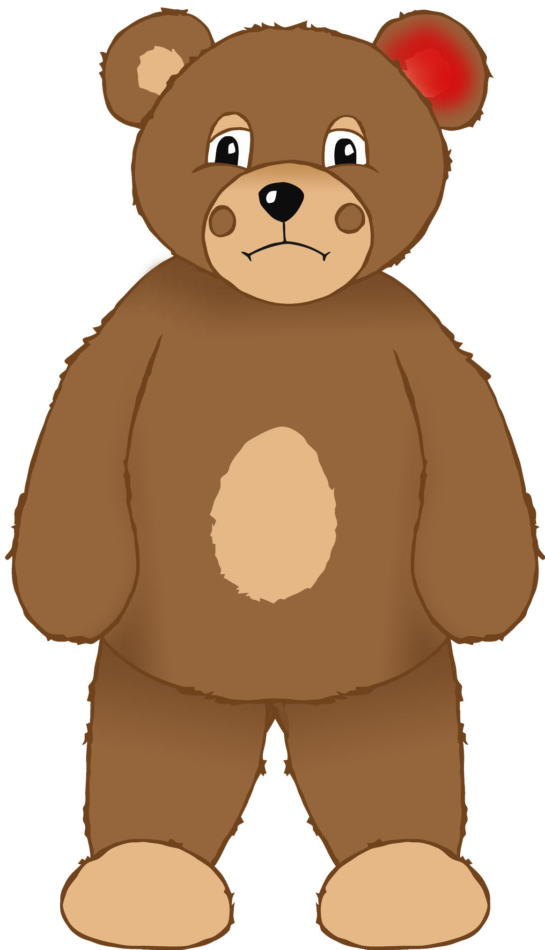

© 2021 Little Owls Resources

© 2021 Little Owls Resources

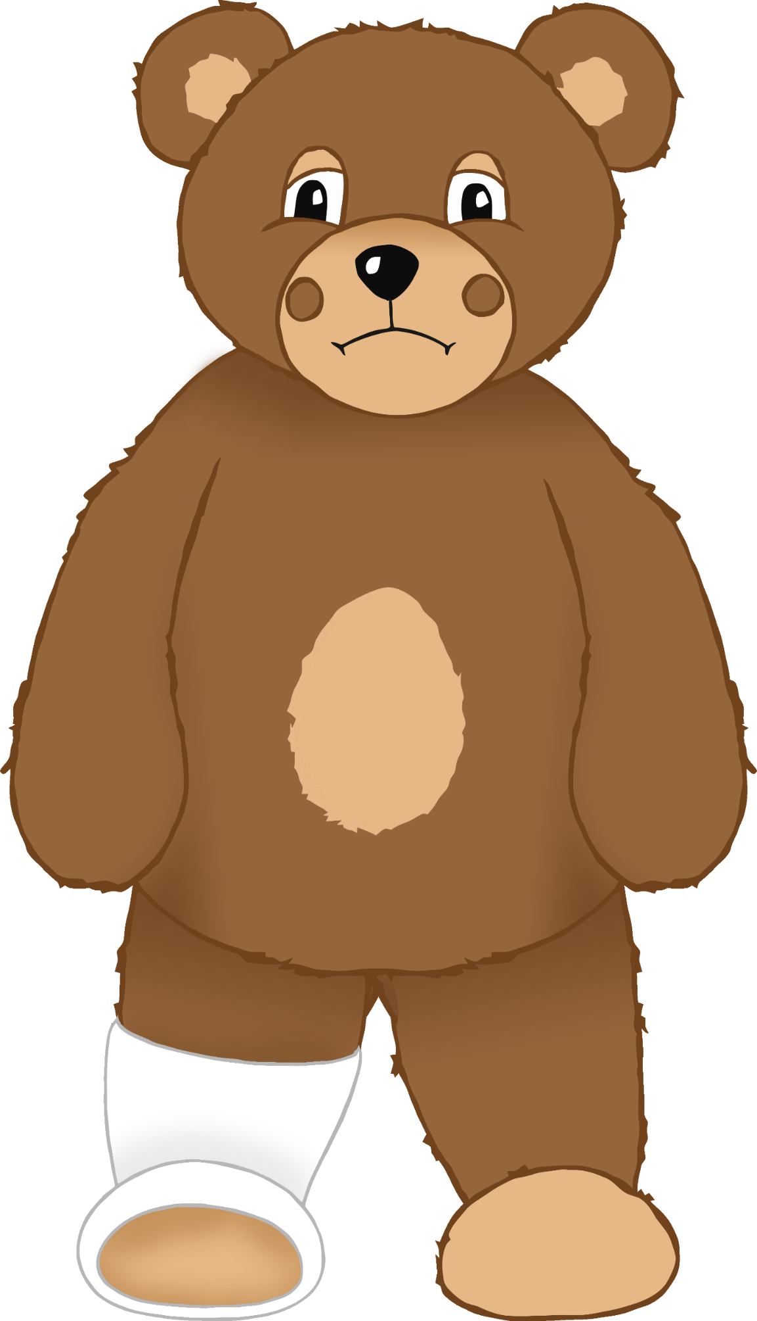

© 2021 Little Owls Resources

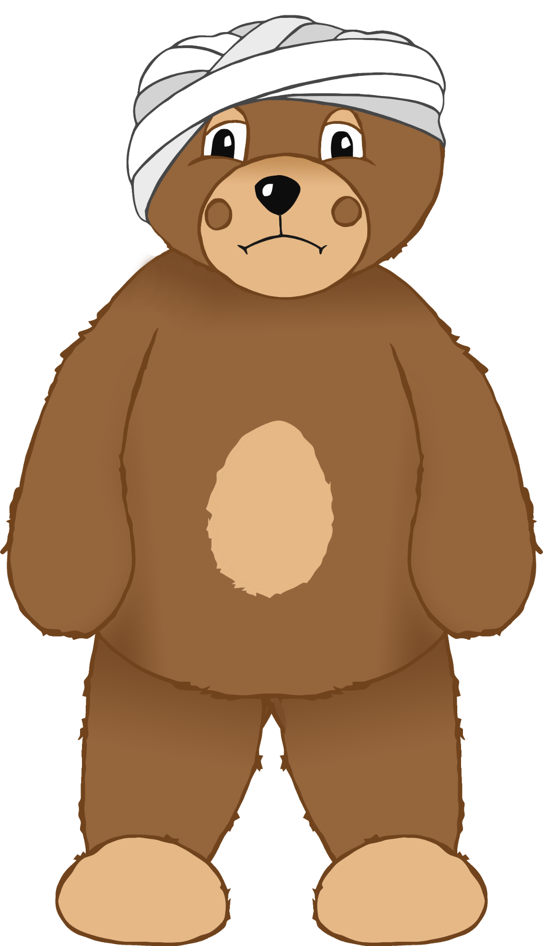

© 2021 Little Owls Resources

© 2021 Little Owls Resources

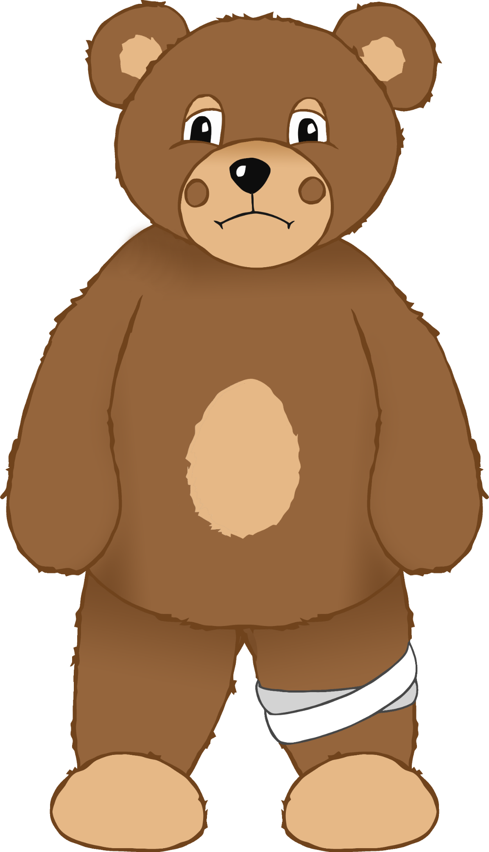

© 2021 Little Owls Resources

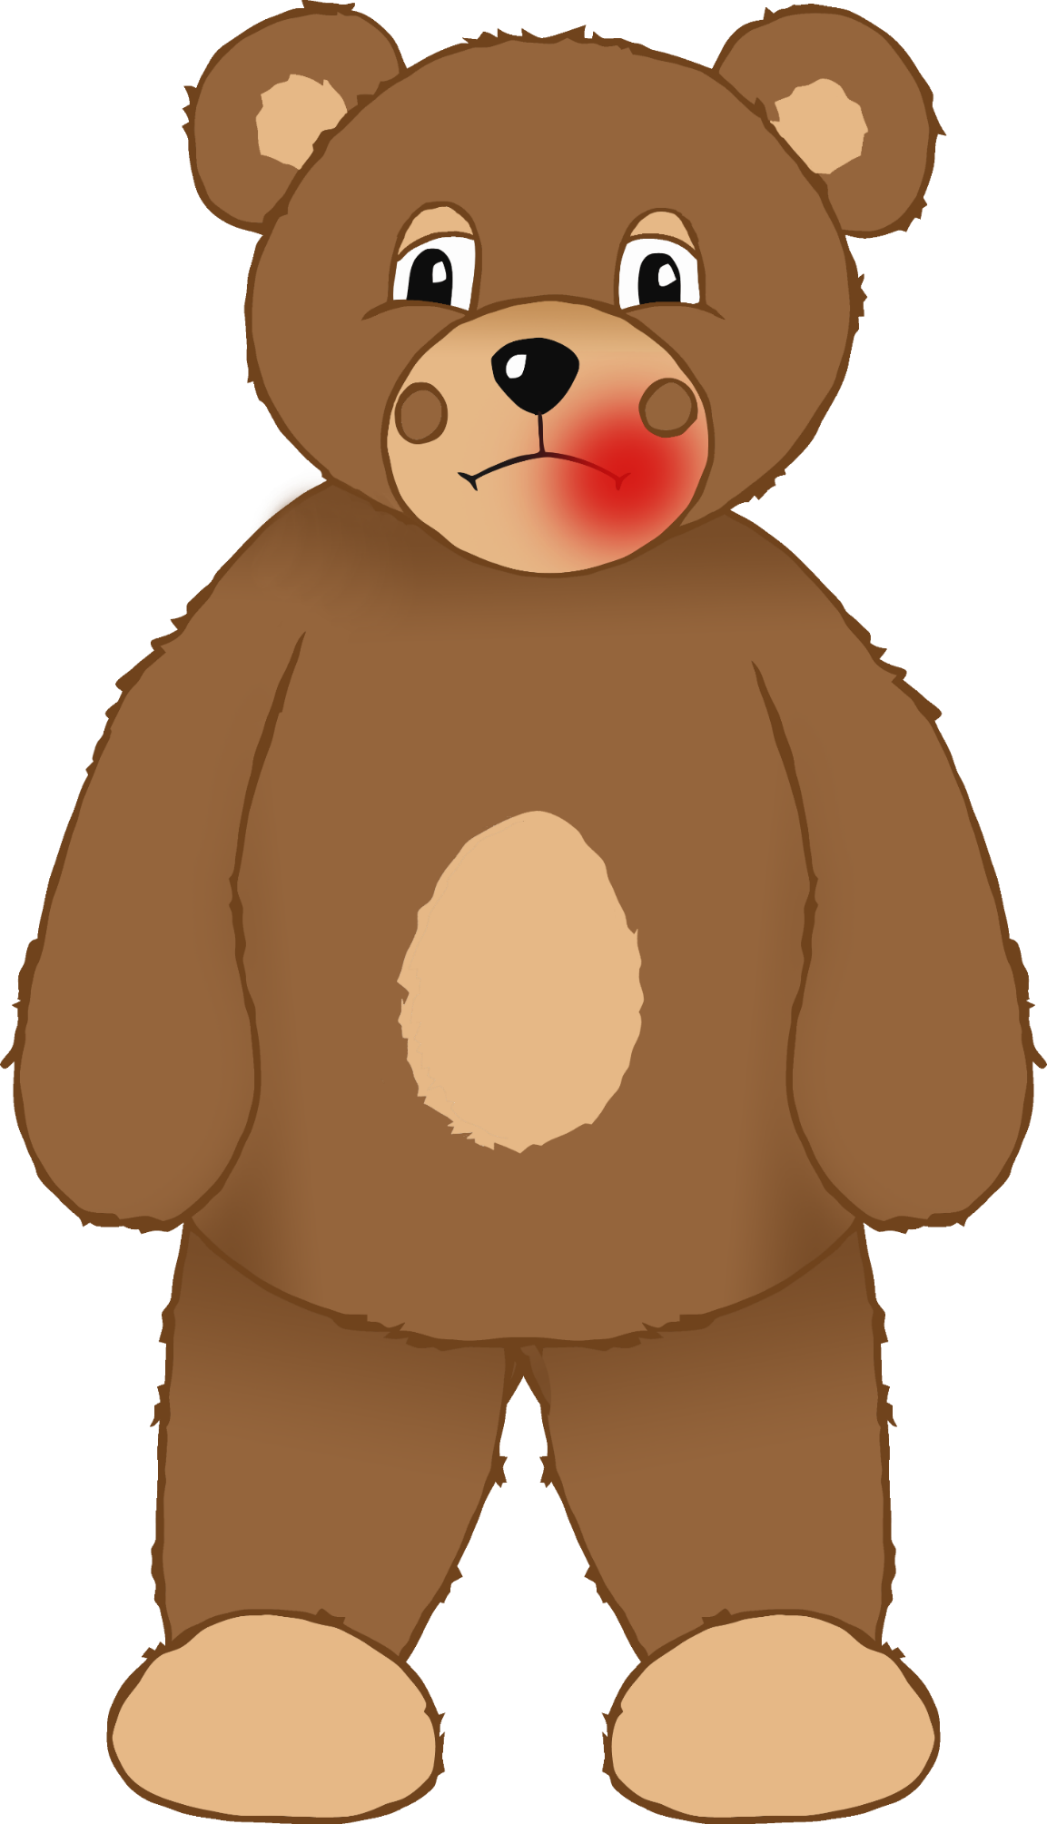

© 2021 Little Owls Resources

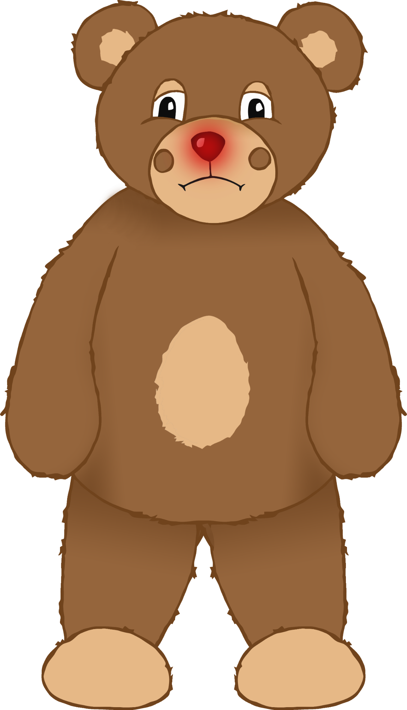

© 2021 Little Owls Resources

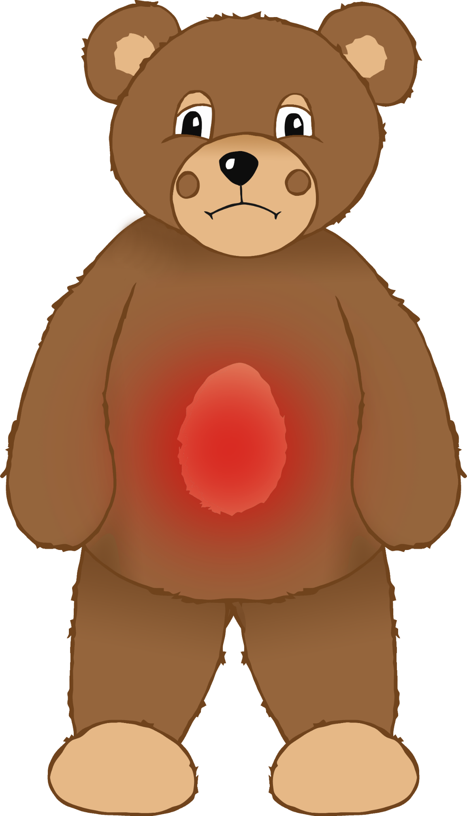

© 2021 Little Owls Resources

© 2021 Little Owls Resources

I fell from a climbing frame and hurt my arm badly. I had to go to the hospital and now my arm is in a sling.

© 2021 Little Owls Resources

I have been feeling ill lately. The inside of my ear has been very painful.

© 2021 Little Owls Resources

I was playing in the garden and I accidentally poked my eye on a stick.

© 2021 Little Owls Resources

I forgot to wear my helmet when I was riding my bike. I fell off and bumped my head. Now I must wear a bandage.

© 2021 Little Owls Resources

I have been feeling poorly recently and I woke up this morning with a headache.

© 2021 Little Owls Resources

I tripped over when I was running with my friend and bumped my knee. Now my knee has a bandage.

© 2021 Little Owls Resources

I accidentally walked into a door and hurt my mouth. It’s very sore!

© 2021 Little Owls Resources

I have had a runny nose for a few days. It is getting sore!

© 2021 Little Owls Resources

I have a pain in my tummy. I might be ill, or maybe I ate too many sweets!

© 2021 Little Owls Resources

I twisted my leg when I was playing football. I had to go to hospital and now I am wearing a cast.

© 2021 Little Owls Resources

I’ve been feeling like I might cry a lot recently. It has been difficult to feel happy.