Birthdays

Our

© 2023 Little Owls Resources

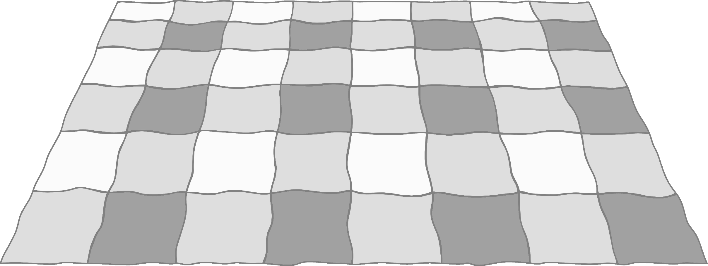

**January**

January

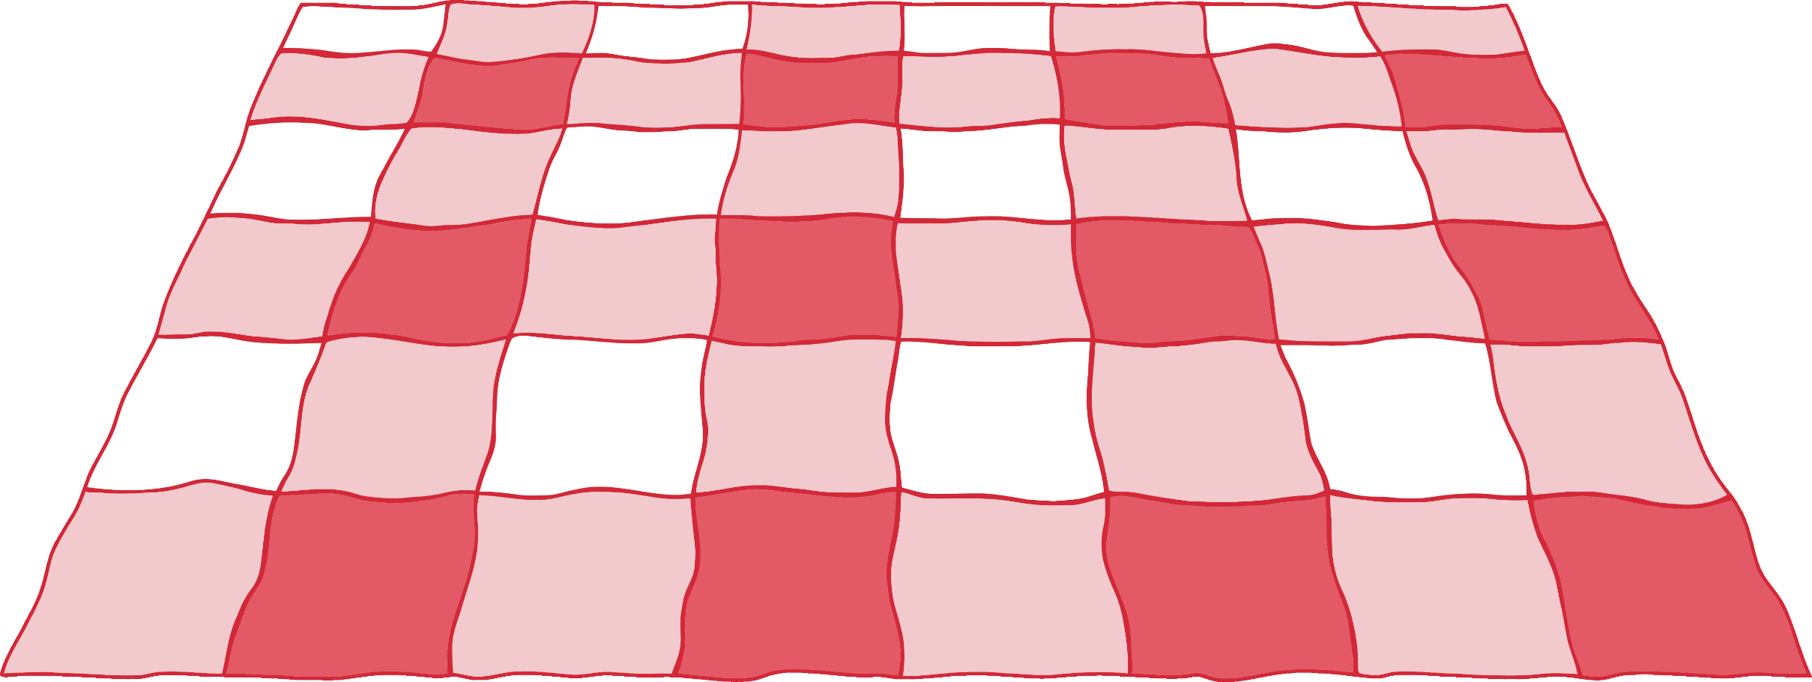

**February**

**March**

**April**

**May**

**June**

**July**

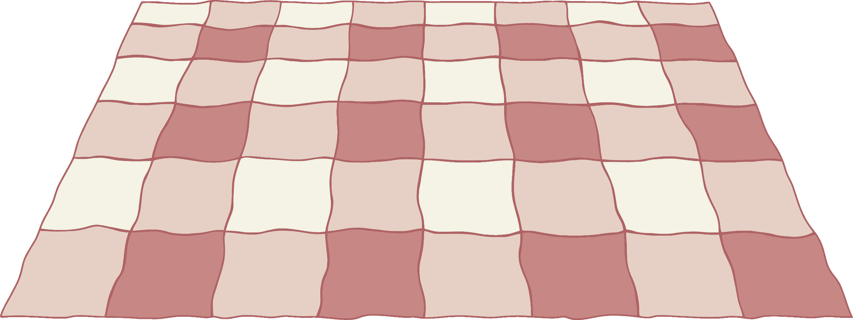

**August**

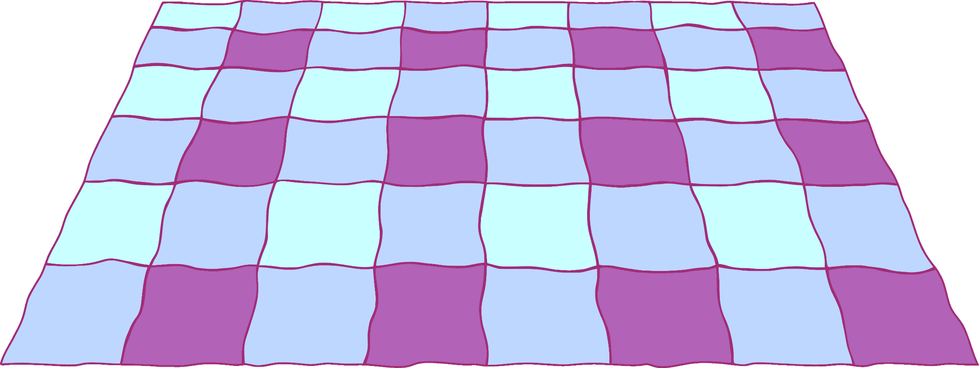

**September**



**October**



**November**

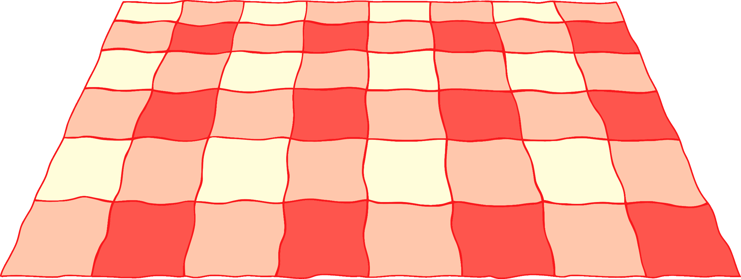

**December**



