Teddy Bears’ Picnic Plates

These number challenge mats can be laminated to be used repeatedly with whiteboard pens or playdough.

© 2021 Little Owls Resources

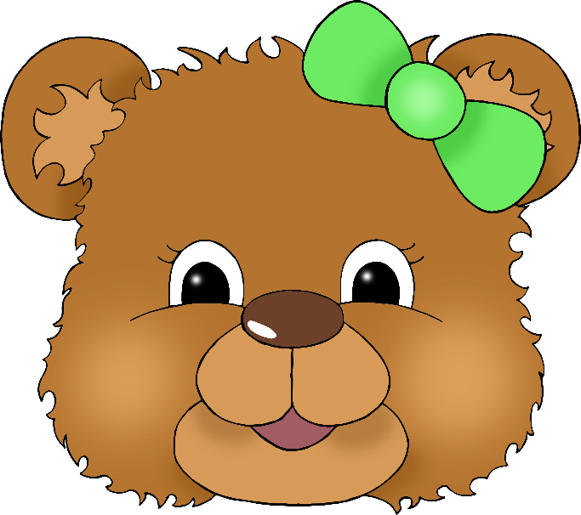

Teddy Bears’ Picnic Plate

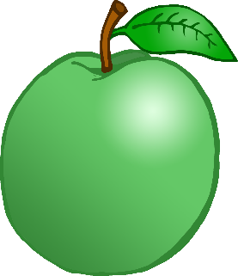

3 apples please.

Teddy Bears’ Picnic Plate

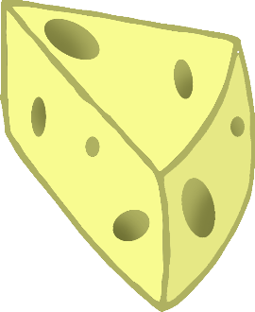

4

pieces of cheese please.

© 2021 Little Owls Resources

Teddy Bears’ Picnic Plate

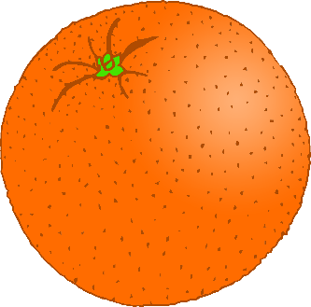

5 oranges please.

© 2021 Little Owls Resources

Teddy Bears’ Picnic Plate

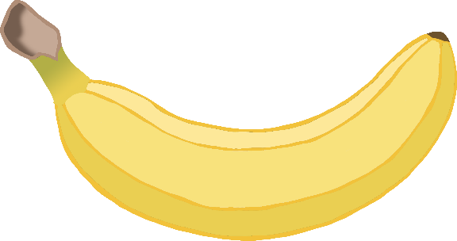

6 bananas please.

© 2021 Little Owls Resources

Teddy Bears’ Picnic Plate

7 buns please.

© 2021 Little Owls Resources

8 eggs please.

© 2021 Little Owls Resources

Teddy Bears’ Picnic Plate

© 2021 Little Owls Resources

Teddy Bears’ Picnic Plate