**Teddy Bears’ Picnic**

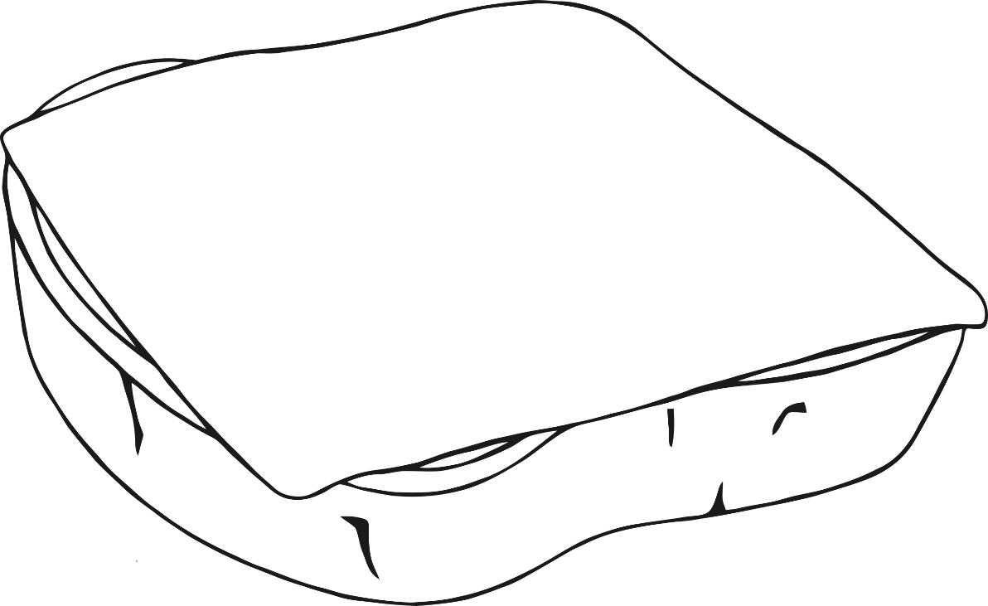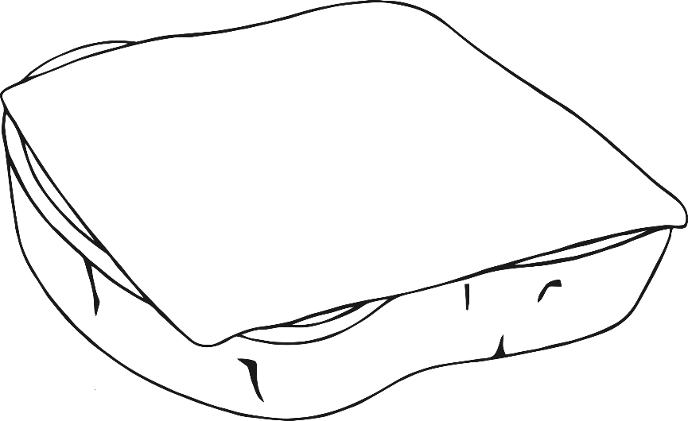

**Teddy Bears’ Picnic**