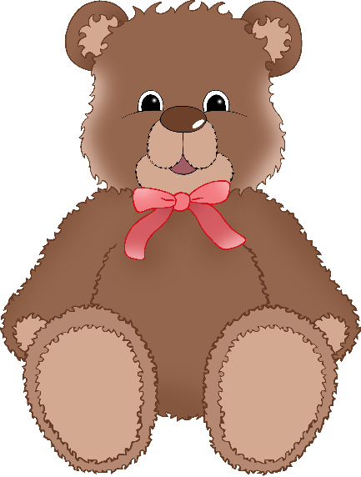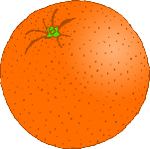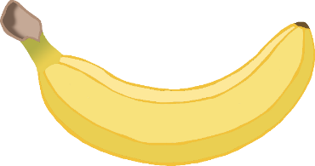

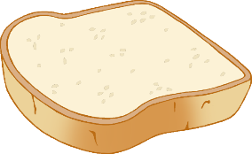

**Teddy**

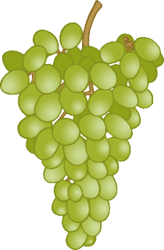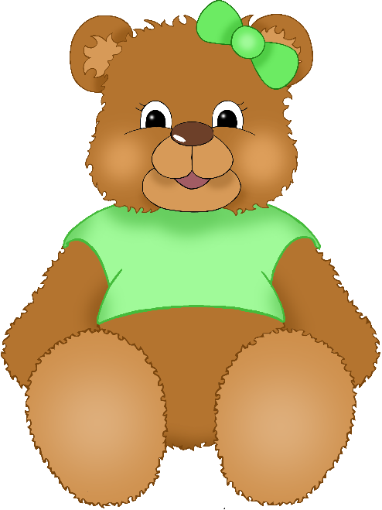

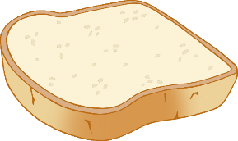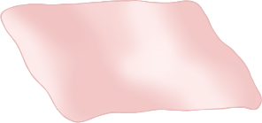

**Bears’**

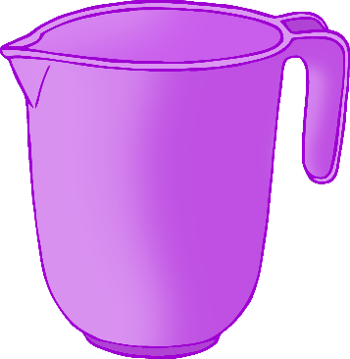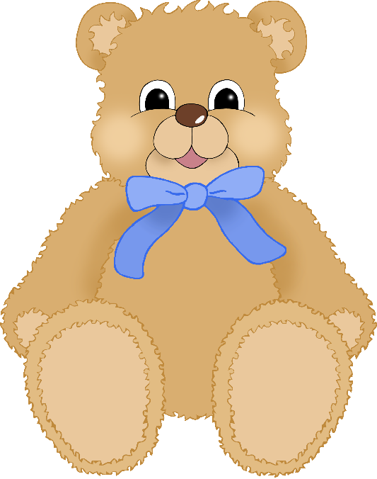

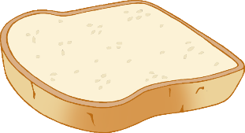

**Picnic**

© 2020 Little Owls Resources