People Who Help Us

Teaching Assistant

© 2023 Little Owls Resources

* Information Posters
* Information Posters (Colouring)
* Drawing/Writing Sheets
* Draw items Sheet
* Draw items Sheet (Colouring)
* Item Poster
* Item Poster (Colouring)
* Multimats for Art & Craft/Loose Parts/Playdough
* 6x 2-Piece individual items puzzles
* 1x 4-Piece all items puzzle

This pack includes:

The pages of this pack give some general information about the role of a teaching assistant and some fun and engaging activities to foster and develop children’s interest in this role in society.

© 2023 Little Owls Resources

Teaching Assistant

I sometimes use puppets when playing and talking with children.

I’m a **teaching assistant.**

I work with a teacher to help children to learn and understand new things.

I might work with a small group to assist them with their work or maybe with just one child who needs my help.

Teaching Assistant

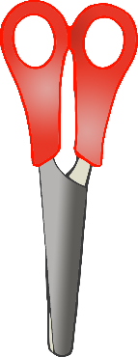

I love to help children as they get creative with arts and crafts!

I love to share books with children and hear them read!

I use a small whiteboard to help children’s understanding.

© 2023 Little Owls Resources

© 2023 Little Owls Resources

**Teaching Assistant**

I sometimes use puppets when playing and talking with children.

I’m a **teaching assistant.**

I work with a teacher to help children to learn and understand new things.

I might work with a small group to assist them with their work or maybe with just one child who needs my help.

**Teaching Assistant**

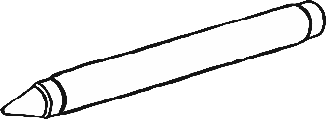

I love to help children as they get creative with arts and crafts!

I use a small whiteboard to help children’s understanding.

I love to share books with children and hear them read!

© 2023 Little Owls Resources

© 2023 Little Owls Resources

Draw a

Teaching Assistant!

© 2023 Little Owls Resources

Teaching Assistant!

Draw and write about a

_________________________________________________________

© 2023 Little Owls Resources

Draw and write about a

Teaching Assistant!

________________________________________________________________________________________________________________________________________________

**Can you draw the items a teaching assistant needs?**

© 2023 Little Owls Resources

**Can you draw the items a teaching assistant needs?**

© 2023 Little Owls Resources

whiteboard and pen

arts and crafts

Teaching Assistant

© 2023 Little Owls Resources

books

puppets

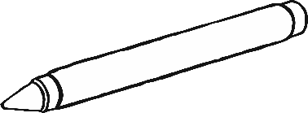

**Teaching Assistant**

**puppets**

**whiteboard and Pen**

**arts and Crafts**

**books**

© 2023 Little Owls Resources

Teaching Assistant Multimat - puppets

© 2023 Little Owls Resources

Teaching Assistant Multimat – whiteboard and pen

and Pen

© 2023 Little Owls Resources

Teaching Assistant Multimat - books

© 2023 Little Owls Resources

Teaching Assistant Multimat – arts and crafts

© 2023 Little Owls Resources

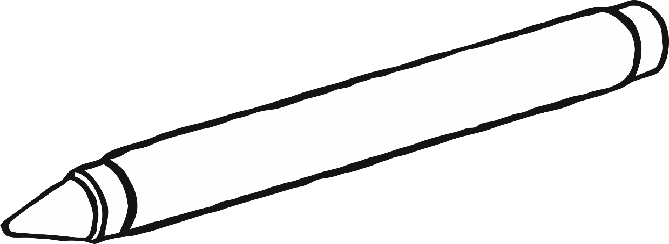

© 2023 Little Owls Resources

© 2023 Little Owls Resources

© 2023 Little Owls Resources

© 2023 Little Owls Resources

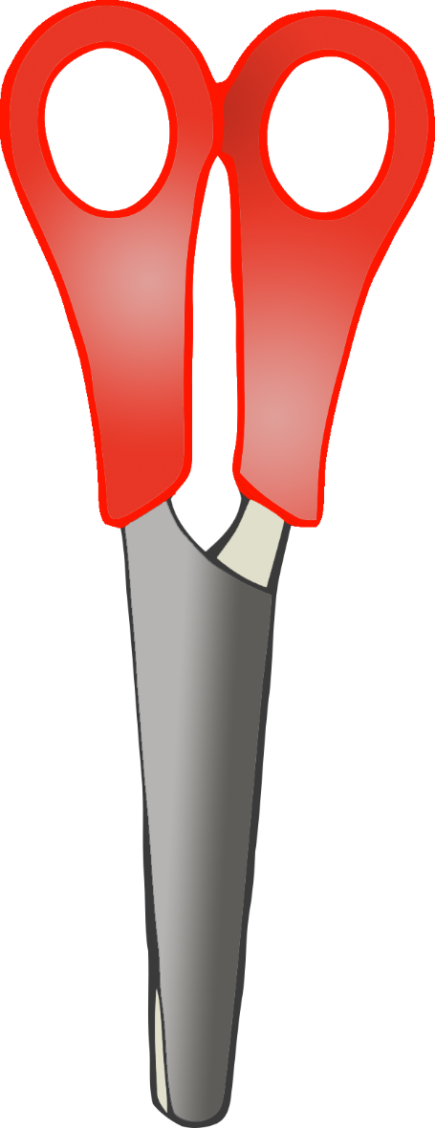

© 2023 Little Owls Resources

© 2023 Little Owls Resources

**Teaching Assistant**

© 2023 Little Owls Resources

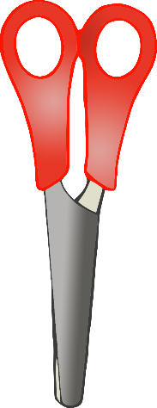

books

arts and crafts

puppets

whiteboard and pen