People Who Help Us

Teacher

© 2021 Little Owls Resources

* Information Posters
* Information Posters (Colouring)
* Drawing/Writing Sheets
* Draw items Sheet
* Draw items Sheet (Colouring)
* Item Poster
* Item Poster (Colouring)
* Multimats for Art & Craft/Loose Parts/Playdough
* 5x 2-Piece individual items puzzles
* 1x 4-Piece all items puzzle

This pack includes:

The pages of this pack give some general information about the role of a teacher and some fun and engaging activities to foster and develop children’s interest in this role in society.

© 2021 Little Owls Resources

Teacher

I’m a **teacher.**

I help children to learn new things.

I think carefully about the children in my class and what they need to get better at.

To help them, I plan fun lessons and exciting activities!

I use a computer to prepare lessons to teach the children.

Teacher

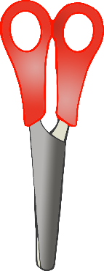

I encourage children to be creative with arts and crafts!

I share ideas with the children using a whiteboard.

I love to read books to the children in my class!

© 2021 Little Owls Resources

© 2021 Little Owls Resources

**Teacher**

**I’m a teacher.**

**I help children to learn new things.**

**I think carefully about the children in my class and what they need to get better at.**

**To help them, I plan fun lessons and exciting activities!**

**I use a computer to prepare lessons to teach the children.**

**Teacher**

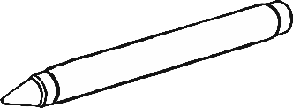

**I encourage children to be creative with arts and crafts!**

**I share ideas with the children using a whiteboard.**

**I love to read books to the children in my class!**

© 2021 Little Owls Resources

© 2021 Little Owls Resources

Draw a Teacher!

© 2021 Little Owls Resources

Draw and write about a Teacher!

_________________________________________________________

© 2021 Little Owls Resources

Draw and write about a Teacher!

________________________________________________________________________________________________________________________________________________

**Can you draw the items a teacher needs?**

© 2021 Little Owls Resources

**Can you draw the items a teacher needs?**

© 2021 Little Owls Resources

Teacher

© 2021 Little Owls Resources

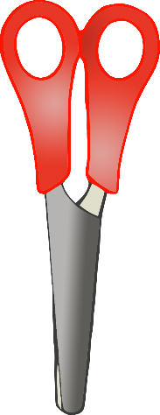

Computer

Arts and Crafts

Whiteboard and Pen

Book

**Teacher**

© 2021 Little Owls Resources

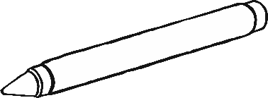

**Book**

**Arts and Crafts**

**Whiteboard and Pen**

**Computer**

Teacher Multimat - Computer

© 2021 Little Owls Resources

Teacher Multimat – Whiteboard and Pen

© 2021 Little Owls Resources

Teacher Multimat – Book

© 2021 Little Owls Resources

Teacher Multimat – Arts and Crafts

© 2021 Little Owls Resources

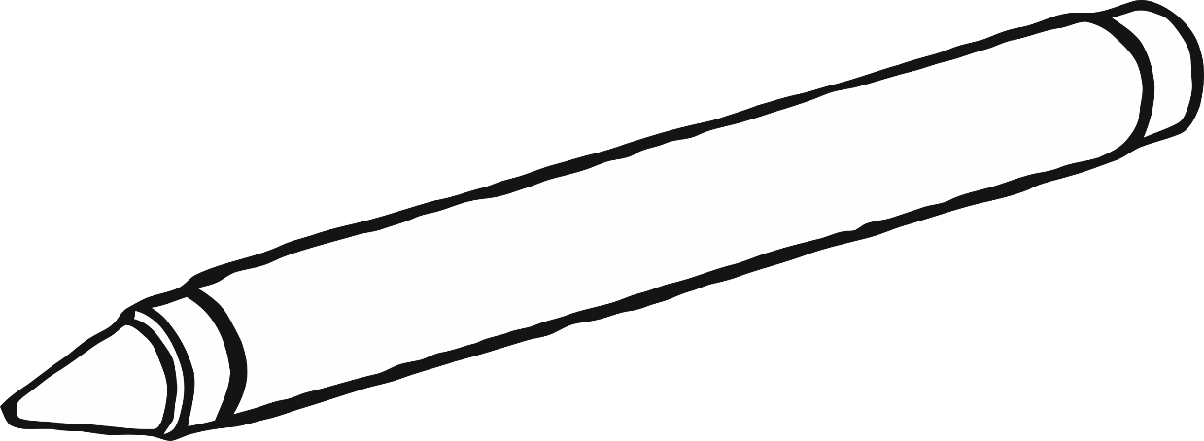

© 2021 Little Owls Resources

© 2021 Little Owls Resources

© 2021 Little Owls Resources

© 2021 Little Owls Resources

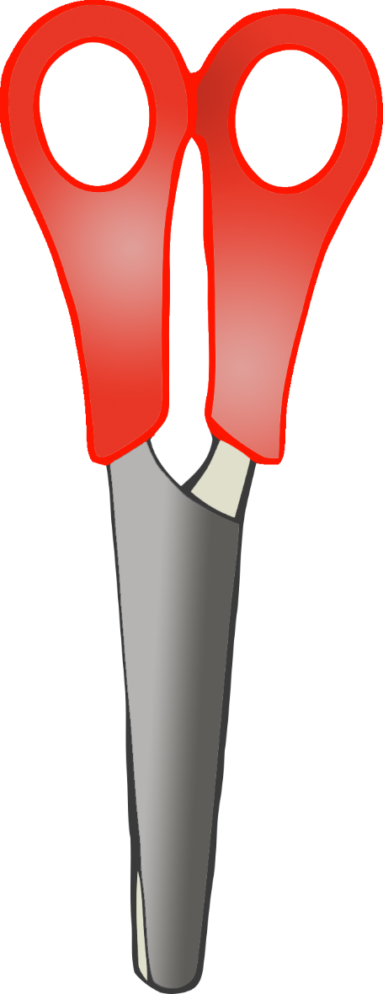

© 2021 Little Owls Resources

**Teacher**

© 2021 Little Owls Resources

Book

Whiteboard and Pen

Computer

Arts and Crafts