Tangram pieces

© 2022 Little Owls Resources

These tangram pieces can be cut out and laminated before being used to make shape pictures.

The children can use these shapes to make their own pictures without overlapping the pieces.

Included are a set of colour tangrams and a set of outline tangrams for colouring in.

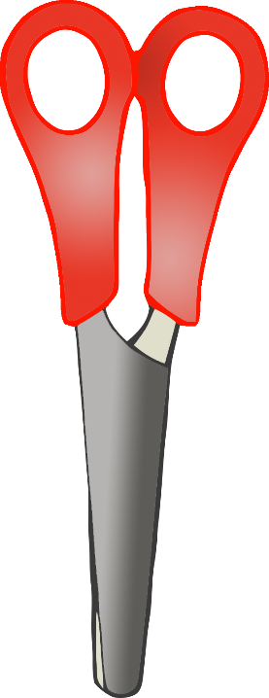

Colour tangram pieces to cut out.

© 2022 Little Owls Resources

Outline tangram pieces to cut out.

© 2022 Little Owls Resources