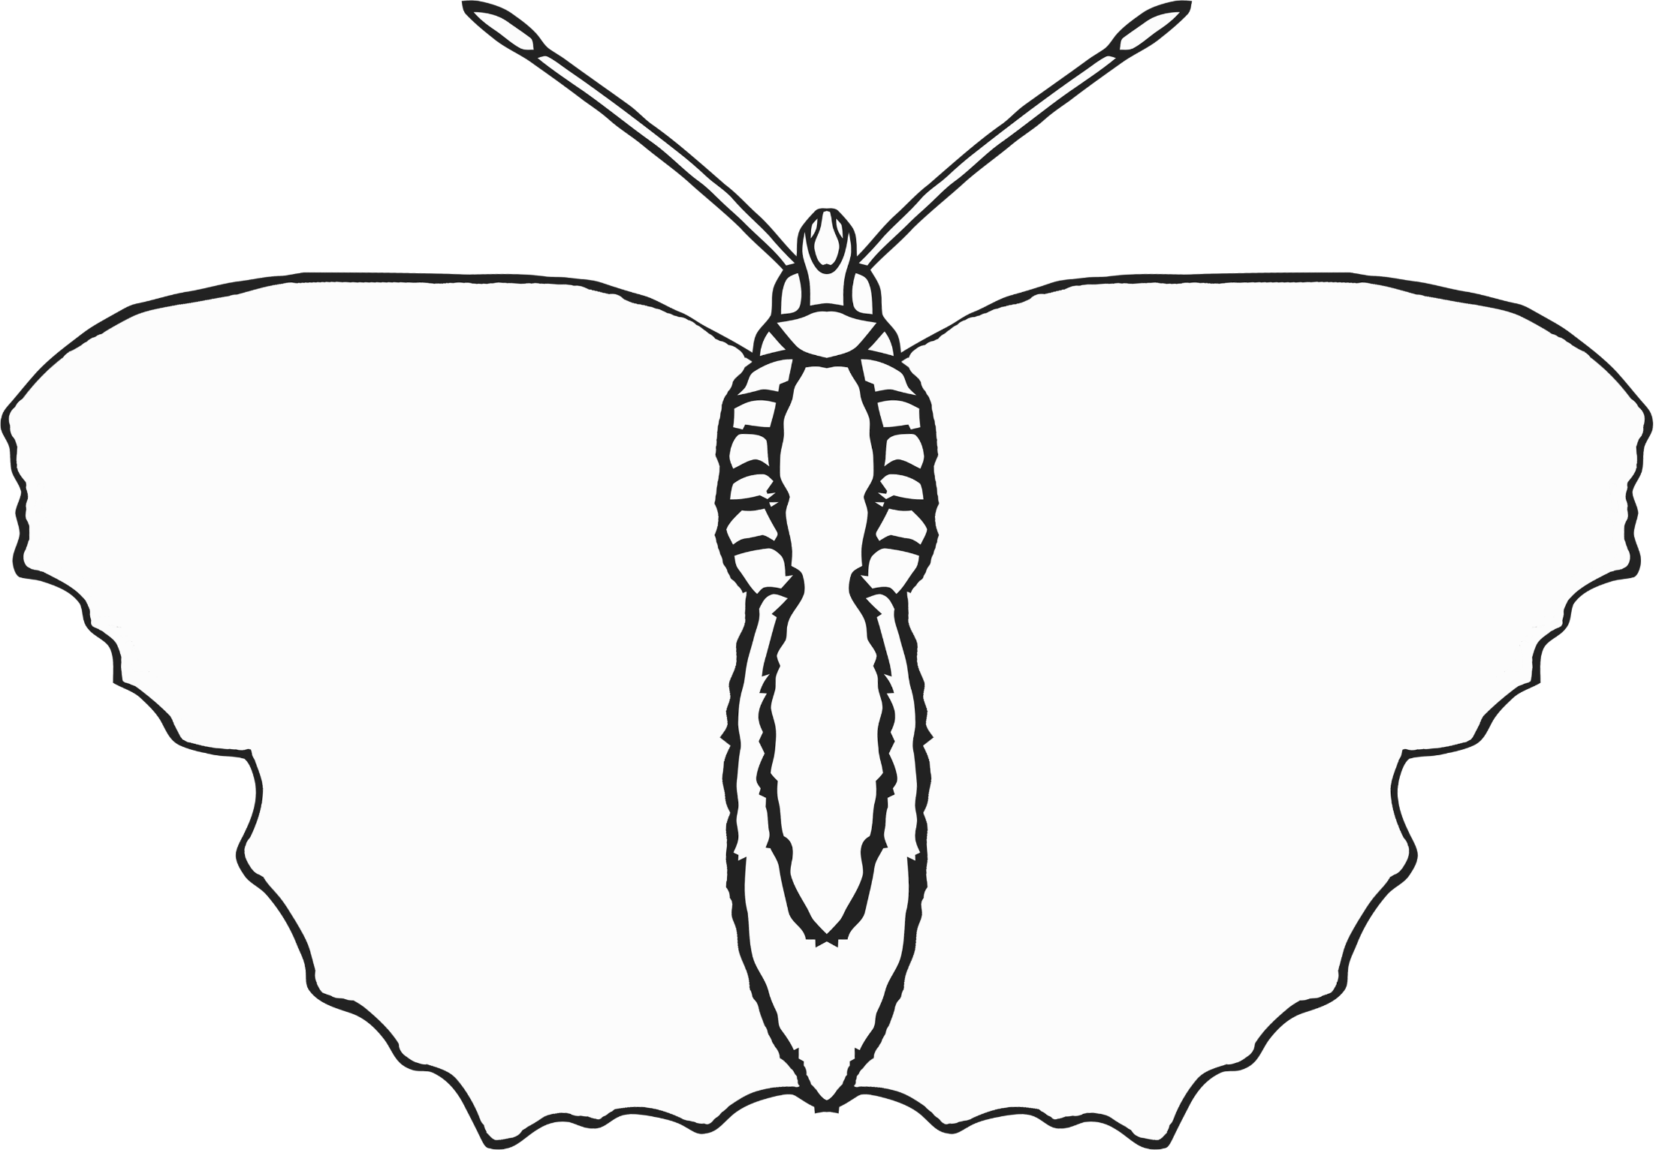

Symmetrical

Butterfly

Paint or draw the same on both sides!

© 2020 Little Owls Resources