**Sunflower**

**Number line Activity**

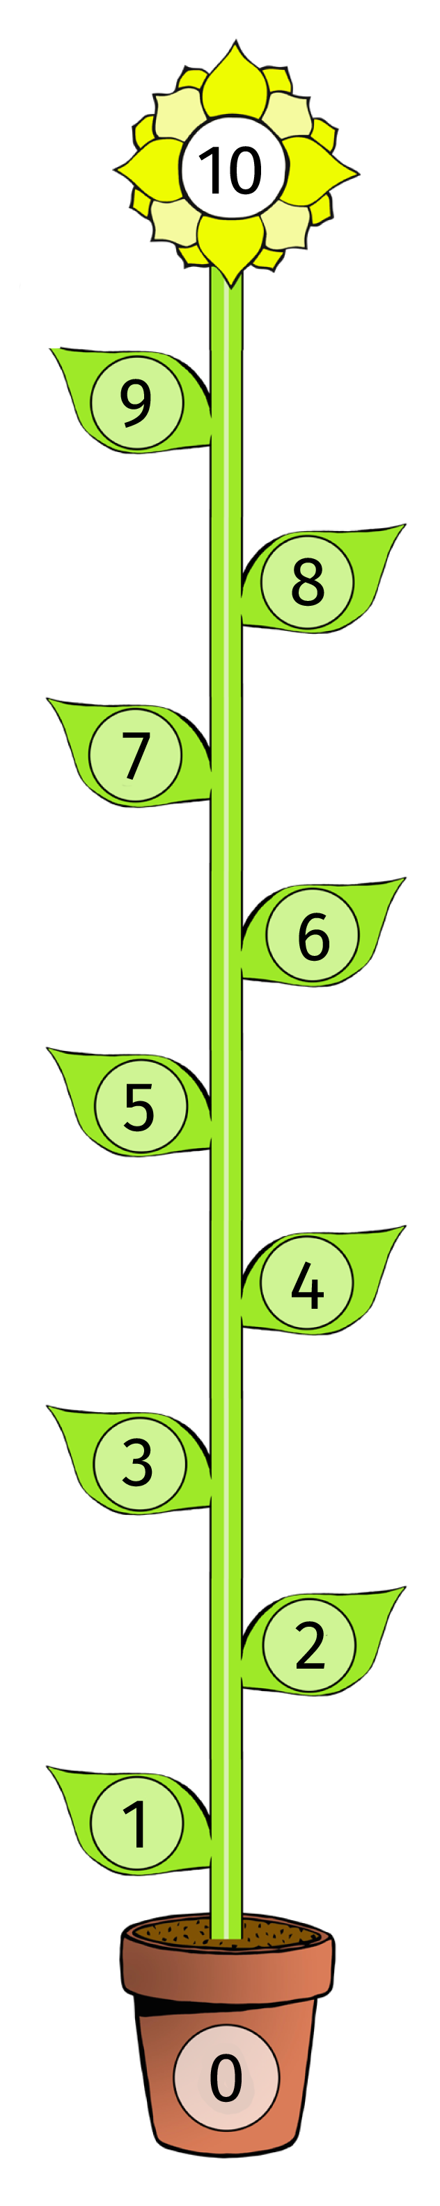

**Floor based activity**

With the resources cut out (and preferably laminated) the children can start the number line with the ‘0’ Pot at the bottom and then think about the next number needed until the plant reaches the flower.

Extension: Adult to have already completed number line but with some numbers missing. Fly the buzzy bee up the leaves saying the numbers until you find the mistake.

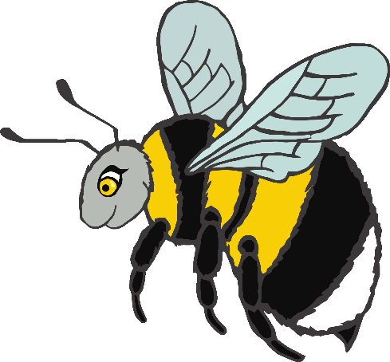



© 2018 Little Owls Resources

**0**



**1**



**2**



**3**



**4**



**5**



**6**



**7**



**8**



**9**

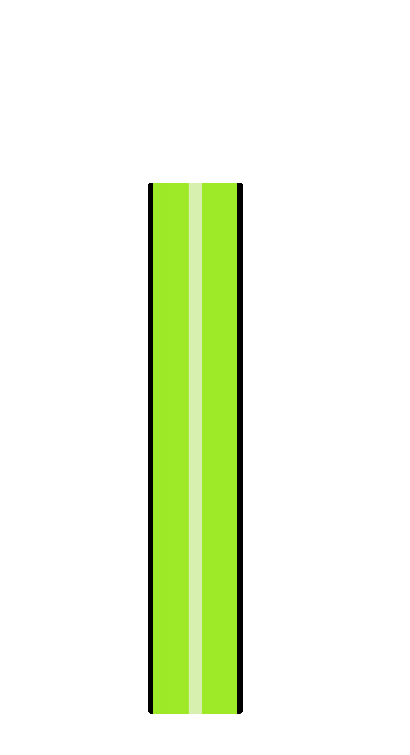

**10**



**10**



**11**



**12**



**13**



**14**



**15**



**16**



**17**



**18**



**19**



**20**