Sun Safety Memory Find

It’s a hot day… Find the things you need!

Game for four players.

Takes turns to turn a card. If it is an item you need, place it on your game board. If you already have that item, place it back where you found it.

The first player to get all four items is the winner!

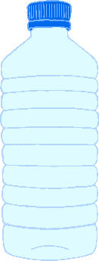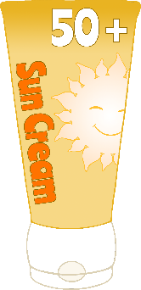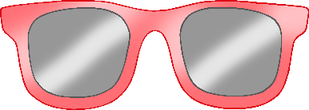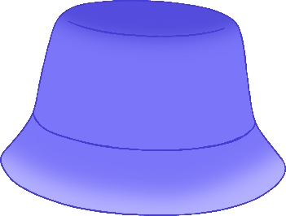

© 2021 Little Owls Resources



© 2021 Little Owls Resources



© 2021 Little Owls Resources



© 2021 Little Owls Resources



