© 2021 Little Owls Resources

**Sun Cream**

**Sun Hat**

**Water**

**Sunglasses**

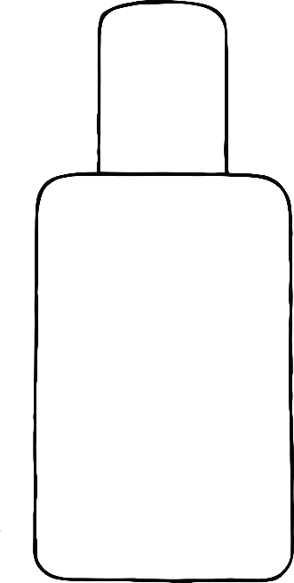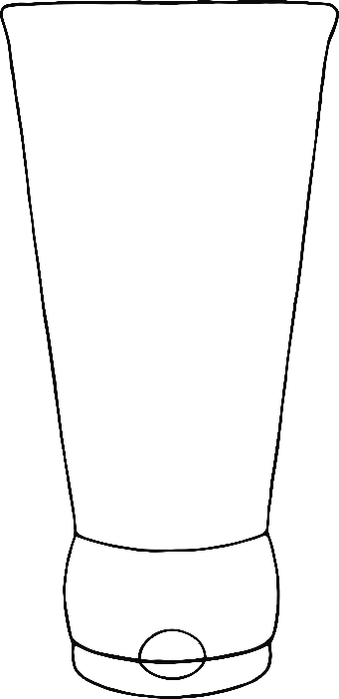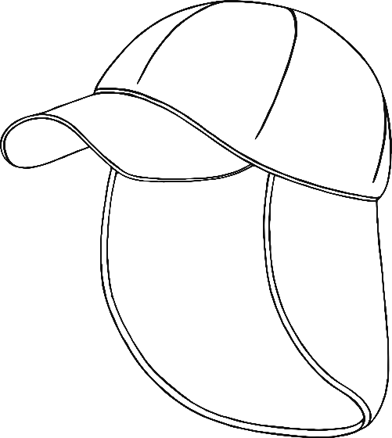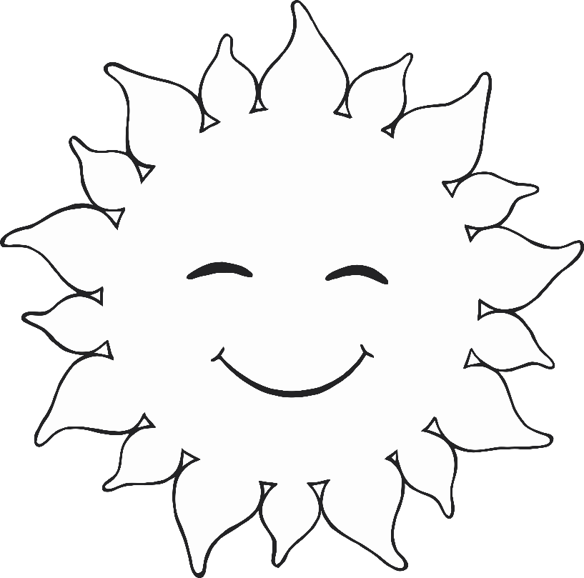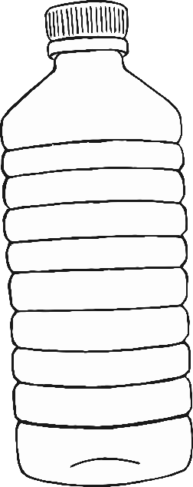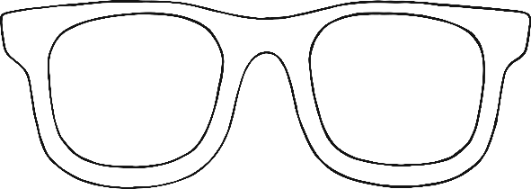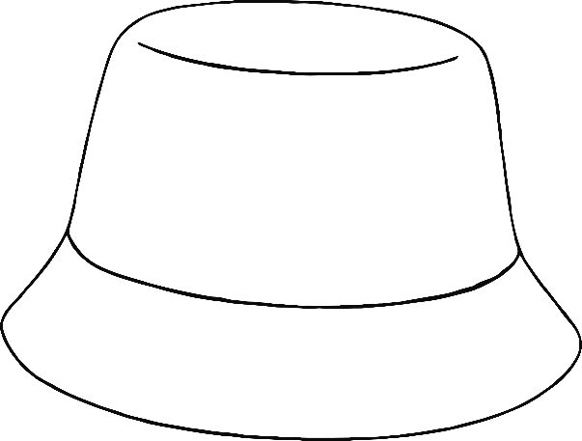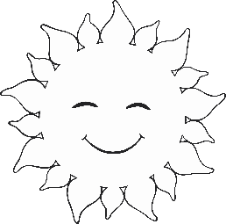

**Sun Cream**

© 2021 Little Owls Resources

**Sun Cream**