© 2021 Little Owls Resources

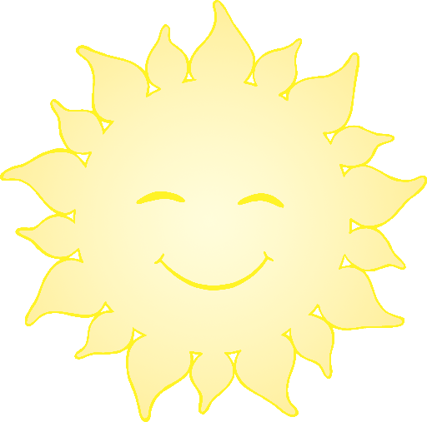

**Sun Safety**

Put on your sun hat!

On a hot, sunny, day…

© 2021 Little Owls Resources



**Sun Safety**

Put on your sun cream!

On a hot, sunny, day…

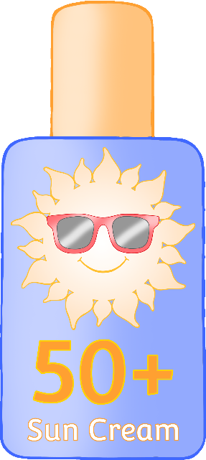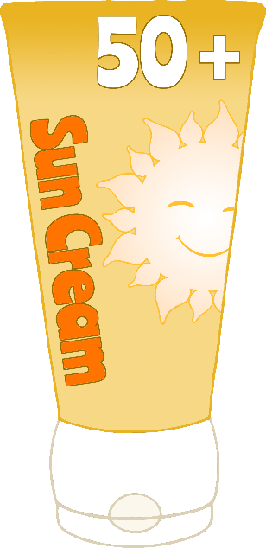

Put on your sunglasses!

© 2021 Little Owls Resources

**Sun Safety**

On a hot, sunny, day…

© 2021 Little Owls Resources

**Sun Safety**

Make sure you drink some water!

On a hot, sunny, day…