sun

sunglasses

sandcastle

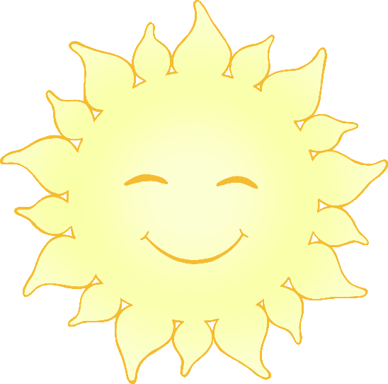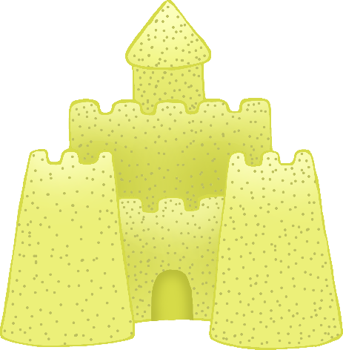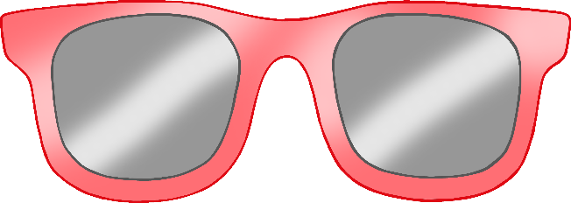

© 2022 Little Owls Resources

© 2022 Little Owls Resources

© 2022 Little Owls Resources

© 2022 Little Owls Resources

© 2022 Little Owls Resources

© 2022 Little Owls Resources

bucket and spade

ice-cream

sun hat

© 2022 Little Owls Resources

© 2022 Little Owls Resources

© 2022 Little Owls Resources

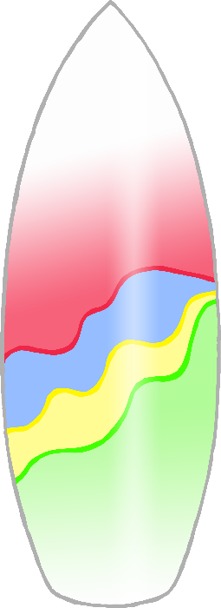

surfboard

sun cream

flip-flops

ice-lolly

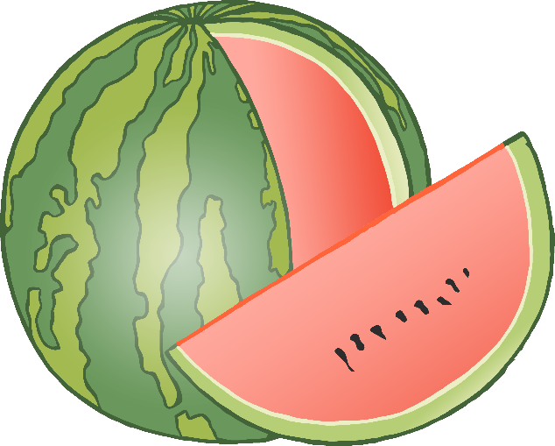

park

© 2022 Little Owls Resources

© 2022 Little Owls Resources

© 2022 Little Owls Resources

watermelon

warm

hot

t-shirt

© 2022 Little Owls Resources

© 2022 Little Owls Resources

© 2022 Little Owls Resources

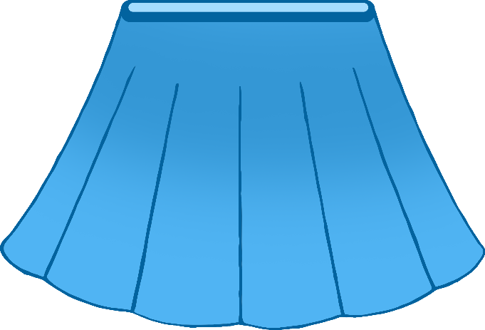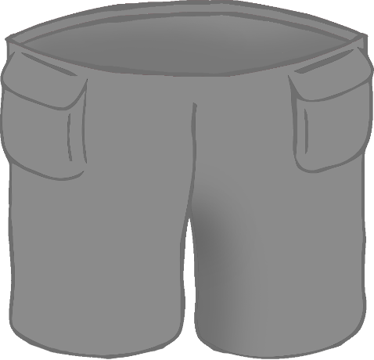

skirt

shorts

sand

© 2022 Little Owls Resources

© 2022 Little Owls Resources

© 2022 Little Owls Resources

water

yellow

orange

© 2022 Little Owls Resources

© 2022 Little Owls Resources

© 2022 Little Owls Resources

red

blue

green

© 2022 Little Owls Resources

© 2022 Little Owls Resources

© 2022 Little Owls Resources

water wings

arm bands

swimming pool

© 2022 Little Owls Resources

© 2022 Little Owls Resources

© 2022 Little Owls Resources

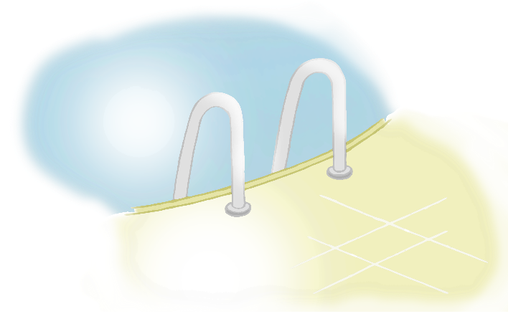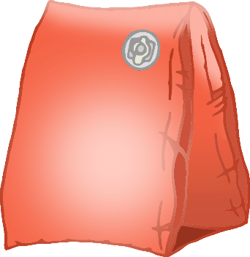

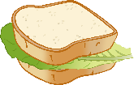

water bottle

beach

picnic

© 2022 Little Owls Resources

© 2022 Little Owls Resources

© 2022 Little Owls Resources

bucket hat

sun cap

© 2022 Little Owls Resources

© 2022 Little Owls Resources