**Summer Word Mat**

© 2022 Little Owls Resources

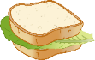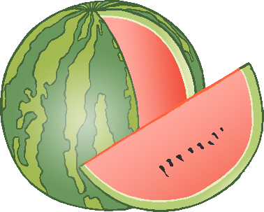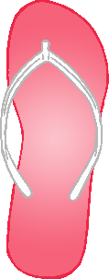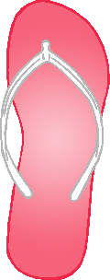

picnic

bucket and spade

watermelon

beach

sun cream

sandcastle

flip-flops

sun hat

ice cream

sunglasses

ice lolly

sun