**George’s Reward Chart**

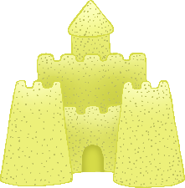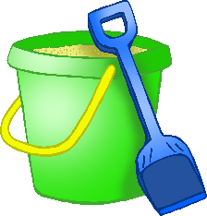

**My Target:**

To eat all my lunch every day.

© 2020 Little Owls Resources

© 2020 Little Owls Resources

To eat all my lunch every day.

**My Target:**

**George’s Reward Chart**

