© 2021 Little Owls Resources

© 2021 Little Owls Resources

ice-cream

ice-cream

ice-cream

ice-cream

© 2021 Little Owls Resources

© 2021 Little Owls Resources

sunglasses

sunglasses

© 2021 Little Owls Resources

© 2021 Little Owls Resources

sunglasses

sunglasses

© 2021 Little Owls Resources

© 2021 Little Owls Resources

bucket and spade

bucket and spade

© 2021 Little Owls Resources

© 2021 Little Owls Resources

bucket and spade

bucket and spade

© 2021 Little Owls Resources

© 2021 Little Owls Resources

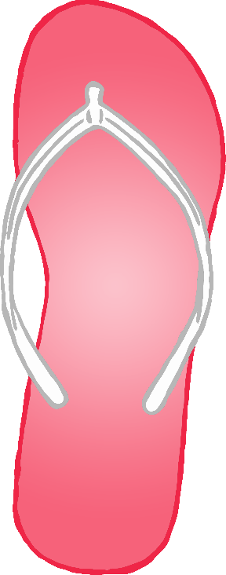

© 2021 Little Owls Resources

© 2021 Little Owls Resources

flip-flop

flip-flop

flip-flop



flip-flop



© 2021 Little Owls Resources

© 2021 Little Owls Resources

© 2021 Little Owls Resources

© 2021 Little Owls Resources

ice lolly

ice lolly

ice lolly

ice lolly

© 2021 Little Owls Resources

© 2021 Little Owls Resources

sun

sun

© 2021 Little Owls Resources

© 2021 Little Owls Resources

sun

sun

© 2021 Little Owls Resources

© 2021 Little Owls Resources

sandcastle

sandcastle

© 2021 Little Owls Resources

© 2021 Little Owls Resources

sandcastle

sandcastle

© 2021 Little Owls Resources

© 2021 Little Owls Resources

watermelon

watermelon

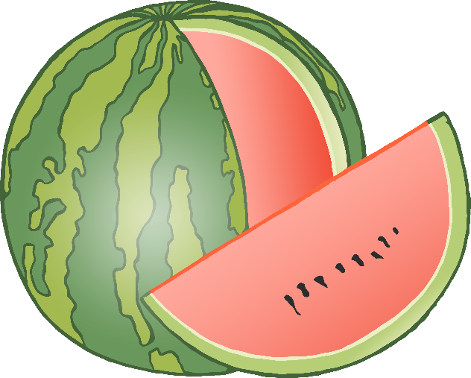

© 2021 Little Owls Resources

© 2021 Little Owls Resources



© 2021 Little Owls Resources

© 2021 Little Owls Resources

watermelon

watermelon