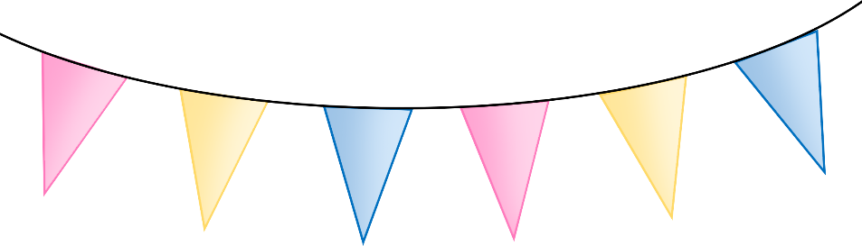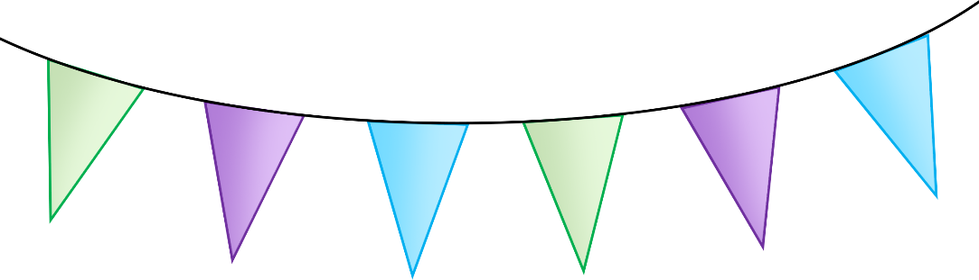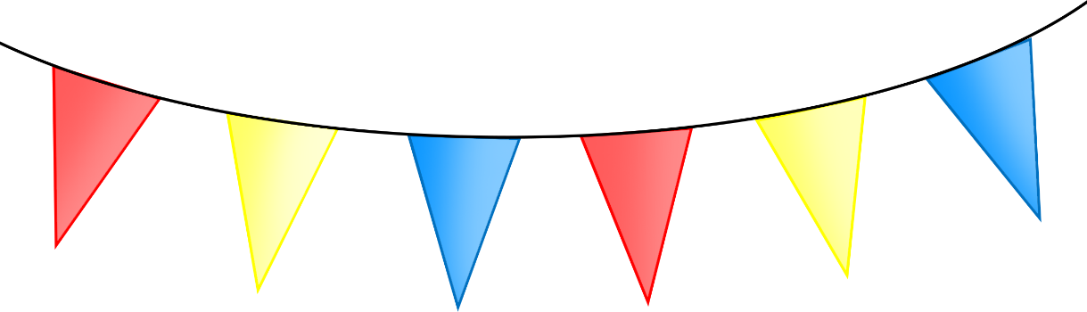

**Summer Fair**

Stalls:

When:

Where:

© 2023 Little Owls Resources

When:

Stalls:

© 2023 Little Owls Resources

Where:

**Summer Fair**

