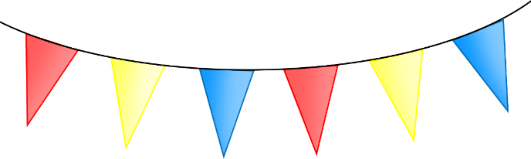

© 2023 Little Owls Resources

© 2023 Little Owls Resources

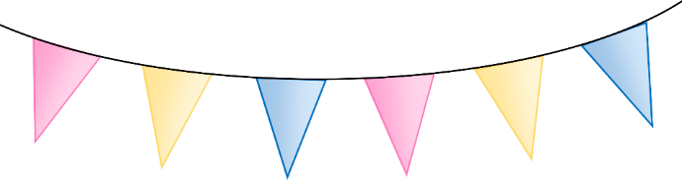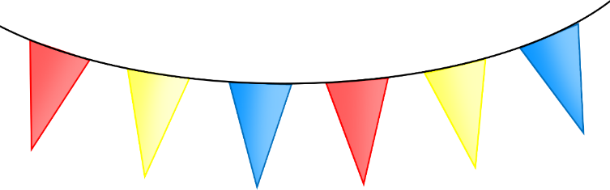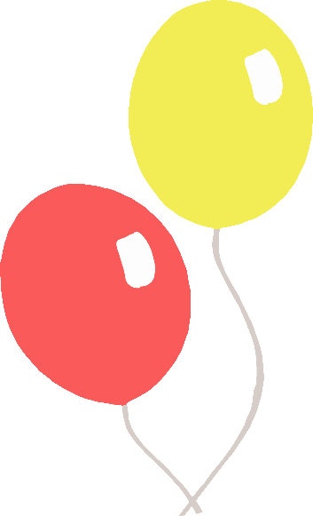

© 2023 Little Owls Resources

© 2023 Little Owls Resources

