

© 2023 Little Owls Resources



Where:

When:

Stalls:

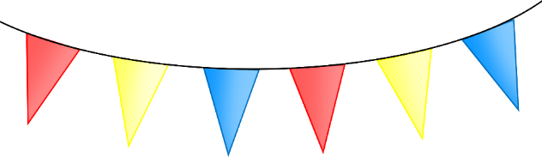

**Summer Fair**



© 2023 Little Owls Resources



Where:

When:

Stalls:



**Summer Fair**

