+-

Summer Checklist **✔️✔️✔️**

© 2021 Little Owls Resources

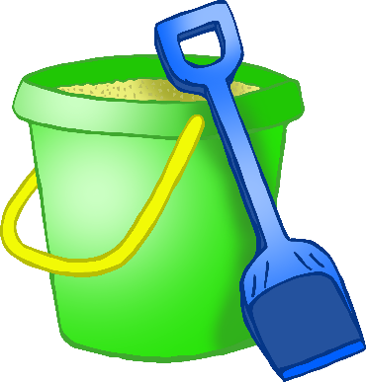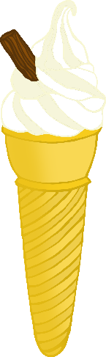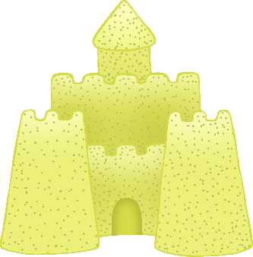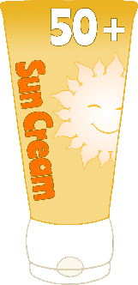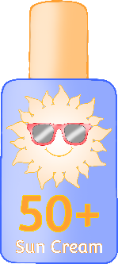

-

sun hat

ice cream

ice lolly

bucket and spade

flip flops

sandcastle

sun cream

sunglasses

Summer Checklist **✔️✔️✔️**

© 2021 Little Owls Resources