Summer CVC Word Builder Game

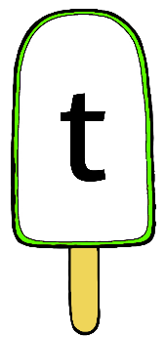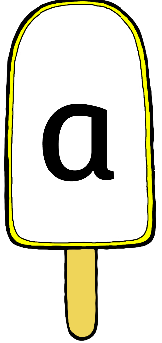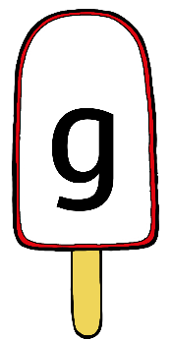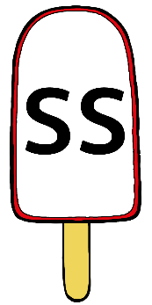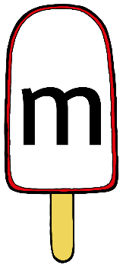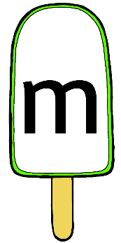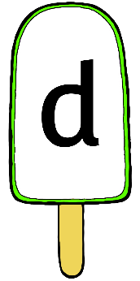

Pick a **green** lolly as the **first** letter.

Next pick a vowel on a **yellow** lolly as the **middle** letter.

Finally pick a **red** lolly as the **final** letter.

Say the sounds of each letter. Try blending the letters together to read the word.

Is it a real word? Is it a nonsense word?

t

t

s

ss

p

p

n

n





e

e

a

a



o

o

i

i

u

u

m

m

d

d

g

g

c

ll

l

k

ff

f

b

b

r

h