**How many altogether?**

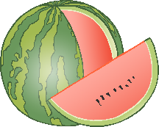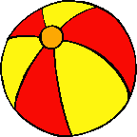



**How many altogether?**