Summer Activity

Challenge!

**1**

Stretch up tall like a sunflower…

**Reach to the sky!**

Summer Activity

Challenge!

**2**

Put on your sunhat, sunglasses, and sun cream!

© 2021 Little Owls Resources

© 2021 Little Owls Resources

Summer Activity

Challenge!

**3**

Dig in the sand with your spade…

Fill your bucket!

Dig! Dig!

Summer Activity

Challenge!

**4**

Make yourself an ice-cream…

Now lick it!

**Yum!**

© 2021 Little Owls Resources

© 2021 Little Owls Resources

Summer Activity

Challenge!

**5**

Tiptoe up to the sea… then **run** back from the waves!

Summer Activity

Challenge!

**6**

Make a sandcastle at the beach!

© 2021 Little Owls Resources

© 2021 Little Owls Resources

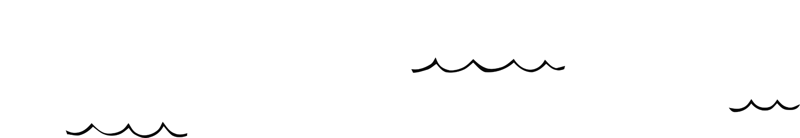

It’s a booming thunderstorm! Stamp your feet!

**Stamp! Stamp!**

Summer Activity

Challenge!

**8**

Summer Activity

Challenge!

**7**

Swim in the sea!

Splash!

© 2021 Little Owls Resources

© 2021 Little Owls Resources