**My**

**Activity Booklet!**

**Summer**

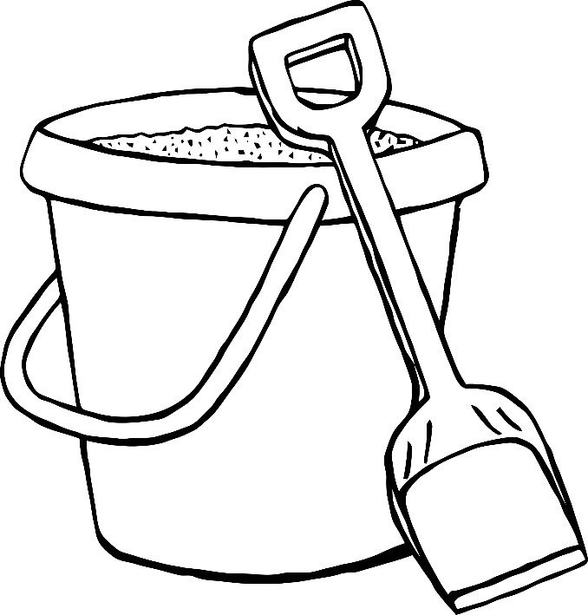

Name:

© 2022 Little Owls Resources

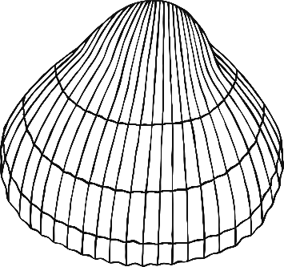

Colour & Cut

Santa mask

© 2021 Little Owls Resources

Design your own…

Cockle shell

© 2022 Little Owls Resources

What’s inside?

Draw what you hope is inside this picnic basket.

© 2022 Little Owls Resources

Draw a line from each picture to the correct sound.

c

s

© 2022 Little Owls Resources

Match

the sound

Finish the pictures

Draw the other half of these pictures.

© 2022 Little Owls Resources

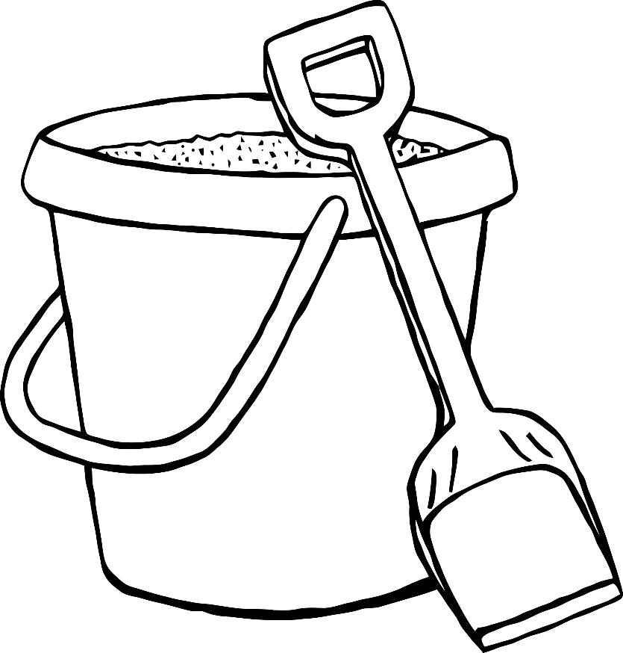

Mindfulness

colouring

Enjoy colouring these pictures.

© 2022 Little Owls Resources