**My**

**Activity Booklet!**

**Summer**

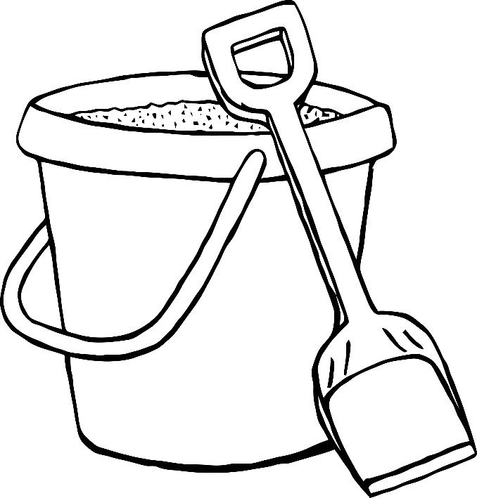

Name:

© 2022 Little Owls Resources

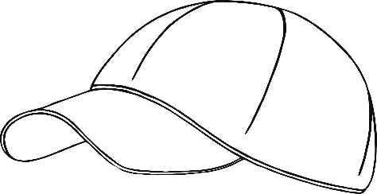

What is it?

Draw a line to what you think each silhouette is.

© 2022 Little Owls Resources

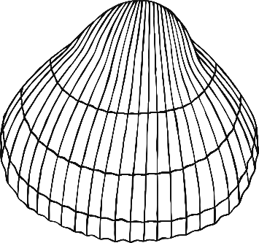

Colour & Cut

Santa mask

© 2021 Little Owls Resources

Design your own…

Cockle shell

© 2022 Little Owls Resources

What’s inside?

Draw what you hope is inside this picnic basket.

© 2022 Little Owls Resources

Colour & Cut

Sandcastle

1

2

3

4

5

6

7

8

9

10

© 2022 Little Owls Resources

Draw a line from each picture to the correct sound.

c

s

© 2022 Little Owls Resources

Match

the sound

Finish the pictures

Draw the other half of these pictures.

© 2022 Little Owls Resources

Draw a line from each picture to the correct sound.

Match

the sound

© 2022 Little Owls Resources

c

sh

s

h

b

**3**

**4**

**0**

**5**

**1**

**2**

Colour

in order

Find and colour the suns in the right order starting with 0.

© 2022 Little Owls Resources

Design your own…

Crab

© 2022 Little Owls Resources

© 2022 Little Owls Resources

Count

& Colour

How many shells are in the rockpools?

Design your own…

Ball

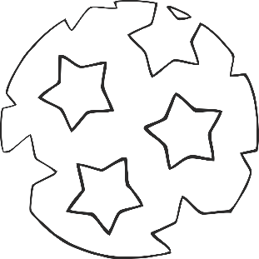

© 2022 Little Owls Resources

Colour & Cut

Watermelon Number Slice

© 2022 Little Owls Resources

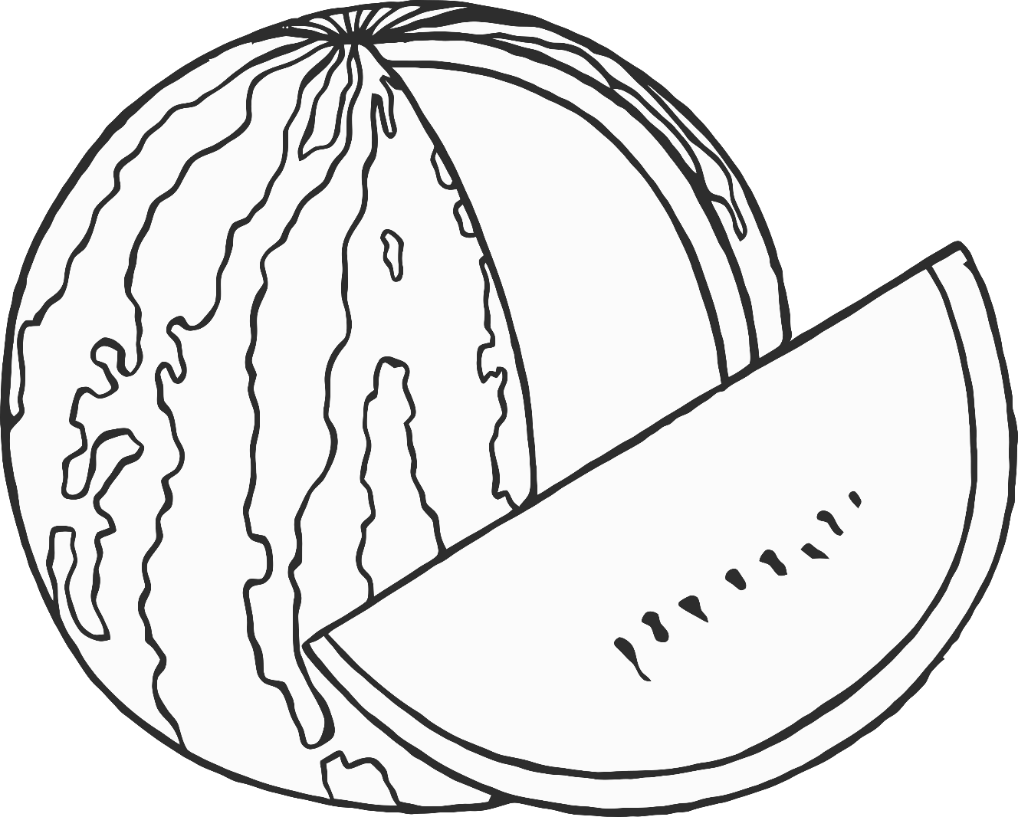

1

2

3

4

5

**3**

**7**

**4**

**10**

**8**

**1**

**6**

**9**

**5**

**2**

**0**

Colour

in order

Find and colour the shells in the right order starting with 0.

© 2022 Little Owls Resources

Finish the pictures

Draw the other half of these pictures.

© 2022 Little Owls Resources

Colour & Cut

Bucket & Space Number Slice

© 2022 Little Owls Resources

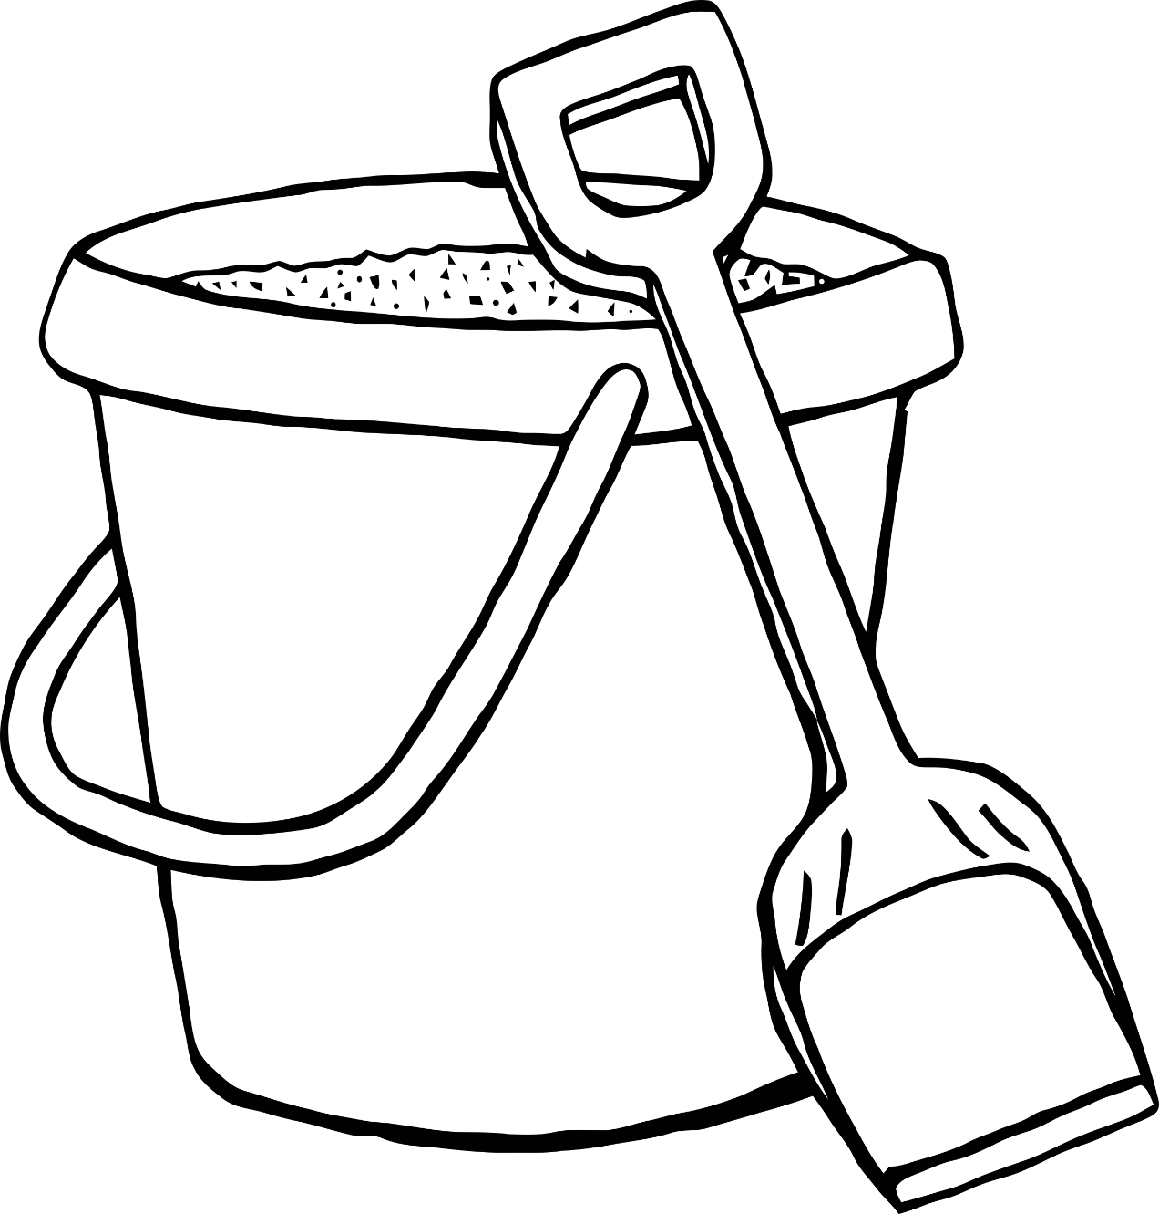

1

2

3

4

5

6

7

8

9

10

Count

& Colour

How many ice-lollies are there?

© 2022 Little Owls Resources

Design your own…

Sun

© 2022 Little Owls Resources

Mindfulness

colouring

Enjoy colouring this picture.

© 2022 Little Owls Resources

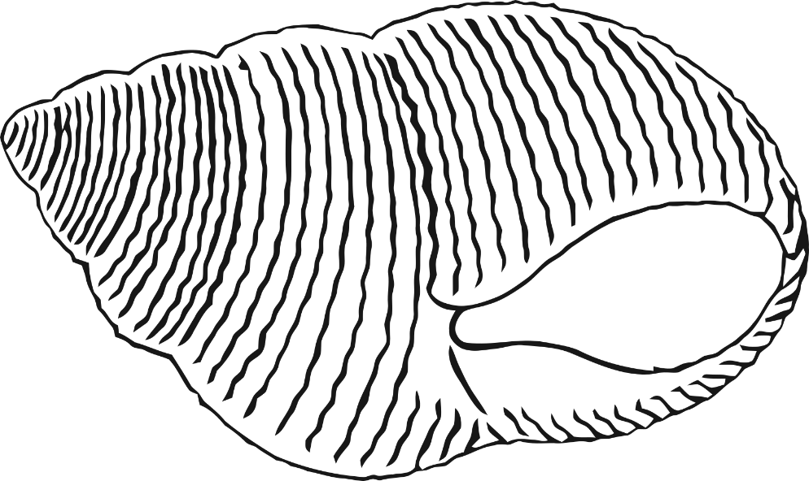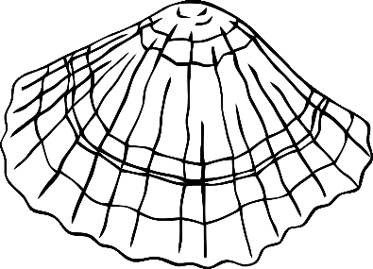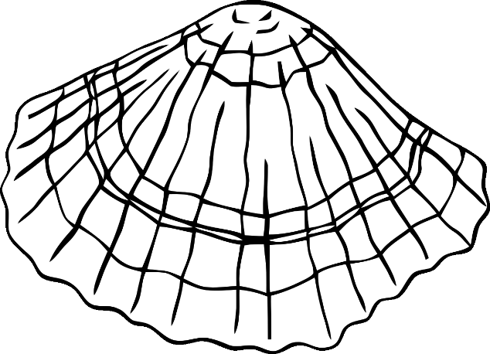

Finish the pictures

Draw the other half of these pictures.

© 2022 Little Owls Resources

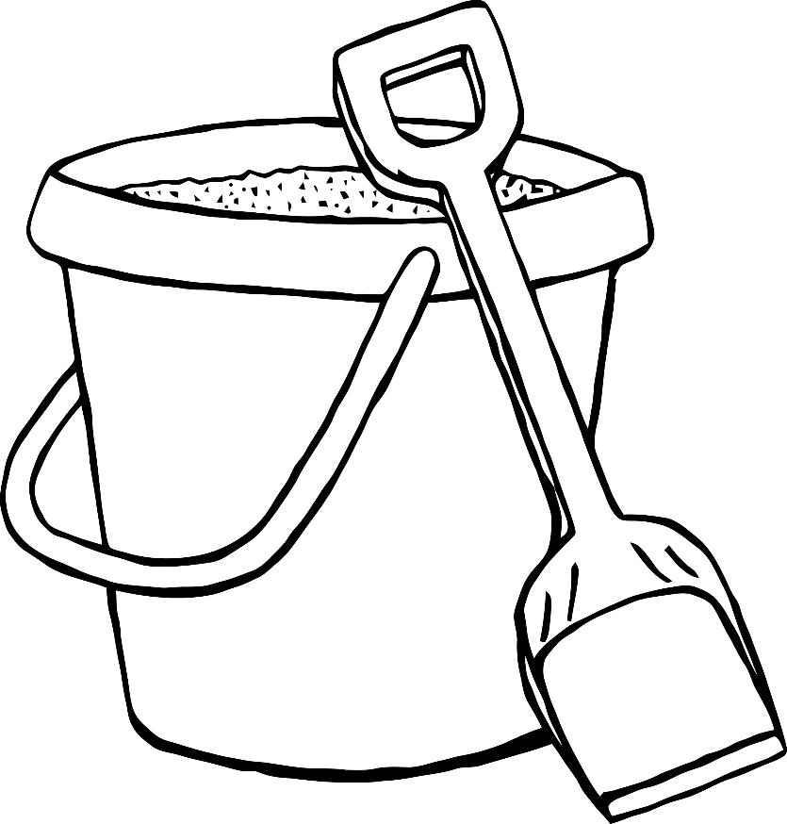

Mindfulness

colouring

Enjoy colouring these pictures.

© 2022 Little Owls Resources