Sudoku (1)

|  |  |  |
| --- | --- | --- |
|  |  |  |
|  |  |  |
|  |  |  |

1

1

3

2

1

2

2

3

3

2

1

3

Sudoku (2)

|  |  |  |
| --- | --- | --- |
|  |  |  |
|  |  |  |
|  |  |  |

1

1

2

2

3

3

Sudoku (3)

1

3

2

|  |  |  |
| --- | --- | --- |
|  |  |  |
|  |  |  |
|  |  |  |

1

1

2

2

3

3

Picture Sudoku (1)

|  |  |  |
| --- | --- | --- |
|  |  |  |
|  |  |  |
|  |  |  |

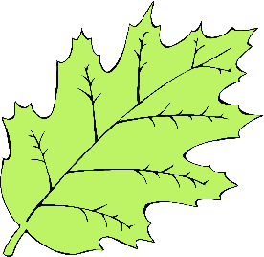

Picture Sudoku (2)

|  |  |  |
| --- | --- | --- |
|  |  |  |
|  |  |  |
|  |  |  |





Picture Sudoku (3)

|  |  |  |
| --- | --- | --- |
|  |  |  |
|  |  |  |
|  |  |  |