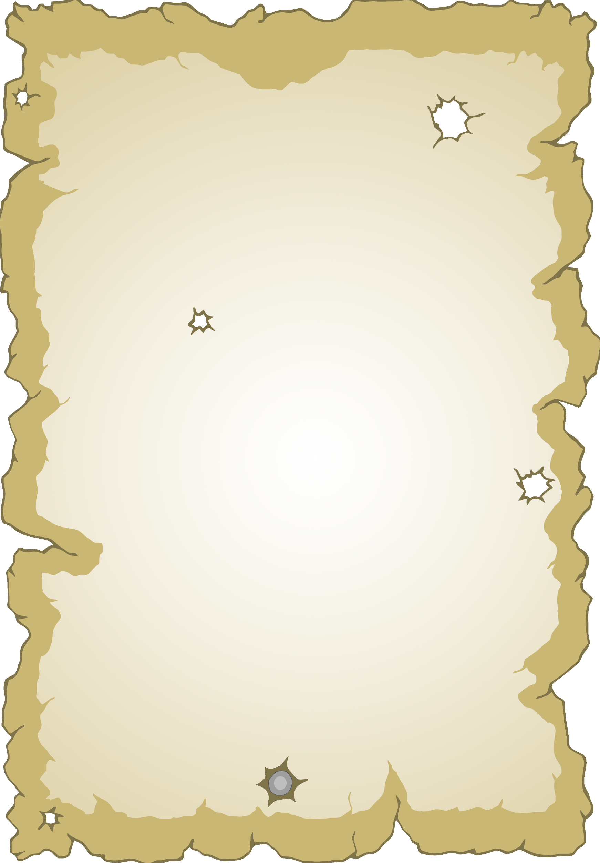

My Story Map

1

2

3

4

© 2021 Little Owls Resources



My Story Map

Setting

Characters

Beginning

Middle

End

© 2021 Little Owls Resources