© 2020 Little Owls Resources

**Lá fhéile Pádraig**

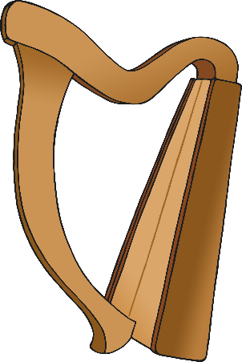

**sona dhaoibh!**

© 2020 Little Owls Resources

**Happy St.**



**Patrick’s Day!**