**Dydd Gŵyl**

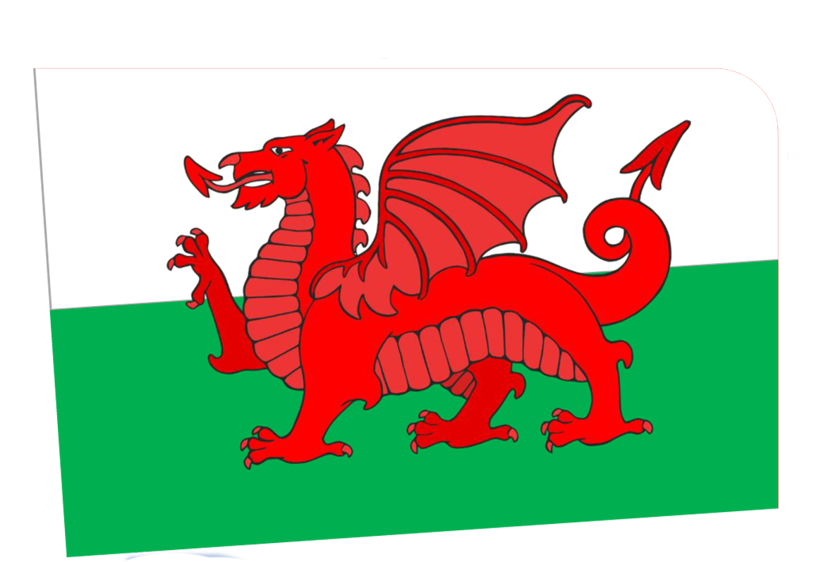

© 2020 Little Owls Resources

**Dewi Hapus!**

**Happy St.**



© 2020 Little Owls Resources

**David’s Day!**